SBTs for Nature
Initial Guidance for Business

Technical Annexes
September 2020

Note to reviewers: all content in this collated document is in draft, and as such will be left open for comment as a ‘living document’. We appreciate your feedback on content, and encourage critical feedback that is oriented towards improvement and strengthening.

Reading Guide
This document contains supporting technical information for the Science Based Targets Network’s Interim Guidance. Content is organized in general by sections of the formal guidance document. For your convenience, please refer to the table of contents below or in the left bar of this document for navigation.

Table of Contents
Reading Guide 2
Table of Contents 2
Technical Annex 1. Biodiversity and Nature’s Contributions to People 6
TA1.1 Biodiversity 6
TA1.2 Nature’s Contributions to People 7
TA 1.3 Overview of trends in NCP, as seen in IPBES Global Assessment 2019 9
TA 1.4 Applications to the AR3T mitigation hierarchy 10
TA 1.5 Translation between schemes and scales 13
TA 1.6 NCP frameworks 14
TA 1.7 Challenges and future research directions 14
Technical Annex 2: Decision Tree for Step 1: Assess 17
TA 2.1 Initial questions 18
TA 2.2 Sector-level materiality assessment 19
TA 2.3 Value chain assessment 20
TA 2.4 Estimated spatial assessment 25
TA 2.5 Company-level materiality assessment (refine estimates) 29
TA 2.6 Full process for Step 1: Assess 31
TA 2.7 Toolbox for Assess 33
Technical Annex 3: Sectoral Materiality Assessment Details 35
TA 3.1 Defining and assessing sectoral materiality 35
TA 3.2 Impact indicators coverage for the hubs 36
TA 3.3 Materiality matrix methodology tests and benchmark 37
TA 3.4 Matrix development and finalization 39
Technical Annex 4: Measurement Framework and Translation 40
TA4.1 Measurement Framework 40
TA4.2 Translation: Introduction 40
TA 4.3 Translation: Connection 41
TA 4.4 Translation: Allocation 46
TA 4.5 Translation: Conversion 58
Technical Annex 5: Mitigation-Conservation-AR3T Crosswalk 59
Technical Annex 6: Avoid 60
TA 6.1 What to avoid? 60
TA 6.2 Approaches to avoidance 62
TA 6.3 How much to Avoid? The concept of “as low as reasonably practicable" (ALARP) 63
TA 6.4 Further information on existing approaches to managing impacts to nature 64
TA 6.5 Data sources for informing avoidance 68
TA 6.6 Maps of potential no-go areas 73
TA 6.7 Maps of potential high-risk areas (KBAs, potential CH) 75
TA 6.8 Regions with high likelihood of threatened or range-restricted species (Range-rarity) 77
TA 6.9 Other resources 79
Technical Annex 7: Transform 83
TA 7.1 Background and context 83
TA 7.2 The need for transformational change 84
TA 7.3 Transformation and transitions for sustainability 86
TA 7.4 Root causes and indirect drivers 88
TA 7.5 The science of transformation 89
TA 7.6 “Transform” as part of science-based targets for nature: what does it mean and what actions can a company take now? 91
Technical Annex 8: MRV 100
Technical Annex 9: Additional Reading 112

Technical Annex 1. Biodiversity and Nature’s Contributions to People
This section provides further description of the key concepts of biodiversity and nature’s contributions to people.

TA1.1 Biodiversity
For biodiversity at the global scale, the private sector broadly aligns to targets such as Convention on Biological Diversity (CBD’s) Aichi Biodiversity Targets, which call for sustainable production and for impacts from the use of natural resources to be kept well within safe ecological limits. Similarly the UN’s Sustainable Development Goal 15 seeks “to protect, restore and promote sustainable use of terrestrial ecosystems, sustainably manage forests, combat desertification, and halt and reverse land degradation and halt biodiversity loss.” Both global scale Target and Goal are in their final year (2020), will likely not be met and planning for new global targets are still underway.
Despite these global ambitions, biodiversity continues to decline and more needs to be done to accurately measure and monitor biodiversity components to effectively implement adaptive management strategies. Currently one challenge is to meaningfully aggregate site-based information for species to a broader scale (e.g. corporate assets within a political boundary or company-wide) so that it can contribute to national accounts for biodiversity and/or be actionable at the company--wide level. While databases such as the Red List admirably detail over 116,000 species recent estimates for global species are around 8 million. Therefore basic informational data gaps remain to be addressed on land and even more so in freshwater and oceanic environments. Further, while several indices and methodologies have been developed to track species trends most remain too high-level, difficult to implement, or costly to be actionable by individual companies. Fortunately, work is in the final stage for new indices and metrics to improve this aspect of scaling for biodiversity. For habitats, the access to fine-scale temporal spatial imagery data makes moving between scales easier than for species. Monitoring of habitat loss or gain over time is more reliable. Further, costs for imagery are decreasing and the ability to gain insights for additional habitats beyond merely ‘forests’ is improving.

TA1.2 Nature’s Contributions to People

Conceptual overview: What are “Nature’s Contributions to People”, or NCPs?
Healthy ecosystems drive our economy. We have nature to thank for the food we eat, the air we breathe, the water we drink, the medicines we use, the raw materials we transform into goods, the places that we go to for rest and recreation, and the places that give us meaning. Without nature, these benefits to humanity would be orders of magnitude more costly (in time, energy, and money), and some would be unattainable. Nature’s Contributions to People (also known as “Ecosystem Goods and Services”) can be broadly grouped into three categories:
- Those that generate the biological materials we use (“material”, “goods”).
- Those that govern the biophysical processes we leverage (“regulating”, “services”).
- Those that influence our sense of personal/social identity, cultural/psychological well-being (“non-material”).
Beyond these three broad categories, there is no one “correct” master list of NCPs. Diverse classification schemes have been developed by different communities for application to various geographies, spatial scales, and use cases. The most well-known schemes are listed and briefly described in the NCP Frameworks Spreadsheet.

TA 1.3 Overview of trends in NCP, as seen in IPBES Global Assessment 2019

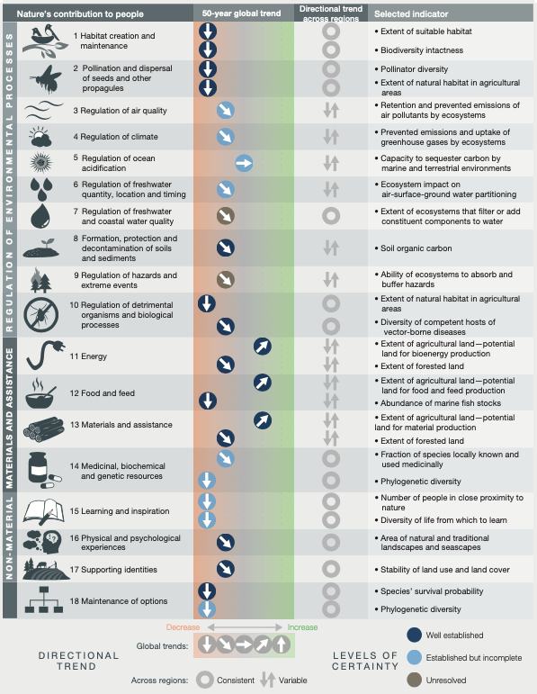
While the wellbeing of our communities and economies absolutely depends on the healthy functioning of the ecosystems that support us, global trends in NCP yield have been consistently downward across all categories measured for the past 50 years. These trends are driven by degradation and over-exploitation of ecosystems, and without urgent action to reverse these trends through better ecosystem management, humanity’s long-term wellbeing may be seriously threatened.

TA 1.4 Applications to the AR³T mitigation hierarchy
Companies should alter the types and locations of their activities so that they do not damage ecosystem structure or function in ways that impair NCP for generations. Some places must be avoided entirely, impact on others must be reduced, others must be restored and regenerated, and the practices impacting these places must be transformed. Maps of parameters such as ecosystem intactness, human impact, restoration potential, Key Biodiversity Areas, Critical Natural Assets, or Irrecoverable Carbon could provide insight into where these places might be and what level of benefit they may yield now, and scenario modeling can enable the estimation of potential impacts on NCP yield of alternative management strategies. A list of some of the available data resources can be found in the NCP Frameworks Spreadsheet.

Avoid
In the SBTN framework, the concept of Avoidance contains the following two sub-categories:
- Impacting certain places or engaging in certain activities is not recommended under any circumstances (i.e. prescriptive or ‘no-go’).
- Impacting certain places or engaging in certain activities may be permissible, to a certain extent, under certain circumstances (i.e. risk-based).
In the NCP context, Avoidance should prevent the (irreversible) compromising of an ecosystem’s ability to provide NCPs, now or in the future. For some types of NCP (likely “regulating” or “cultural”), this may translate into prescriptive no-go recommendations for pristine places or damaging activities. Carbon storage for climate mitigation is one of the clearest examples of a case for which a spatial no-go recommendation is meaningful. The flood risk reduction and water supply capacities of ecosystems like coastal mangrove forests and upland forested watersheds provide other examples. For other types of NCPs (likely “provisioning”), risk-based avoidance recommendations may be more appropriate, or even recommendations on reduction, management, stewardship, or restoration instead of avoidance. Further analysis is required for the development of specific recommendations (certain types of NCPs, spatial scales, contexts). In general, it should be noted that NCPs can be rival, that different NCPs may have synergistic/trade-off relationships with one another, and that different groups of people may be more or less able to substitute, buy, trade, or engineer their way out problems related to NCP degradation, depending on their level of wealth/power.
A preliminary analysis done by CI and King’s College London combines a collection of global provisioning, regulating, and cultural NCP datasets calculated with the Co$tingNature system to map the aggregated spatial distribution of high-performing areas for NCP around the world. The project examined the spatial relationships between these areas and the world’s ecoregions and found that some ecoregions are especially high-performing for NCPs globally (Fig. 1a). CI and King’s also identified the highest-performing parts of each ecoregion in terms of NCP provision (Fig. 1b). Only 5% of the planet’s land surface contains both high-performing areas for NCP and intact ecosystems (Fig. 1c), meaning most of the world’s NCP is generated by areas experiencing some level of human impact. Thus, “manage” may be a more appropriate strategy than “avoid” for many of the places providing NCP around the world. However, loss of the remaining intact places providing high NCP is strongly undesirable, so “avoid” is appropriate for these areas (Fig. 1c) as well as for areas of high irrecoverable carbon (Fig. 1d; dataset from Noon et al., in review). Ongoing work explores the spatial patterns of individual NCP categories and will leverage new layers and analyses currently underway as part of a partnership between CI, the Natural Capital Project at Stanford, Cornell, and King’s College London.
In terms of biodiversity, each ecoregion is biologically distinct; therefore, NCP provision is examined by ecoregion. To optimally sustain both biodiversity and NCP provision, a global strategy should consider opportunities across all ecoregions. A similar analysis can be done for other regional breakdown approaches, such as political boundaries (e.g. countries, states, municipalities) or watersheds, if representation across those categories is deemed important.
If an area coverage target is declared and mapped (based for example on political considerations), the percent of utility captured by that area can be calculated. Similarly, if a desired utility threshold is declared, the area required to capture that utility can be calculated and mapped. Utility thresholds can also be derived from calculating the marginal utility yielded by each additional increment of area and looking for the point of diminishing marginal returns. NCP categories used to create aggregate maps for Figs. 1, 2, and 3 are those of the C$Nv3 scheme as described in the NCP Frameworks Spreadsheet. Figures 1-4 are in preparation for publication and should not be shared or reproduced.

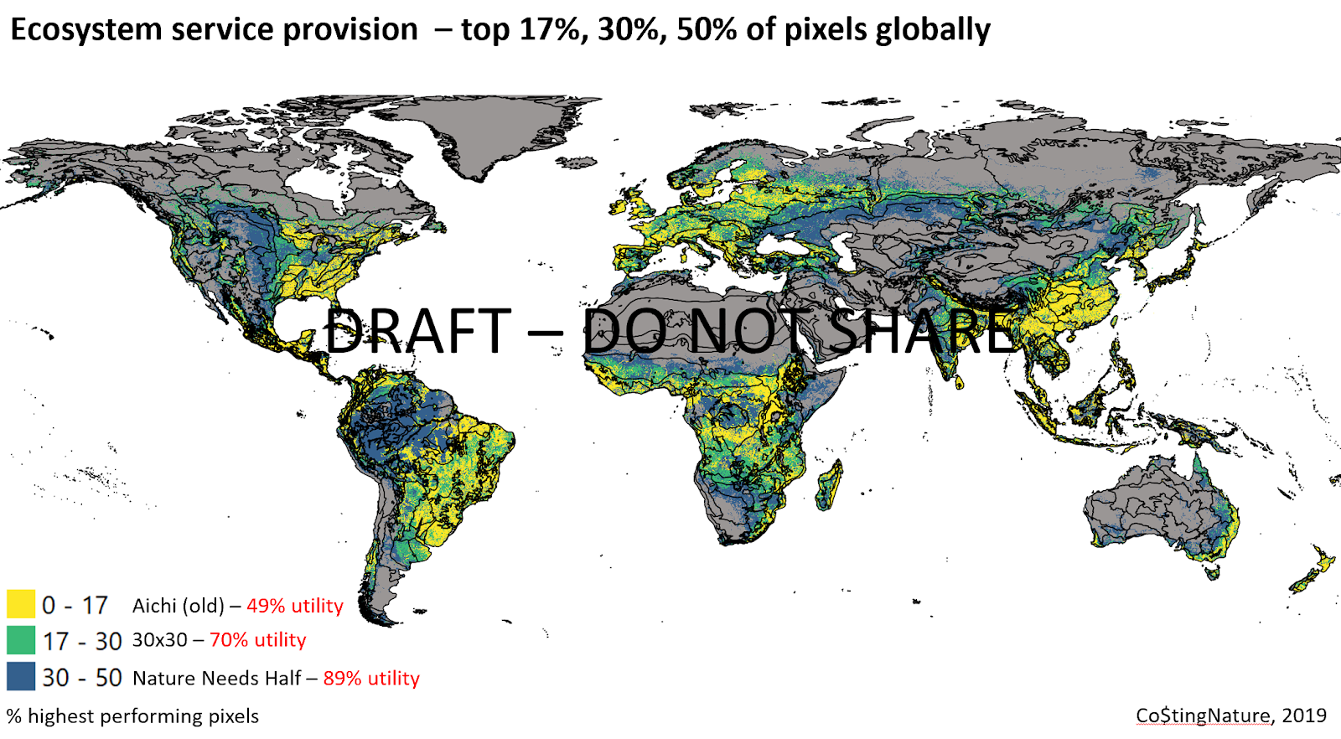  a | 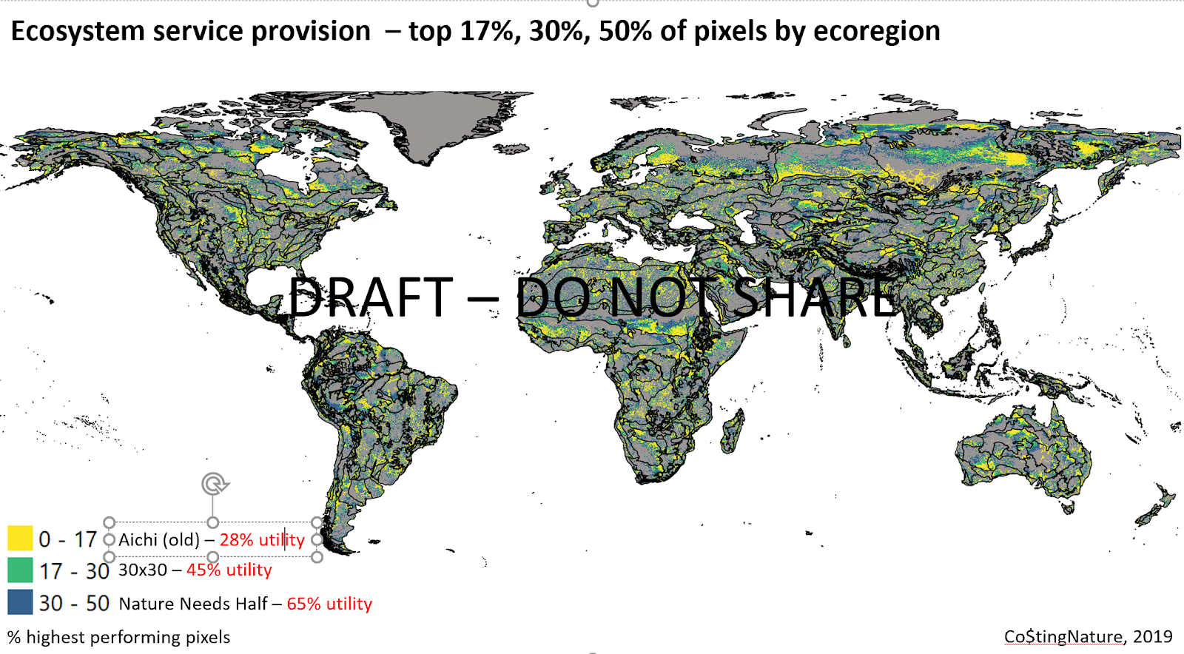  b
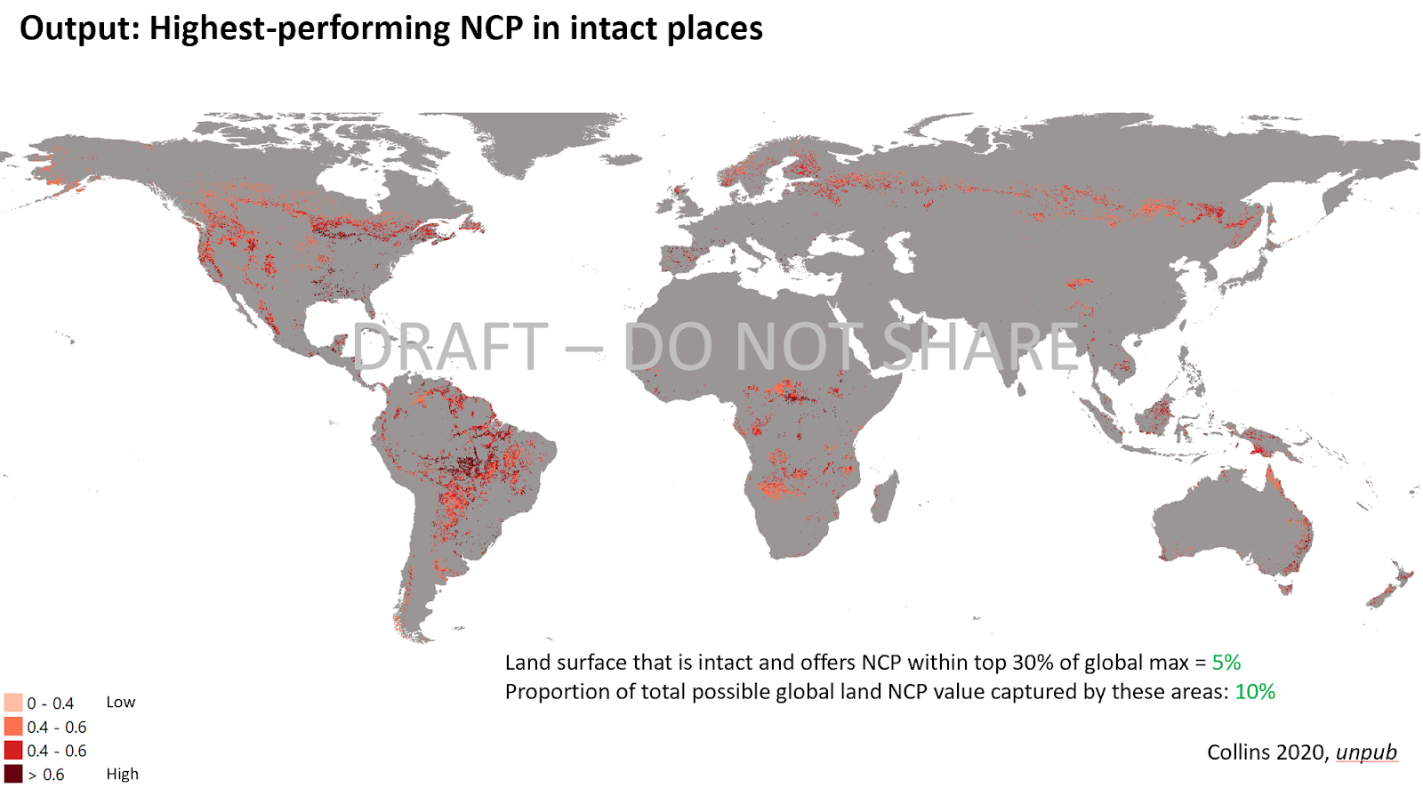  c | 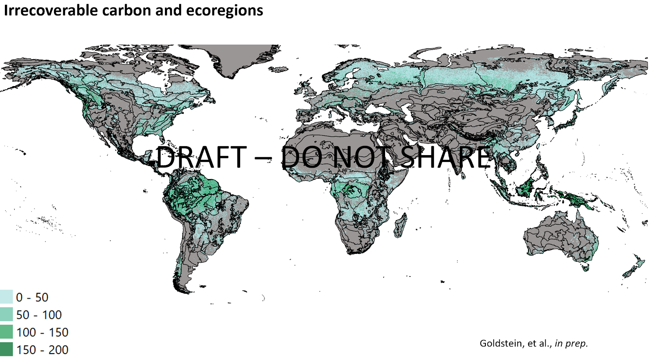  d
Figure 1. Assessment of critical natural capital globally, by ecoregion, and considering intactness, with areas of high importance for carbon storage. Unpublished work. Please do not distribute. a.) Highest-performing areas for ecosystem service provision, ranked globally. b.) Highest-performing areas for ecosystem service provision, ranked by ecoregion. c.) Intact areas that are also high-performing for ecosystem service provision. NCP categories used to create aggregate maps for a., b., and c. are those of the C$Nv3 scheme as described in the NCP Frameworks Spreadsheet. Image credits: Conservation International and policysupport.org/King's College London. d.) The places harboring the greatest quantities of irrecoverable carbon are in green. Companies should avoid disturbing these places. Units: Metric tons C per hectare. Image credit: Conservation International, data presented in Noon et al. in review.

Reduce
In places that already experience human impact and yet still perform reasonably well in terms of NCP generation and/or carbon storage/sequestration, reduction of impact may lead to performance improvements. For example, reducing fishing in over-exploited fish stocks can increase catch per unit effort (source), and reduction of grazing pressure in over-grazed systems can improve both livestock yield and increase soil carbon storage and sequestration (source). Reduction opportunities can be identified by juxtaposing maps of anthropogenic pressure (e.g. ecosystem intactness, human footprint) with a map of Critical Natural Capital (for NCP overall) or service-specific maps such as a map of Irrecoverable Carbon (for climate change mitigation).

Regenerate & Restore
Places that are degraded and do not currently generate much NCP or store/sequester significant amounts of carbon might be able to do so if they were restored/regenerated. For example, vegetation restoration can improve water availability and quality by increasing rainwater infiltration into the soil (source), reducing erosion and sediment transport (source), and slowing nutrient transport (source), all while sequestering carbon (source). Such places could be identified using maps of restoration potential, models of ecosystem function / NCP generation, and/or historical knowledge (including that gathered through stakeholder engagement) about pre-degradation NCP generation.

Transform
Companies should transform practices that cause damage to, or prevent the restoration of, the places important for NCP generation and/or carbon storage/sequestration as discussed in the Avoid, Reduce, and Restore & Regenerate sections. For example, attention should be paid not only to the lands directly used for generating the raw materials the company needs to create its products but also the impacts caused by the emission of wastes from the manufacturing process.

TA 1.5 NCP frameworks
The NCP Frameworks Spreadsheet contains a mix of NCP schemes and other environmental impact / biophysical / planetary health schemes/frameworks. The selection of the “correct” scheme is context-dependent.

TA 1.6 Challenges and future research directions
- What to do when data-driven decision-making must contend with political realities?
- When data is unavailable or inconclusive, how best to leverage the precautionary principle?
- How best to attribute potential NCPs to population sizes or levels of wellbeing, thus deriving ‘realized’ NCPs? Varies by NCP type? How best to estimate value?
- How to handle tradeoffs, co-benefits, rivalry between services? Short-term vs. long-term costs of different decisions? Unforeseen consequences?
- Best ethical/fair practices when engaging with different groups of people having different levels of power?
- What to do if costs are shifted between different elements of the population with different relative amounts of wealth/power?
- How to assess degree of dependence of different groups of people on different NCPs, based on vulnerability, poverty, ability to seek alternatives.
- Should ecosystems be permitted to be impacted if the NCPs they provide can be substituted, through trade, aid, engineering? Is it better to bet that the former or the latter will be more resilient to shocks? Or should it be “both”?
- When is ‘avoid’ the right strategy (risk-based vs. prescriptive (no-go)), and when is restore, manage, or transform more appropriate?
- How do regulating, provisioning, and cultural NCPs differ in terms of appropriate strategies?
- What to do when the data needed to derive a certain NCP is only available at a too coarse of a spatial scale or only updated once every five years? What to do when model assumptions smooth out too much variability?
- Should we prioritize areas of highest benefit? Emphasize doing no harm? Accept certain levels of risk? How much?
- Different types of NCPs are relevant in different geographies and at different spatial scales.
- Data availability varies widely by time, space, and NCP type.
- Many more NCPs exist than can currently be mapped/modeled, meaning any NCP analysis is an underestimate of the full range of benefits nature provides humanity.

Technical Annex 2: Data Collection Guide for Step 1: Assess
This DRAFT Data Collection Guide is intended to guide a user through the process of Step 1. This will include:
- Sector-level materiality assessment: using the sectoral materiality checklists, the company first screens for environmental issues;
- Value chain assessment: using models and tools, the company assesses where impacts and dependencies most likely occur throughout the value chain, both in supply chain tiers and in geographic places
- Company-level assessment: using the outputs from the sector-level materiality assessment, and value chain assessment, companies refine estimates where further detail is needed, and identify any additional issue areas based on business priorities or the specifics of their business.
This process will provide initial estimates of an actor’s environmental footprint and a shortlist of potential thematic and spatial target areas.
The questions and templates below are meant to help you benchmark against SBTN’s proposed process for carrying out Step 1 of SBT setting.
If you choose to complete the templates below, we recommend you compile these in a separate document (with the date of assessment clearly recorded), so that you can reference these during your SBT setting process.
SBTN is not currently offering a validation service for this assessment.
----------

TA 2.1 - Initial questions

1. In the following table, please mark the appropriate rows to indicate which sector classifications apply to your business.
The following sectors are taken from the Global Industry Classification Standard (GICS). The GICS classifications are chosen since the methodology is widely accepted globally and across all industries. Some businesses will need to select multiple sectors.
Note: SBTN is still determining whether GICS is the optimal classification scheme. Feedback on the matter is welcome.

Template 1: Sector relevance
Sector | Examples of industry (groups), sub-industry | This sector is a part of my business (Y/N)
Consumer Discretionary | e.g. apparel; automobiles; household durables; hotels, resorts and cruise lines
Consumer Staples | e.g. agricultural products, drug retail, tobacco, personal products
Energy | e.g. oil and gas drilling, oil and gas transportation
Financials | e.g. banks, capital markets, consumer finance, insurance
Health Care | e.g. pharmaceuticals, health care facilities, health care equipment
Industrials | e.g. buildings, construction, machinery, professional services, roads and railways
Information Technology | e.g. data processing, application software, electronic components, semiconductors
Materials | e.g. chemicals, containers and packaging, forestry products, mining
Real Estate | e.g. real estate development, equity real estate investment trusts
(Tele)Communication Services | e.g. wireless telecoms, advertising, publishing, cable & satellite, movies & entertainment
Utilities | e.g. electric, gas, water, renewables

2. Of the following business activities, please identify and indicate those which apply to you.
The table below is taken from the ENCORE risk assessment tool.
This information will be used to determine the outputs of Step 1a, as well as 1b, 1c, and again in Step 2: Interpret.

Template 2: Business activities
Sector | Sub-industry | Process | Relevant?  (Y/N)
Consumer Discretionary | Cable & Satellite | Cable and satellite installations on land
Consumer Discretionary | Homebuilding | Construction
Consumer Discretionary | Hotels, Resorts & Cruise Lines | Cruise line provision
Consumer Discretionary | Distributors | Distribution
Consumer Discretionary | Consumer Electronics | Electronics and hardware production
Consumer Discretionary | Footwear | Footwear production
Consumer Discretionary | Hotels, Resorts & Cruise Lines | Hotels and resorts provision
Consumer Discretionary | Housewares & Specialties | Houseware and specialities production
Consumer Discretionary | Advertising | Infrastructure holdings
Consumer Discretionary | Apparel Retail | Infrastructure holdings
Consumer Discretionary | Automotive Retail | Infrastructure holdings
Consumer Discretionary | Broadcasting | Infrastructure holdings
Consumer Discretionary | Computer & Electronics Retail | Infrastructure holdings
Consumer Discretionary | Department Stores | Infrastructure holdings
Consumer Discretionary | Education Services | Infrastructure holdings
Consumer Discretionary | General Merchandise Stores | Infrastructure holdings
Consumer Discretionary | Home Improvement Retail | Infrastructure holdings
Consumer Discretionary | Home furnishing Retail | Infrastructure holdings
Consumer Discretionary | Internet & Direct Marketing Retail | Infrastructure holdings
Consumer Discretionary | Movies & Entertainment | Infrastructure holdings
Consumer Discretionary | Publishing | Infrastructure holdings
Consumer Discretionary | Specialty Stores | Infrastructure holdings
Consumer Discretionary | Apparel, Accessories & Luxury Goods | Jewellery production
Consumer Discretionary | Casinos & Gaming | Leisure facility provision
Consumer Discretionary | Auto Parts & Equipment | Manufacture of machinery, parts & eqpt
Consumer Discretionary | Automobile Manufacturers | Manufacture of machinery, parts & eqpt
Consumer Discretionary | Home Furnishings | Manufacture of machinery, parts & eqpt
Consumer Discretionary | Household Appliances | Manufacture of machinery, parts & eqpt
Consumer Discretionary | Motorcycle Manufacturers | Manufacture of machinery, parts & eqpt
Consumer Discretionary | Apparel, Accessories & Luxury Goods | Natural fibre production
Consumer Discretionary | Textiles | Natural fibre production
Consumer Discretionary | Leisure Products | Production of leisure / personal products
Consumer Discretionary | Restaurants | Restaurant provision
Consumer Discretionary | Apparel, Accessories & Luxury Goods | Synthetic fibre production
Consumer Discretionary | Textiles | Synthetic fibre production
Consumer Discretionary | Tires & Rubber | Tyre and rubber production
Consumer Staples | Brewers | Alcoholic fermentation and distilling
Consumer Staples | Distillers & Vintners | Alcoholic fermentation and distilling
Consumer Staples | Agricultural Products | Aquaculture
Consumer Staples | Food Distributors | Distribution
Consumer Staples | Agricultural Products | Freshwater wild-caught fish
Consumer Staples | Drug Retail | Infrastructure holdings
Consumer Staples | Food Retail | Infrastructure holdings
Consumer Staples | Hypermarkets & Super Centres | Infrastructure holdings
Consumer Staples | Agricultural Products | Large-scale irrigated arable crops
Consumer Staples | Agricultural Products | Large-scale livestock (beef and dairy)
Consumer Staples | Agricultural Products | Large-scale rainfed arable crops
Consumer Staples | Packaged Foods & Meats | Processed food and drink production
Consumer Staples | Soft Drinks | Processed food and drink production
Consumer Staples | Personal Products | Production of leisure or personal products
Consumer Staples | Agricultural Products | Saltwater wild-caught fish
Consumer Staples | Agricultural Products | Small-scale irrigated arable crops
Consumer Staples | Agricultural Products | Small-scale livestock (beef and dairy)
Consumer Staples | Agricultural Products | Small-scale rainfed arable crops
Consumer Staples | Tobacco | Tobacco production
Energy | Integrated Oil & Gas | Integrated oil and gas
Energy | Oil & Gas Equipment & Services | Manufacture of machinery, parts & eqpt
Energy | Coal & Consumable Fuels | Mining
Energy | Oil & Gas Drilling | Oil and gas drilling
Energy | Oil & Gas Exploration & Production | Oil and gas exploration surveys
Energy | Oil & Gas Refining & Marketing | Oil and gas refining
Energy | Oil & Gas Equipment & Services | Oil and gas services
Energy | Oil & Gas Storage & Transportation | Oil and gas storage
Energy | Oil & Gas Storage & Transportation | Oil and gas transportation
Financials | Asset Management & Custody Banks | Financial services
Financials | Consumer Finance | Financial services
Financials | Diversified Banks | Financial services
Financials | Diversified Capital Markets | Financial services
Financials | Financial Exchanges & Data | Financial services
Financials | Insurance Brokers | Financial services
Financials | Investment Banking & Brokerage | Financial services
Financials | Life & Health Insurance | Financial services
Financials | Multi-line Insurance | Financial services
Financials | Multi-Sector Holdings | Financial services
Financials | Other Diversified Financial Services | Financial services
Financials | Property & Casualty Insurance | Financial services
Financials | Regional Banks | Financial services
Financials | Reinsurance | Financial services
Financials | Specialized Finance | Financial services
Financials | Thrifts & Mortgage Finance | Financial services
Health Care | Health Care Distributors | Distribution
Health Care | Health Care Services | Infrastructure holdings
Health Care | Health Care Technology | Infrastructure holdings
Health Care | Biotechnology manufacturing | Life science, pharma and biotech manufacture
Health Care | Life Sciences manufacturing | Life science, pharma and biotech manufacture
Health Care | Pharmaceuticals manufacturing | Life science, pharma and biotech manufacture
Health Care | Biotechnology services | Life science, pharma, biotech tools & services
Health Care | Life Sciences Tools services | Life science, pharma, biotech tools & services
Health Care | Pharmaceuticals services | Life science, pharma, biotech tools & services
Health Care | Managed Health Care | Managed health care
Health Care | Health Care Facilities | Provision of health care
Industrials | Airlines | Airport services
Industrials | Airport Services | Airport services
Industrials | Highways & Rail tracks | Construction
Industrials | Air Freight & Logistics | Distribution
Industrials | Trading Companies & Distributors | Distribution
Industrials | Electrical Components & Equipment | Electronics and hardware production
Industrials | Environmental & Facilities Services | Environmental and facilities services
Industrials | Building Products | Glass making
Industrials | Construction & Engineering | Infrastructure builds
Industrials | Diversified Support Services | Infrastructure holdings
Industrials | Human Resource & Employment Services | Infrastructure holdings
Industrials | Research & Consulting Services | Infrastructure holdings
Industrials | Security & Alarm Services | Infrastructure holdings
Industrials | Construction & Engineering | Infrastructure maintenance contracts
Industrials | Aerospace & Defense | Manufacture of machinery, parts & eqpt
Industrials | Agricultural & Farm Machinery | Manufacture of machinery, parts & eqpt
Industrials | Construction Machinery, Heavy Trucks | Manufacture of machinery, parts & eqpt
Industrials | Heavy Electrical Equipment | Manufacture of machinery, parts & eqpt
Industrials | Industrial Machinery | Manufacture of machinery, parts & eqpt
Industrials | Trucking | Manufacture of machinery, parts & eqpt
Industrials | Marine Ports & Services | Marine ports and services
Industrials | Marine | Marine transportation
Industrials | Railroads | Railway transportation
Information Technology | Technology Distributors | Distribution
Information Technology | Communications Equipment | Electronics and hardware production
Information Technology | Electronic Components | Electronics and hardware production
Information Technology | Electronic Equipment & Instruments | Electronics and hardware production
Information Technology | Electronic Manufacturing Services | Electronics and hardware production
Information Technology | Tech. Hardware, Storage & Peripherals | Electronics and hardware production
Information Technology | IT Consulting & Other Services | Infrastructure holdings
Information Technology | Office Services & Supplies | Infrastructure holdings
Information Technology | Semiconductor Equipment | Manufacture of semiconductor equipment
Materials | Aluminium | Alumina refining
Materials | Commodity Chemicals | Catalytic cracking, fractional distillation and crystallization
Materials | Industrial Gases | Catalytic cracking, fractional distillation and crystallization
Materials | Specialty Chemicals | Catalytic cracking, fractional distillation and crystallization
Materials | Construction Materials | Construction materials production
Materials | Industrial Gases | Cryogenic air separation
Materials | Industrial Gases | Gas adsorption
Materials | Diversified Chemicals | Incomplete combustion
Materials | Iron | Iron extraction
Materials | Iron | Iron metal production
Materials | Forest Products | Large-scale forestry
Materials | Industrial Gases | Membrane technology
Materials | Metal & Glass Containers | Metal processing
Materials | Aluminium | Mining
Materials | Copper | Mining
Materials | Diversified Metals & Mining | Mining
Materials | Gold | Mining
Materials | Precious Metals & Minerals | Mining
Materials | Silver | Mining
Materials | Industrial Gases | Natural gas combustion
Materials | Paper Packaging | Paper packaging production
Materials | Diversified Chemicals | Polymerization
Materials | Forest Products | Production of forest & wood-based products
Materials | Paper Products | Production of paper products
Materials | Industrial Gases | Recovery and separation of CO2
Materials | Forest Products | Small-scale forestry
Materials | Specialty Chemicals | Solids processing
Materials | Steel | Steel production
Materials | Fertilizers & Agricultural Chemicals | Synthetic fertilizer production
Materials | Diversified Chemicals | Vulcanisation
Real Estate | Diversified Real Estate Activities | Real estate activities
Real Estate | Real Estate Development | Real estate activities
Real Estate | Real Estate Operating Companies | Real estate activities
Real Estate | Real Estate Services | Real estate activities
Telecomm. Services | Alternative Carriers | Cable and satellite installations on land
Telecomm. Services | Alternative Carriers | Fibre-optic cable installation (marine)
Telecomm. Services | Integrated Telecommunication Services | Telecomm. and wireless services
Telecomm. Services | Wireless Telecommunication Services | Telecomm. and wireless services
Utilities | Renewable Electricity | Biomass energy production
Utilities | Electric Utilities | Electric, nuclear transmission & distribution
Utilities | Independent Power Producers & Energy Traders | Electric, nuclear transmission & distribution
Utilities | Gas Utilities | Gas distribution
Utilities | Gas Utilities | Gas retail
Utilities | Renewable Electricity | Geothermal energy production
Utilities | Electric Utilities | Hydropower production
Utilities | Independent Power Producers & Energy Traders | Hydropower production
Utilities | Renewable Electricity | Hydropower production
Utilities | Electric Utilities | Infrastructure holdings
Utilities | Independent Power Producers & Energy Traders | Infrastructure holdings
Utilities | Electric Utilities | Nuclear and thermal power stations
Utilities | Independent Power Producers & Energy Traders | Nuclear and thermal power stations
Utilities | Renewable Electricity | Solar energy provision
Utilities | Water Utilities | Water services (e.g. waste water, treatment and distribution)
Utilities | Renewable Electricity | Wind energy provision

----------

TA 2.2 - Sector-level materiality assessment
Objective: Using the sectoral materiality matrices provided by SBTN, identify WHICH of your sector’s impacts and dependencies on nature are most significant for the purposes of target setting

3. Have you identified issues which are thought to be material for your sector?
Responses:
- Yes → Please move to Question 4
- No → Identify issues with sector-level materiality for your business
Supporting Text:
For the purposes of this assessment, the materiality assessment focuses on the significance of an entity’s impacts and dependencies on nature (societal materiality) - see Technical Annex on Materiality (TA 3).
Please use the following matrix to identify the issue areas which are material for your sector.
Interim results are shown below, grouped by key issue area (note not all SBTN Issue Areas are currently available in ENCORE), and GICS Sector and Subindustry. Each value is formatted to represent materiality for (upstream/direct operations/downstream), where VL = very low, L = low, M = medium, H = high, and VH = very high. Blank values do not indicate a lack of impact, but rather a lack of data. We will be working to fill in these blanks over the coming years.

 |  | Land/Sea Use Change |  |  | Resource Exploitation | Climate Change | Pollution |  |  |  | Invasives and Other
Sector | Sub-Industry | Terrestrial ecosystem use | Freshwater ecosystem use | Marine ecosystem use | Water use | GHGs emissions | Non-GHG air pollutants | Water pollutants | Soil pollutants | Solid waste | Disturbance
Consumer Discretionary | Advertising | M / / | M / / | M / / | M / M / | VH / / | M / M / | M / M / | M / L / | M / H / | M / /
Consumer Discretionary | Apparel Retail | M / / | M / / | M / / | M / M / | VH / / | M / M / | M / M / | M / L / | M / H / | M / /
Consumer Discretionary | Apparel, Accessories & Luxury Goods | M / / | M / / | M / / | M / / | VH / / | M / / | M / / | M / M / | M / / | M / /
Consumer Discretionary | Auto Parts & Equipment | M / / | M / / | M / / | M / H / | VH / / | M / VH / | M / VH / | M / VH / | M / H / | M / /
Consumer Discretionary | Automobile Manufacturers | M / / | M / / | M / / | M / H / | VH / / | M / VH / | M / VH / | M / VH / | M / H / | M / /
Consumer Discretionary | Automotive Retail | M / / | M / / | M / / | M / M / | VH / / | M / M / | M / M / | M / L / | M / H / | M / /
Consumer Discretionary | Broadcasting | M / / | M / / | M / / | M / M / | VH / / | M / M / | M / M / | M / L / | M / H / | M / /
Consumer Discretionary | Cable & Satellite | M / VL / | M / L / | M / / | M / / | VH / / | M / / | M / / | M / / | M / / | M / VH /
Consumer Discretionary | Casinos & Gaming | M / / | M / / | M / / | M / / | VH / / | M / / | M / / | M / / | M / H / | M / /
Consumer Discretionary | Computer & Electronics Retail | M / / | M / / | M / / | M / M / | VH / / | M / M / | M / M / | M / L / | M / H / | M / /
Consumer Discretionary | Consumer Electronics | M / / | M / / | M / / | M / / | VH / / | M / / | M / VH / | M / VH / | M / M / | M / /
Consumer Discretionary | Department Stores | M / / | M / / | M / / | M / M / | VH / / | M / M / | M / M / | M / L / | M / H / | M / /
Consumer Discretionary | Distributors | M / / | M / / | M / L / | M / / | VH / H / | M / M / | M / L / | M / VL / | M / / | M / L /
Consumer Discretionary | Education Services | M / / | M / / | M / / | M / M / | VH / / | M / M / | M / M / | M / L / | M / H / | M / /
Consumer Discretionary | Footwear | M / / | M / / | M / / | M / M / | VH / / | M / M / | M / M / | M / H / | M / H / | M / /
Consumer Discretionary | General Merchandise Stores | M / / | M / / | M / / | M / M / | VH / / | M / M / | M / M / | M / L / | M / H / | M / /
Consumer Discretionary | Home furnishing Retail | M / / | M / / | M / / | M / M / | VH / / | M / M / | M / M / | M / L / | M / H / | M / /
Consumer Discretionary | Home Furnishings | M / / | M / / | M / / | M / H / | VH / / | M / VH / | M / VH / | M / VH / | M / H / | M / /
Consumer Discretionary | Home Improvement Retail | M / / | M / / | M / / | M / M / | VH / / | M / M / | M / M / | M / L / | M / H / | M / /
Consumer Discretionary | Homebuilding | M / / | M / H / | M / / | M / H / | VH / M / | M / L / | M / VL / | M / M / | M / / | M / H /
Consumer Discretionary | Hotels, Resorts & Cruise Lines | M / / | M / / | M / / | M / / | VH / / | M / / | M / / | M / / | M / M / | M / /
Consumer Discretionary | Household Appliances | M / / | M / / | M / / | M / H / | VH / / | M / VH / | M / VH / | M / VH / | M / H / | M / /
Consumer Discretionary | Housewares & Specialties | M / / | M / / | M / / | M / / | VH / / | M / VH / | M / VH / | M / H / | M / VH / | M / /
Consumer Discretionary | Internet & Direct Marketing Retail | M / / | M / / | M / / | M / M / | VH / / | M / M / | M / M / | M / L / | M / H / | M / /
Consumer Discretionary | Leisure Products | M / / | M / / | M / / | M / H / | VH / VH / | M / L / | M / H / | M / M / | M / H / | M / /
Consumer Discretionary | Motorcycle Manufacturers | M / / | M / / | M / / | M / H / | VH / / | M / VH / | M / VH / | M / VH / | M / H / | M / /
Consumer Discretionary | Movies & Entertainment | M / / | M / / | M / / | M / M / | VH / / | M / M / | M / M / | M / L / | M / H / | M / /
Consumer Discretionary | Publishing | M / / | M / / | M / / | M / M / | VH / / | M / M / | M / M / | M / L / | M / H / | M / /
Consumer Discretionary | Restaurants | M / / | M / / | M / / | M / / | VH / / | M / / | M / / | M / / | M / H / | M / /
Consumer Discretionary | Specialty Stores | M / / | M / / | M / / | M / M / | VH / / | M / M / | M / M / | M / L / | M / H / | M / /
Consumer Discretionary | Textiles | M / VL / | M / / | M / / | M / H / | VH / / | M / / | M / / | M / M / | M / / | M / /
Consumer Discretionary | Tires & Rubber | M / / | M / / | M / / | M / VH / | VH / H / | M / H / | M / M / | M / / | M / VH / | M / H /
Consumer Staples | Agricultural Products | H / / | M / / | M / / | M / / | VH / / | L / / | M / VL / | L / / | M / / | L / /
Consumer Staples | Brewers | H / / | M / / | M / / | M / VH / | VH / H / | L / / | M / VL / | L / VL / | M / M / | L / /
Consumer Staples | Distillers & Vintners | H / / | M / / | M / / | M / VH / | VH / H / | L / / | M / VL / | L / VL / | M / M / | L / /
Consumer Staples | Drug Retail | H / / | M / / | M / / | M / M / | VH / / | L / M / | M / M / | L / L / | M / H / | L / /
Consumer Staples | Food Distributors | H / / | M / / | M / L / | M / / | VH / H / | L / M / | M / L / | L / VL / | M / / | L / L /
Consumer Staples | Food Retail | H / / | M / / | M / / | M / M / | VH / / | L / M / | M / M / | L / L / | M / H / | L / /
Consumer Staples | Hypermarkets & Super Centres | H / / | M / / | M / / | M / M / | VH / / | L / M / | M / M / | L / L / | M / H / | L / /
Consumer Staples | Packaged Foods & Meats | H / / | M / / | M / / | M / VH / | VH / / | L / / | M / H / | L / / | M / H / | L / /
Consumer Staples | Personal Products | H / / | M / / | M / / | M / H / | VH / VH / | L / L / | M / H / | L / M / | M / H / | L / /
Consumer Staples | Soft Drinks | H / / | M / / | M / / | M / VH / | VH / / | L / / | M / H / | L / / | M / H / | L / /
Consumer Staples | Tobacco | H / VH / | M / / | M / / | M / VH / | VH / VH / | L / / | M / H / | L / H / | M / / | L / /
Energy | Coal & Consumable Fuels | M / / | M / H / | H / / | H / / | VH / VH / | M / H / | M / M / | M / VH / | M / L / | H / H /
Energy | Integrated Oil & Gas | M / H / | M / / | H / / | H / M / | VH / VH / | M / VH / | M / H / | M / M / | M / VH / | H / /
Energy | Oil & Gas Drilling | M / VH / | M / H / | H / / | H / / | VH / / | M / M / | M / H / | M / VH / | M / / | H / /
Energy | Oil & Gas Equipment & Services | M / / | M / / | H / / | H / / | VH / / | M / VL / | M / VL / | M / VL / | M / H / | H / /
Energy | Oil & Gas Exploration & Production | M / H / | M / M / | H / / | H / / | VH / H / | M / M / | M / H / | M / VH / | M / M / | H / /
Energy | Oil & Gas Refining & Marketing | M / / | M / / | H / / | H / VH / | VH / / | M / M / | M / M / | M / VL / | M / / | H / /
Energy | Oil & Gas Storage & Transportation | M / L / | M / / | H / / | H / / | VH / VL / | M / / | M / / | M / / | M / / | H / /
Financials | Asset Management & Custody Banks | VL / / | / / | / / | VL / / | L / / | VL / / | VL / / | / / | H / H / | / /
Financials | Consumer Finance | VL / / | / / | / / | VL / / | L / / | VL / / | VL / / | / / | H / H / | / /
Financials | Diversified Banks | VL / / | / / | / / | VL / / | L / / | VL / / | VL / / | / / | H / H / | / /
Financials | Diversified Capital Markets | VL / / | / / | / / | VL / / | L / / | VL / / | VL / / | / / | H / H / | / /
Financials | Financial Exchanges & Data | VL / / | / / | / / | VL / / | L / / | VL / / | VL / / | / / | H / H / | / /
Financials | Insurance Brokers | VL / / | / / | / / | VL / / | L / / | VL / / | VL / / | / / | H / H / | / /
Financials | Investment Banking & Brokerage | VL / / | / / | / / | VL / / | L / / | VL / / | VL / / | / / | H / H / | / /
Financials | Life & Health Insurance | VL / / | / / | / / | VL / / | L / / | VL / / | VL / / | / / | H / H / | / /
Financials | Multi-line Insurance | VL / / | / / | / / | VL / / | L / / | VL / / | VL / / | / / | H / H / | / /
Financials | Multi-Sector Holdings | VL / / | / / | / / | VL / / | L / / | VL / / | VL / / | / / | H / H / | / /
Financials | Other Diversified Financial Services | VL / / | / / | / / | VL / / | L / / | VL / / | VL / / | / / | H / H / | / /
Financials | Property & Casualty Insurance | VL / / | / / | / / | VL / / | L / / | VL / / | VL / / | / / | H / H / | / /
Financials | Regional Banks | VL / / | / / | / / | VL / / | L / / | VL / / | VL / / | / / | H / H / | / /
Financials | Reinsurance | VL / / | / / | / / | VL / / | L / / | VL / / | VL / / | / / | H / H / | / /
Financials | Specialized Finance | VL / / | / / | / / | VL / / | L / / | VL / / | VL / / | / / | H / H / | / /
Financials | Thrifts & Mortgage Finance | VL / / | / / | / / | VL / / | L / / | VL / / | VL / / | / / | H / H / | / /
Health Care | Biotechnology manufacturing | / / | / / | / / | / VH / | / / | / M / | / H / | / M / | / H / | / /
Health Care | Biotechnology services | / / | / / | / / | / / | / / | / / | / / | / / | / H / | / /
Health Care | Health Care Distributors | / / | / / | / L / | / / | / H / | / M / | / L / | / VL / | / / | / L /
Health Care | Health Care Facilities | / / | / / | / / | / / | / / | / / | / VH / | / H / | / H / | / /
Health Care | Health Care Services | / / | / / | / / | / M / | / / | / M / | / M / | / L / | / H / | / /
Health Care | Health Care Technology | / / | / / | / / | / M / | / / | / M / | / M / | / L / | / H / | / /
Health Care | Life Sciences manufacturing | / / | / / | / / | / VH / | / / | / M / | / H / | / M / | / H / | / /
Health Care | Life Sciences Tools services | / / | / / | / / | / / | / / | / / | / / | / / | / H / | / /
Health Care | Managed Health Care | / / | / / | / / | / / | / VH / | / / | / M / | / M / | / / | / /
Health Care | Pharmaceuticals manufacturing | / / | / / | / / | / VH / | / / | / M / | / H / | / M / | / H / | / /
Health Care | Pharmaceuticals services | / / | / / | / / | / / | / / | / / | / / | / / | / H / | / /
Industrials | Aerospace & Defense | M / / | M / / | M / / | M / H / | VH / / | M / VH / | M / VH / | M / VH / | M / H / | M / /
Industrials | Agricultural & Farm Machinery | M / / | M / / | M / / | M / H / | VH / / | M / VH / | M / VH / | M / VH / | M / H / | M / /
Industrials | Air Freight & Logistics | M / / | M / / | M / L / | M / / | VH / H / | M / M / | M / L / | M / VL / | M / / | M / L /
Industrials | Airlines | M / / | M / / | M / / | M / L / | VH / / | M / M / | M / / | M / VL / | M / L / | M / H /
Industrials | Airport Services | M / / | M / / | M / / | M / L / | VH / / | M / M / | M / / | M / VL / | M / L / | M / H /
Industrials | Building Product | M / / | M / / | M / / | M / / | VH / / | M / VH / | M / M / | M / / | M / M / | M / /
Industrials | Construction & Engineering | M / M / | M / / | M / VL / | M / M / | VH / / | M / / | M / L / | M / L / | M / / | M / /
Industrials | Construction Machinery & Heavy Trucks | M / / | M / / | M / / | M / H / | VH / / | M / VH / | M / VH / | M / VH / | M / H / | M / /
Industrials | Diversified Support Services | M / / | M / / | M / / | M / M / | VH / / | M / M / | M / M / | M / L / | M / H / | M / /
Industrials | Electrical Components & Equipment | M / / | M / / | M / / | M / / | VH / / | M / / | M / VH / | M / VH / | M / M / | M / /
Industrials | Environmental & Facilities Services | M / / | M / / | M / / | M / / | VH / / | M / / | M / / | M / / | M / M / | M / /
Industrials | Heavy Electrical Equipment | M / / | M / / | M / / | M / H / | VH / / | M / VH / | M / VH / | M / VH / | M / H / | M / /
Industrials | Highways & Rail tracks | M / / | M / H / | M / / | M / H / | VH / M / | M / L / | M / VL / | M / M / | M / / | M / H /
Industrials | Human Resource & Employment Services | M / / | M / / | M / / | M / M / | VH / / | M / M / | M / M / | M / L / | M / H / | M / /
Industrials | Industrial Machinery | M / / | M / / | M / / | M / H / | VH / / | M / VH / | M / VH / | M / VH / | M / H / | M / /
Industrials | Marine | M / / | M / / | M / H / | M / / | VH / / | M / / | M / VH / | M / H / | M / / | M / VH /
Industrials | Marine Ports & Services | M / / | M / M / | M / M / | M / / | VH / / | M / / | M / M / | M / M / | M / H / | M / VH /
Industrials | Railroads | M / / | M / / | M / / | M / / | VH / / | M / / | M / M / | M / M / | M / / | M / VH /
Industrials | Research & Consulting Services | M / / | M / / | M / / | M / M / | VH / / | M / M / | M / M / | M / L / | M / H / | M / /
Industrials | Security & Alarm Services | M / / | M / / | M / / | M / M / | VH / / | M / M / | M / M / | M / L / | M / H / | M / /
Industrials | Trading Companies & Distributors | M / / | M / / | M / L / | M / / | VH / H / | M / M / | M / L / | M / VL / | M / / | M / L /
Industrials | Trucking | M / / | M / / | M / / | M / H / | VH / / | M / VH / | M / VH / | M / VH / | M / H / | M / /
Information Technology | Communications Equipment | L / / | VL / / | L / / | M / / | VH / / | M / / | M / VH / | M / VH / | M / M / | M / /
Information Technology | Electronic Components | L / / | VL / / | L / / | M / / | VH / / | M / / | M / VH / | M / VH / | M / M / | M / /
Information Technology | Electronic Equipment & Instruments | L / / | VL / / | L / / | M / / | VH / / | M / / | M / VH / | M / VH / | M / M / | M / /
Information Technology | Electronic Manufacturing Services | L / / | VL / / | L / / | M / / | VH / / | M / / | M / VH / | M / VH / | M / M / | M / /
Information Technology | IT Consulting & Other Services | L / / | VL / / | L / / | M / M / | VH / / | M / M / | M / M / | M / L / | M / H / | M / /
Information Technology | Office Services & Supplies | L / / | VL / / | L / / | M / M / | VH / / | M / M / | M / M / | M / L / | M / H / | M / /
Information Technology | Semiconductor Equipment | L / / | VL / / | L / / | M / VH / | VH / / | M / / | M / M / | M / H / | M / / | M / /
Information Technology | Technology Distributors | L / / | VL / / | L / L / | M / / | VH / H / | M / M / | M / L / | M / VL / | M / / | M / L /
Information Technology | Technology Hardware, Storage & Peripherals | L / / | VL / / | L / / | M / / | VH / / | M / / | M / VH / | M / VH / | M / M / | M / /
Materials | Aluminium | H / / | M / / | M / / | H / / | VH / / | M / / | M / M / | M / / | M / / | M / /
Materials | Commodity Chemicals | H / VL / | M / / | M / / | H / H / | VH / / | M / VH / | M / / | M / M / | M / M / | M / /
Materials | Construction Materials | H / / | M / VH / | M / H / | H / / | VH / / | M / H / | M / L / | M / / | M / H / | M / M /
Materials | Copper | H / / | M / H / | M / / | H / / | VH / VH / | M / H / | M / M / | M / VH / | M / L / | M / H /
Materials | Diversified Chemicals | H / / | M / / | M / / | H / VH / | VH / / | M / / | M / / | M / / | M / / | M / /
Materials | Diversified Metals & Mining | H / / | M / H / | M / / | H / / | VH / VH / | M / H / | M / M / | M / VH / | M / L / | M / H /
Materials | Fertilizers & Agricultural Chemicals | H / / | M / / | M / / | H / H / | VH / / | M / VH / | M / M / | M / / | M / / | M / /
Materials | Forest Products | H / / | M / / | M / / | H / / | VH / / | M / / | M / / | M / / | M / / | M / /
Materials | Gold | H / / | M / H / | M / / | H / / | VH / VH / | M / H / | M / M / | M / VH / | M / L / | M / H /
Materials | Industrial Gases | H / / | M / / | M / / | H / / | VH / / | M / / | M / / | M / / | M / / | M / /
Materials | Iron | H / VL / | M / / | M / / | H / VH / | VH / / | M / H / | M / / | M / / | M / / | M / M /
Materials | Metal & Glass Containers | H / / | M / / | M / / | H / M / | VH / VH / | M / M / | M / M / | M / M / | M / H / | M / /
Materials | Paper Packaging | H / / | M / / | M / / | H / / | VH / / | M / H / | M / VH / | M / VH / | M / / | M / /
Materials | Paper Products | H / / | M / / | M / / | H / / | VH / / | M / VH / | M / VH / | M / / | M / / | M / /
Materials | Precious Metals & Minerals | H / / | M / H / | M / / | H / / | VH / VH / | M / H / | M / M / | M / VH / | M / L / | M / H /
Materials | Silver | H / / | M / H / | M / / | H / / | VH / VH / | M / H / | M / M / | M / VH / | M / L / | M / H /
Materials | Specialty Chemicals | H / / | M / / | M / / | H / / | VH / / | M / / | M / H / | M / / | M / / | M / /
Materials | Steel | H / / | M / / | M / / | H / / | VH / / | M / / | M / / | M / / | M / H / | M / /
Real Estate | Diversified Real Estate Activities | L / VH / | VL / / | VL / / | L / / | H / VH / | L / H / | L / VL / | L / VL / | M / H / | VL / /
Real Estate | Real Estate Development | L / VH / | VL / / | VL / / | L / / | H / VH / | L / H / | L / VL / | L / VL / | M / H / | VL / /
Real Estate | Real Estate Operating Companies | L / VH / | VL / / | VL / / | L / / | H / VH / | L / H / | L / VL / | L / VL / | M / H / | VL / /
Real Estate | Real Estate Services | L / VH / | VL / / | VL / / | L / / | H / VH / | L / H / | L / VL / | L / VL / | M / H / | VL / /
Telecommunication Services | Alternative Carriers | / / | / / | / / | / / | / / | / / | / / | / / | / / | / H /
Telecommunication Services | Integrated Telecommunication Services | / H / | / / | / / | / / | / / | / / | / VL / | / / | / H / | / /
Telecommunication Services | Wireless Telecommunication Services | / H / | / / | / / | / / | / / | / / | / VL / | / / | / H / | / /
Utilities | Electric Utilities | M / / | M / / | M / / | M / L / | VH / VL / | M / / | M / / | M / / | M / / | M / /
Utilities | Gas Utilities | M / / | M / / | M / / | M / / | VH / / | M / / | M / / | M / / | M / / | M / /
Utilities | Independent Power Producers & Energy Traders | M / / | M / / | M / / | M / L / | VH / VL / | M / / | M / / | M / / | M / / | M / /
Utilities | Renewable Electricity | M / / | M / / | M / / | M / / | VH / / | M / / | M / / | M / / | M / / | M / /
Utilities | Water Utilities | M / H / | M / M / | M / / | M / H / | VH / / | M / / | M / H / | M / / | M / / | M / /

Once you have identified the issues which are potentially material for your sector, please record these and their degree of materiality (using 1-5, with 1 being Very Low and 5 being Very High) in Template 3 and move to Question 4.

Template 3: Material issue areas
Sector | Terrestrial ecosystem use | Freshwater ecosystem use | Marine ecosystem use | Water use | GHG emissions | Non-GHG air pollutants | Water pollutants | Soil pollutants | Solid waste | Invasives & Disturbances
Upstream
Direct operations
Downstream
We suggest completing this template using the values in the table above: VH, H, M, L, VL or Unknown (where blank)

Further guidance based on questions received from companies:
- Companies should look to the SBT matrix for the values to fill in Template 3, for upstream and direct operations impact scores.
- Given the lack of data on downstream impacts in the current matrix, we suggest that companies getting started today use life cycle inventory (LCI) databases to assess downstream impacts. We will be providing this additional detail to companies more publicly later this year.
- For further questions in this guide, companies would be expected to focus only on those aspects of their business/value chain(s) for which they received high materiality scores, based on the materiality matrix (upstream and direct operations) + LCI data (downstream).

----------

TA 2.3 - Value chain assessment
Objective: Assess WHERE impacts and dependencies occur across your value chain
In this section, you will conceptualize all identified material impacts and dependencies for your business activities, associated with the Upstream, Direct Operations and Downstream components of your value chain(s) (as applicable).
This part of the assessment prompts companies to think about all business activities that may be material. This requires an assessment of the entire value chain and is a qualitative assessment -- location data are not needed.

4. Which aspects of your value chain will you focus on in this part of the assessment?
Responses:
- Direct operations (e.g. Scope 1, gate to gate) → Please use Template 4 for Question 5
- Direct Operations & Upstream (e.g. Scope 2, cradle to gate) → Please use Template 5 for Question 5
- Direct Operations, Upstream and Downstream (e.g. Scope 3, Full life cycle/cradle to grave) → Please use Template 6 for Question 5
Supporting Text:
The definitions describing aspects of the value chain applicable to your business or enterprise are provided below. It is recommended that initial assessments to identify potential SBTs be completed for all value chain aspects that received a score of medium, high, or very high in the initial materiality screening or ‘Sector-level materiality assessment.’ Companies are welcome to assess their full value chain--upstream, direct operations, and downstream--in order to verify materiality scores attributed in Step 1a. Companies will be able to justify inclusions and exclusions in the later steps of SBT setting.
Note that the definitions below differ from the GHG protocol definitions of scope and are derived from the Natural Capital Protocol (2016) and ISO 14040.
Direct Operations (gate-to-gate): All activities that are owned or controlled by the business and/or enterprise.
Upstream (cradle-to-gate): Covers the activities of upstream (inputs to process) suppliers to business/enterprise back to original extraction, including purchases (e.g. sourcing commodities for the fashion industry). An example would be the extraction of raw materials, refinement of those materials and transport as an input to your operations.
Downstream (gate-to-grave): Covers activities linked to the purchase, use, re-use, recovery, recycling, and final disposal of the business’ products and services (e.g. energy or water requirements during the use phase and end of life fate for a product).
Refer to the Natural Capital Protocol (2016) to understand how to differentiate between activities and compartmentalise them into the different areas of your value chain. Some activities will cross between areas of your value chain (e.g. transportation is found throughout upstream and downstream processes, from raw materials at the farm level to a manufacturing facility to a retailer), refer to the GHG Protocol to understand the intricacies between cumulative and indirect impacts associated with your upstream and downstream operations.
----------------------------------------------------------------------------------------------------------------------------
BOX: Value chain boundaries in the GHG Protocol, Natural Capital Protocol and Life Cycle Assessment
We highlight three approaches to value chain assessment. The GHG Protocol separates the value chain into three “Scopes”: Scope 1 (all GHGs from direct operations), Scope 2 (purchased energy), and Scope 3 (all other value chain GHGs). The Natural Capital Protocol (NCP) instead separates the value chain into three general parts: upstream (cradle to gate), direct operations, and downstream (gate to end of life). The treatment of value chains and their boundaries in life cycle assessment (LCA) is defined by the practitioner, based on the objective and scope used for the analysis, but typically include all processes upstream and downstream of the product and all material and energy inputs up to 95-98% of the overall process. The SBTN will follow the Natural Capital Protocol’s terminology, as it is more closely aligned with our goals than the GHG Protocol, notably around GHG splitting out Scope 2 (purchased energy) from the rest of the upstream value chain, which is critical for GHG accounting but less so for impacts and dependencies on nature.
----------------------------------------------------------------------------------------------------------------------------

5. Have you identified potential material impacts and dependencies for the aspect of your value chain determined in Q4?
Responses:
- Yes → Please fill in your appropriate template (below), and proceed to the next question.
- No → Identify the material impacts and dependencies for aspect(s) of your value chain using the suggested tools/resources below, then fill in the appropriate template below.
Supporting Text:
If your answer is Yes, you should be able to fill in the appropriate template with the potential material impacts and dependencies for the aspect of your value chain you identified in Question 4. Please use the categories listed in Resource 1: Categories for value chain assessment to fill out the templates appropriate to you. If you used ENCORE to conduct this assessment, you may be able to record materiality ratings for each impact and dependency (though these are from a generalized, i.e. location neutral, perspective).
If your answer is No, use one of the resources listed in our toolbox, see below. We most highly recommend ENCORE to identify the material impacts and dependencies related to your company (from the Materiality Assessment) for each aspect of your value chain as per Question 4.
If you are not sure which business activities are relevant to your business, please use the ENCORE tool or see CDP’s Activity Classification Scheme.
Once you have completed this template, you will have a conceptual mapping of each material impact and dependency for your company at activity level, and also for each aspect of your value chain. This data should help to verify initial materiality scores attributed at sector level in Question 3.
*Note: this part of the assessment is focused on understanding which impacts and dependencies are associated with different business activities. The spatial assessment (Questions 6 & 7) will support location-specific data collection needed in order to better understand the severity of these impacts and dependencies. Because it is often difficult for companies to determine the exact location and/or proxy locations (e.g. for companies working with large supply chains), we broke these two phases of assessment apart to make the process more manageable.

Example Template
Template 4: Direct Operations Only
Business activity (description) | Number of sites with this activity | Dependencies (list all) | Impacts (list all)
Dairy production | 5 | Direct physical inputs: Animal-based energy (VH), Genetic materials (VL), Ground water (VH), Surface water (VH)  Production process enablers: Pollination (VL), Soil Quality (H), Ventilation (VL), Water flow maintenance (M), Water quality (M)  Mitigation of direct impacts: Bioremediation (M), Dilution by atmosphere and ecosystems (L), Filtration (M), Mediation of sensory impacts (L)  Protection from disruption: Buffering and attenuation of mass flows (L), Climate regulation (M), Disease control (M), Flood and storm protection (M), Mass stabilization and erosion control (L), Pest control (L) | Water use  Terrestrial ecosystem use  GHG emissions  Water pollutants  Soil pollutants
*Example above created using ENCORE

Template 4: One value chain aspect (e.g. Direct Operations) only
Template 4: One value chain aspect
Value chain aspect
Business activity (description) | Number of sites with this activity | Dependencies (list all) | Impacts (list all)
Please add further rows as necessary.

Template 5: Two value chain aspects (e.g. Direct Operations and Upstream) only
Template 5: Two value chain aspects
Value chain aspect 1
Business activity | # of sites reliant on this business activity | Dependencies (list all) | Impacts (list all)
Activity 1
Activity 2
Value chain aspect 2
Business activity | # of inputs/suppliers reliant on this business activity | Dependencies (list all) | Impact drivers (list all)
Activity 1

Activity 2

Please add further rows as necessary.
For suppliers/inputs, please try to use a standard classification, i.e. use either supplier or input.

Template 6: All three value chain aspects (Direct Operations, Upstream and Downstream)
Template 6: Direct Operations, Upstream, and Downstream
Value chain aspect 1
Business activity | # of sites reliant on this business activity | Dependencies (list all) | Impact drivers (list all)
Activity 1
Activity 2
Value chain aspect 2
Business activity | # of inputs reliant on this business activity | Dependencies (list all) | Impact drivers (list all)
Activity 1
Activity 2
Value chain aspect 3
Business activity | # of products/services reliant on this business activity | Dependencies (list all) | Impact drivers (list all)
Activity 1
Activity 2
Please add further rows as necessary.

Further supporting information

Impacts
Can be positive or negative contributions of a company or other actor toward the state of nature, including pollution of air, water, soil; fragmentation or disruption of ecosystems and habitats for non-human species; alteration of ecosystem regimes

See ENCORE definitions: https://encore.naturalcapital.finance/en/data-and-methodology/impact-drivers

Dependencies
Aspects of nature’s contributions to people (i.e., ecosystem services) that a person or organization relies on to function, including water flow and quality regulation; regulation of hazards like fires and floods; pollination; carbon sequestration

See ENCORE definitions: https://encore.naturalcapital.finance/en/data-and-methodology/services

Resource 1: Categories of impacts and dependencies for value chain assessment
Dependencies | Impacts
Direct Physical Input
Animal-based energy | Disturbances
Fibres and other materials | Freshwater ecosystem use
Genetic materials | GHG emissions
Ground water | Marine ecosystem use
Surface water | Non-GHG air pollutants
Enables Production Process | Other resource use
Pollination | Soil pollutants
Maintain nursery habitats | Solid waste
Soil quality | Terrestrial ecosystem use
Ventilation | Water pollutants
Water flow maintenance | Water use
Water quality
Mitigates Direct Impacts
Bioremediation
Mediation of sensory impacts
Dilution by atmosphere and ecosystems
Filtration
Protection from Disruption
Mass stabilisation and erosion control
Disease control
Pest control
Flood and storm protection
Climate regulation
Buffering and attenuation of mass flows

Resource 2. Toolbox for Step 1 from the Initial Guidance for Business.
See Technical Annex 2.7 for more details on each tool.

 |  | Land | Freshwater | Oceans
Tools by realm |  | Global Forest Water | Water Risk Filter | Ocean+
 |  | trends.earth | Aqueduct | Plastic Scan
Issue-  specific tools | Climate change | Scope 3 Evaluator
 |  | GHGP Tool
 | Biodiversity (species, ecosystems, NCPs) | Integrated Biodiversity Assessment Tool (IBAT)
 |  | Global Biodiversity Information Facility
Cross-  cutting tools | Spatial Analysis | InVEST
 |  | UN Biodiversity Lab (previously Nature Map)
 |  | Resource Watch
 | Supply Chain Modeling | (Environmentally Extended) Input-Output Models (e.g. EXIOBASE)
 |  | Product Biodiversity Footprint for Financial Institutions (BFFI) or Bioscope
 |  | trase.earth
 | Materiality Assessment | ENCORE
 |  | CDP (covering Water, Forests, Climate)
 | Compiled Tool Databases | Iris+
 |  | SHIFT
 |  | Biodiversity Guidance Navigation Tool
 |  | Metrics Database

--------

TA 2.4 - Estimated spatial assessment
Objective: Assess WHERE these impacts and dependencies occur in terms of geographic locations
The estimated spatial assessment (Questions 6 & 7) builds upon the company’s value chain assessment (summarized in Template 4, 5, or 6) by prompting the company to think about locations, associated with their business activities, that are materially significant.
These next questions ask about the type of data you have access to. This will allow you to spatially map and quantify identified material impacts and dependencies across your value chain(s). Data collected in this phase will be needed in Step 2.
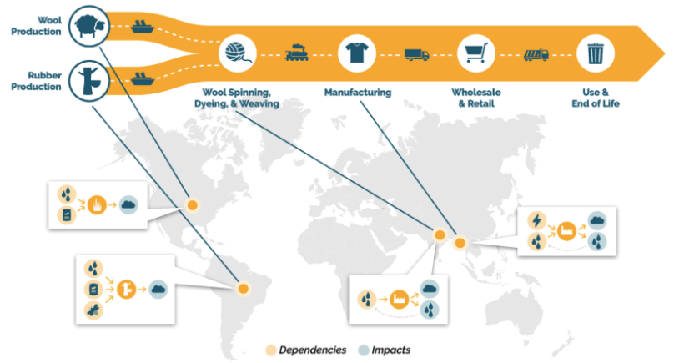

6. Do you have access to the necessary data required for aspects of your value chain identified as potentially material in Questions 3 and 5?
Supporting Text:
To answer Yes, you will have primary data for business activities within your direct operations identified as material in Question 3 (and verified in Question 5), as well as primary or secondary data for other aspects of your value chain determined to be material in those preceding questions. This can be understood as SBTN’s interim spatial data quality rule for Step 1.
If you answered No, you will need to collect the appropriate data (see rule above) before proceeding to the next question.
Responses:
- Yes → Next question
- No / Unknown → Please see the supporting text above and the resources provided in the toolbox above, then proceed to the next question.
Further information:
Primary Data: Collected from site level assessments on the state of nature through measured data. Impact factors are not used. To access primary data you would require knowledge on the locations of all your owned and operated sites and facilities, including the latitude and longitude coordinates or the associated shapefiles. In the absence of this knowledge the use of secondary data is required.
Secondary Data: Derived from modelled or proxy level data. This could include data averaged from commodity sourcing (e.g. kg of PO4e by kg leather purchased, hectares of land use per tons of lumber purchased) at the national or regional level (e.g., FAOSTAT), industry average process-level life cycle inventories (e.g. ecoinvent) or the use of input-output data models to provide estimates of impact drivers using associated pressure data. Here uncertainties in the quality of the data used will need to be considered and disclosed. To better understand data uncertainties and the reporting standards for these (to ensure transparency), refer to Natural Capital Protocol (2016) on dealing with uncertainties. Or in Life Cycle Assessment the use of the Pedigree Matrix to characterize LCI data uncertainty through six indicators: Reliability, Completeness, Temporal Correlation, Geographical Correlation, Technological and Sample Size.
Resources: Natural Capital Protocol (2016); Biodiversity Guidance to accompany the Natural Capital Protocol (2020, in Progress); Assessment on biodiversity measurement approaches for businesses and financial institutions, Update Report 2 (2019).

7. Have you estimated where your material impacts and dependencies occur spatially?
Responses:
- Yes → Please fill out Template 7 and then proceed to the next question.
- No → Establish where your material impacts and dependencies occur spatially, then fill out Template 6 before proceeding to the next question.
Supporting Text:
By answering Yes to Question 7, it is assumed that users requiring an assessment of their direct operations will know the approximate location of their sites (i.e. GIS coordinates or shapefiles).
Activities that are material and part of the upstream and downstream areas of your value chain will often require secondary data sources (see Template 7 and Resource 2). This information can be obtained using global datasets for the country or region that your commodities are sourced from, and the areas in which they are sold.
If you have answered No, please use one of the resources listed in our toolbox, see Resource 2.
Use Template 7 to determine the spatial information required along your value chain for all identified impacts and dependencies material to your operations. Questions 8a and 8b will guide you through the process of completing the checklist based on available tools and datasets.

 |  |  | Business activities
 |  | Materiality ranking (Question 3) | Approximate location  (Primary Data) | Country / Regional  (Secondary Data) | Materiality ranking (Question 5)
Value Chain Aspect | Upstream |  |  |  |  | Impacts
 |  |  |  |  |  | Dependencies
 | Direct Operations |  |  |  |  | Impacts
 |  |  |  |  |  | Dependencies
 | Downstream |  |  |  |  | Impacts
 |  |  |  |  |  | Dependencies

Template 7. Spatial information required for value chain assessment

----------

TA 2.5 - Company-level materiality assessment (refine estimates)
Objective: Refine list of potential target categories and locations for target setting based on unique attributes of the business
For the purposes of this assessment, company-level materiality refers to:
The significance of a company’s environmental impacts (and/or dependencies) related to its operations and value chains, across different locations in space. Parameters used to understand significance (e.g. time frame, geographic distribution, potential severity) should correspond to societal preferences (SBTN Glossary).
Important note for users of this guide: SBTN is currently developing more stringent criteria on exclusion and inclusion. We will provide this when it becomes available.
As well, based on updated guidance currently under development by our technical teams, it is likely that the exclusion step currently presented as following the spatial assessment (all parts of Question 8 below) would actually come earlier in the overall assessment process (e.g. after the sector-level assessment, but before the value chain assessment). This way, companies are able to comfortably simplify the scope of the overall assessment earlier on in the process.

8a. Can you justify the exclusion of any material issue areas identified at the sector level that are not relevant for your company?
Responses:
- Yes → Please identify which issue areas associated with your sector you are including for target setting, and which you are excluding in the template below. Rationale should be provided for areas excluded at business level but identified as material at sector level, as well as for areas included at business level but identified as immaterial at sector level.
- No → Please proceed to the Closing Text
Supporting Text:
Issue areas that were identified in Question 3 but are not determined as material in your business activities require a rationale for their exclusion. Similarly, issue areas not identified as material at sector level in Question 3, but which you choose to include for target setting should be specified and rationale provided for their inclusion.
To answer Yes to the above question, you should have a final list of the material impacts and dependencies related to your business activities (Template 7).

Template 8: Exclusion of sector-level material issue areas
 | Terrestrial ecosystem use | Freshwater ecosystem use | Marine ecosystem use | Water use | GHG emissions | Non-GHG air pollutants | Water pollutants | Soil pollutants | Solid waste | Invasives & Disturbances
Upstream
Direct operations
Downstream

To complete this template, you can copy Template 3 and then add “Include” or “Exclude” in the appropriate cells. A detailed rationale should be provided for issue areas marked with either of these values as an appendix to Template 8.

8b. Do you report on your current actions related to any of the issue areas in Template 8 already?
Responses:
- Yes → Please add this information as an appendix to Template 8, including what specifically is reported on
- No → Please proceed to the next question
Supporting Text:
Identifying the issues and specifics of what your company does, and how you report will assist you when setting baselines for your targets in Step 3.
If No, you do not currently act or report on material issues related to your sector, you can proceed to the next question.

8c. Do you disclose this information to a specific platform?
Responses:
- Yes → Please add this information as an appendix to Template 8, including what specifically is disclosed and where
- No → Please see the Supporting Text

Supporting Text:
To answer Yes to the above question, we suggest you add information on the platform(s) where you disclose material impacts and dependencies, for which issues as an appendix to Template 8.
If you have answered No to 8a, 8b, and 8c, you may not have enough supporting information to justifiably exclude these material issue areas from your target plan.
--------

Closing text
You’ve just completed the Data Collection Guide Step 1! If you are using this and are a member of SBTN’s Corporate Engagement Program, please contact Jess if you want to share your template with our technical team. This is optional.

Welcome to the journey!

--------

TA 2.6 Full process for Step 1: Assess
Please note the image below is based on an older version of the phased approach in Step 1. It is included for illustrative purposes to show how the steps come together, and to give an indication of the degree of prescription we are currently intending to provide. We will be updating this before September publication.
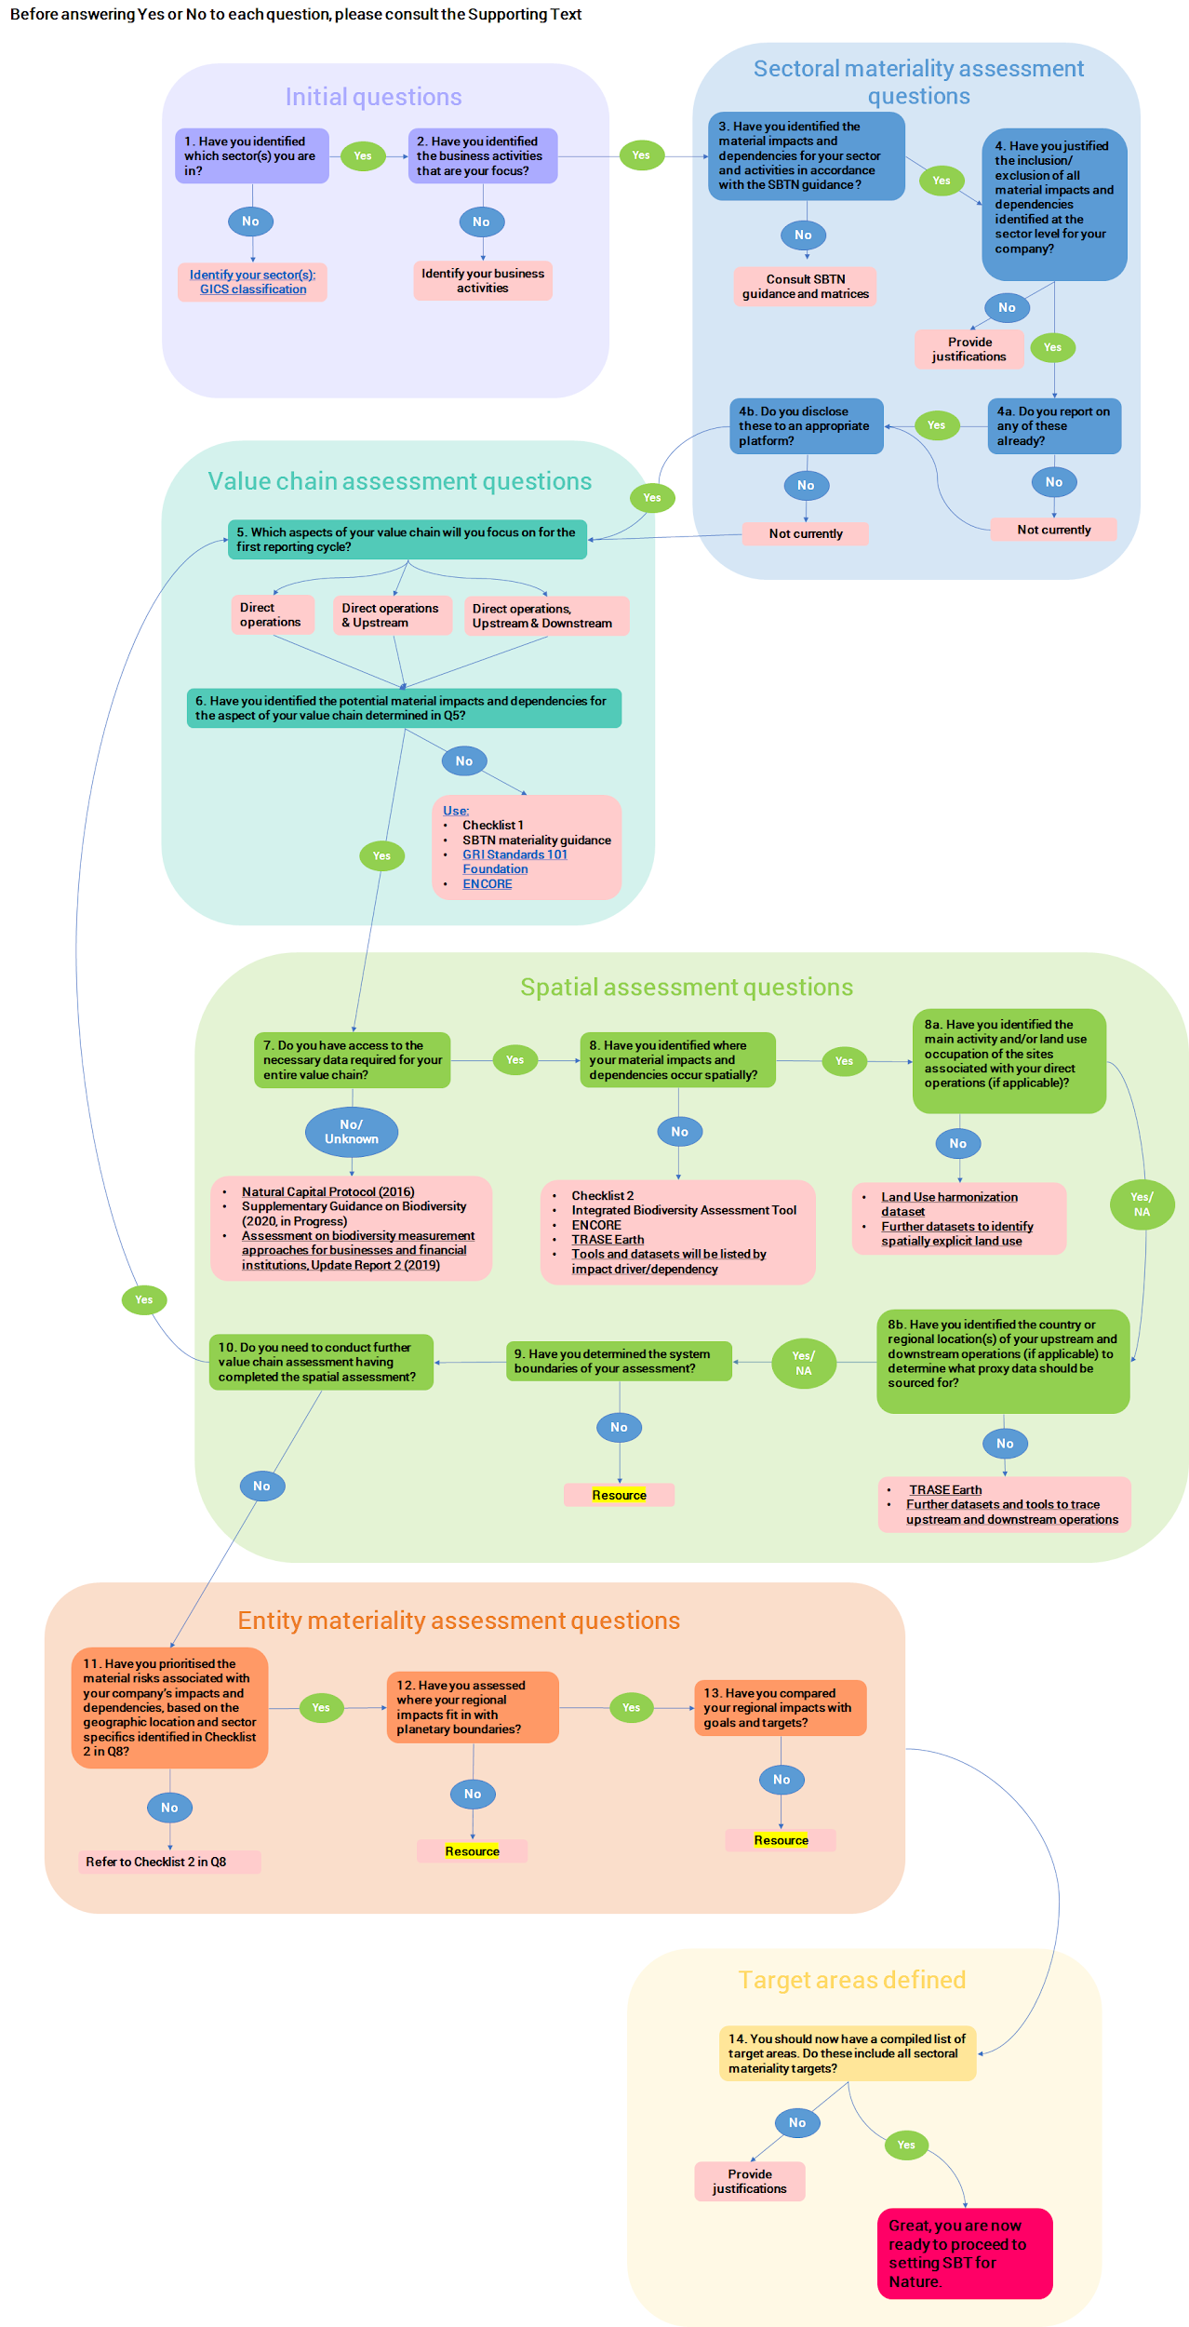

TA 2.7 Toolbox for Assess
There are several existing tools and platforms for end users to begin identifying business activities, where they occur geographically, and across the value chain. Below, you will find a non-exhaustive list of tools and platforms for Step 1 ‘Assess’, first by Earth system and second, more general, cross-cutting tools covering multiple Earth systems. Please note that many tools and platforms to assess corporate impacts and dependencies on nature are still in development and growing in number. The tools and platforms provided represent a small sample of those available now that can help companies to immediately begin Step 1. Most tools and platforms are developed for ease of use by a layperson. A few tools may require more expertise or ability to devote time to gather and input the information properly.
The criteria used for tool selection include: 1) publicly available and free, 2) updated regularly, 3) global extent, and ideally, 4) regional granularity for deeper dive.
Tools by Biophysical System
Water
Water Ris k Filter: Free, online tool that helps companies explore, assess, value and respond to water-related risks facing their operations and suppliers globally. Regular reassessments can demonstrate water-related trends and enable strategic choices in your supply chain. The results of the risk assessment and response recommendations provide your company with guidance on where to focus, including actions and programs that can be initiated with suppliers, or other companies.
Aqueduct: Free, online tool that enables companies to combine the twelve different indicators of water risk to create a global water risk map using pre-set and customizable indicator weightings, so it is tailored to the company’s specific concerns.
Land
Global Forest Watch: Free, online platform that provides data and tools for monitoring forests. Companies can access near real-time information about forest data around the world and can track their supply chain ensuring that they meet "no deforestation" commitments, for example.
Trends.Earth: Free, online platform that monitors land changes using earth observations in an innovative desktop and cloud-based system. Users plot time series of key indicators of land change to produce maps and other graphics that can support monitoring and reporting, and to track the impact of sustainable land management or other projects.
Biodiversity
Integrated Biodiversity Assessment Tool: Online tool offering a range of plans including a free plan that provides information on biodiversity risks and opportunities using IUCN Red List of Threatened Species, Key Biodiversity Areas and Protected Areas. The tool helps businesses incorporate biodiversity considerations into decisions and planning including whether to site an operation in a given area, develop action plans to manage biodiversity risks and impacts, report on biodiversity targets, and assess risks in a particular region.
Global Biodiversity Information Facility: Free, open access data on biodiversity from varying sources which includes museum and herbarium specimens, historic literature, ongoing wildlife monitoring programs and citizens' observations. The data provides the foundation for informing biodiversity policy such as Essential Biodiversity Variables, extinction risk
assessments, strategies for targeting invasive alien species, protected area siting and management, and conserving plant genetic resources for agriculture.
Climate
Scope 3 Evaluator: Free, online tool that enables companies to measure, report and reduce emissions in their value chain. Companies employing this tool will significantly reduce the time needed to estimate scope 3 emissions. The tool allows the users to determine a rough approximation of their full scope 3 footprint, regardless of their organization type and size and identify areas in which to pursue a more accurate inventory and focus their reduction efforts.
GHGP Tool: Online tools that enable companies to develop comprehensive and reliable inventories of their GHG emissions. To cover all their emissions, companies can employ multiple tools which include cross-sector, country-specific and sector-specific tools.
Ocean
Ocean+: Initiative that provides access to and use of global, regional and national biodiversity data and information to support the transition to a healthy ocean. Ocean+ offers a variety of products to help inform ocean biodiversity decisions which include Ocean+ Library (information on global marine and coastal datasets of biodiversity importance) and Ocean Data Viewer (view and download spatial datasets).
Plastic Scan: Online tool that allows companies to measure the amount of plastic they use, and amount of plastic waste is generated along their value chain. Based on the results, companies receive recommendations on potential improvements to their workflow, enabling them to save money while reducing plastic pollution.
Cross-cutting Tools
Spatial Analysis
InVEST: Free, open-source software models used to map and value the goods and services from nature. Users can assess quantified tradeoffs associated with alternative management choices and identify areas where investment in natural capital can enhance human development and conservation.
UN Biodiversity Lab: Free, online, open-source interactive mapping platform for addressing biodiversity conservation and development challenges. The platform allows policymakers and other stakeholders to access global data layers, upload national datasets, and analyze these datasets in combination to provide key information on the CBD’s Aichi Biodiversity Targets and on the nature-based Sustainable Development Goals.
Resource Watch: Free, online platform that maintains hundreds of datasets on the state of the planet’s resources and citizens. The platform enables companies to track and visualize business risks and opportunities across your global operations for multiple issues or pull data into your own systems for analysis.
Supply Chain
Environmentally Extended Input-Output Models (e.g. EXIOBASE): EEIOs are used to evaluate linkages between economic consumption activities and environmental impacts. EEIO evaluates the upstream and consumption-based drivers of downstream environmental impacts and those embodied in goods and services that are traded between nations. One example is EXIOBASE which is a global, detailed Multi-Regional Environmentally Extended Supply and Use/Input Output (MR EE SUT/IOT) database.
The Product Biodiversity Footprint for Financial Institutions (BFFI) uses a well known method for life cycle assessment (LCA) that adequately covers biodiversity issues. Bioscope - https://bioscope.info/ - is a simplified version of the BFFI tool for non-experts.
More information on BFFI: https://crem.nl/wp-content/uploads/2019/01/Towards-asn-banks-biodiversity-footprint-pilot-project.pdf

For information on Bioscope: https://pre-sustainability.com/customer-cases/bioscope-tool-for-easily-determining-biodiversity-impact/

Trase.earth: Free, open-access online platform that provides greater supply chain transparency. The platform offers data of mapped supply chains for key commodities such as palm oil and soy from entire countries and regions.
Materiality
ENCORE: Free, online platform that allows companies to explore natural capital risks. Users identify the materiality of impacts and dependencies on over 20 ecosystem services for production processes of >130 sub-industries and learn about location-specific risks using maps of natural capital assets and drivers of environmental change.
CDP (covering Water, Forests, and Climate): Free, online disclosure platform for companies to disclose water, forests and climate risk either voluntarily or through requests from investors or customers through a questionnaire. The data supports companies in managing their own environmental risks and opportunities as well as providing vital information back to their customers and investors.
Compiled Tool Databases
Iris+: Free, online resource used to identify, measure and manage social and environmental impact and report their impact to investors in a consistent and standard way. The metrics contained in the IRIS+ system align with the Global Reporting Initiative (GRI) and multiple other frameworks, standards, methodology, and assessment tools.
SHIFT: Online platform that supports companies in navigating the sea of sustainability tools by finding and comparing options and helping to select the sustainability tool(s) that suits your company. SHIFT also hosts the Natural Capital Toolkit, a free, online database that supports companies in finding the right tool as they implement the Natural Capital Protocol and sector guides. The toolkit helps companies understand which tools to use, for what and when to measure and value natural capital.
Biodiversity Guidance Navigation Tool: Tool is still in development and not currently available. Contact the Capitals Coalition for more information.
Metrics Database: Database is available in draft from the Aligning Biodiversity Measures for Business collaboration. For the latest version, please contact UNEP-WCMC.

Technical Annex 3: Sectoral Materiality Assessment Details

TA 3.1 Defining and assessing sectoral materiality
The challenge of defining a sectoral materiality assessment is the lack of comprehensive global data covering a comprehensive list of impact and dependency indicators and activity sectors (and potentially geographies). The closest data that can be used for this purpose is input/output databases such as Exiobase (publicly available database, but limited in scope) or EORA (licenced database, more extensive database). SBTN tested the Exiobase database which is at the moment too limited to develop a robust materiality assessment at a sectoral level. More research is required, in particular around the use of the EORA IO database which is more extensive in scope. Other sources of data could come from specific initiatives, analysis and reports such as the CDP (water, forest and climate) which already analysed sectoral materiality.
In the meantime, an intermediate solution has focused on the use of ENCORE materiality ratings for impacts and dependencies (https://encore.naturalcapital.finance/en). Please note, that the materiality ratings for impacts are not yet publicly available in ENCORE, but will be by September. The tool currently contains materiality ratings for all ecosystem services and production process relationships (more details here) and will soon be expanded to incorporate work just completed to look at materiality of impacts (based on 11 impact drivers and 5 criteria: likelihood, frequency, timeframe, spatial scale and severity). The materiality scoring is publicly available, although it focuses on a business materiality rather than societal. For this reason, we adjusted the ENCORE scoring method to focus on what matters for the society rather than the business (timeframe and spatial scale were not considered, leaving only the severity, frequency and likelihood criteria).
In order to provide a high level illustration of the materiality ratings for a short list of sectors, we aggregated the materiality scores to 11 high level sectors (1st level of classification of GICS) across the 11 indicators of ENCORE (see below tables in TA 4.3). We further develop the scoring towards each sector’s supply chain, using IO databases (i.e. model of the economy). The tables are read in line for each relevant selected sector. The upper table presents the direct materiality while the second presents the supply chain materiality. This level of aggregation is not recommended to use directly by end-users. It is only provided as an illustration otherwise the materiality matrix contains 177 lines which is not convenient to reflect in this report.

TA 3.2 Impact indicators coverage for the hubs
The data sources available do not match the Hubs’ indicators at the moment, as illustrated in the figure below. An intermediate solution is to use the current materiality matrix available indicators as proxy indicators to the Hubs’ indicators and priorities. More developments, data compilation and matching methodology is required in the future.
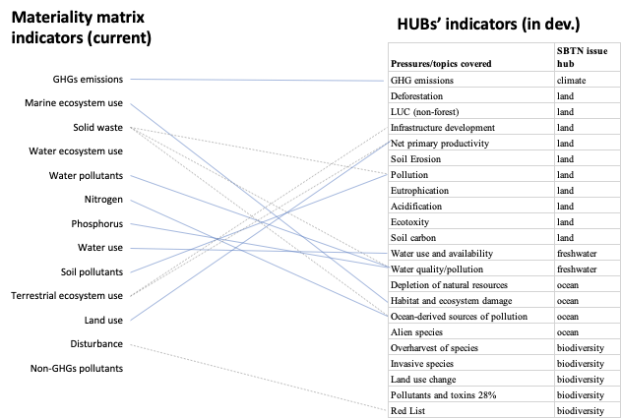
Dependencies materiality matrix
Currently, the materiality matrix is only developed based on impact indicators. However, the ENCORE tool contains all the information to cover dependencies. The materiality scoring can be updated in the same way that it is done for impact scores.

TA 3.3 Materiality matrix methodology tests and benchmark
Below is a comparison of a materiality matrix from a business and societal perspective. The removal of the timeframe and geographical scale parameters provide different materiality results. For instance, for climate change which is less of a priority for business (long term and global) than for societal (very high materiality for almost all sectors). Below, VH stands for Very High, H stands for High, M stands for Medium, L stands for Low, VL stands for Very Low and cells are blank where there is insufficient data.
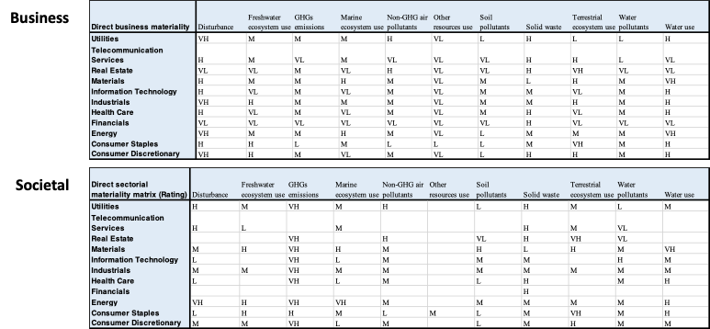
Below is a comparison between considering and not considering spatial scale on the direct ENCORE materiality matrix. In the scenario that considers spatial scale, higher weight is given to global impact over local impact. The difference between the two matrices is not huge, but still differences exist. Overall, based on these results, it is recommended not to consider spatial scales in this context or consider it in a different form.
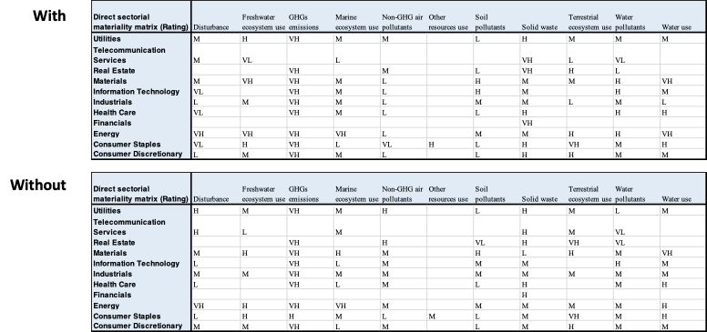
The definition of materiality used at the SBTN is defined according to the impact per sector but also according to the relative contribution of each impact to the overall impact on the planet. This weighting per indicator can be done through various methods (impact valuation, LCA, planetary boundaries overshoot scores, Red List species, etc). We used the IPBES report to provide a first test of such weighting which gives higher importance to some indicators rather than others (see below). Note that if no weighting is applied, there is an implicit equal weighting between the indicators. The weighted results have the effect to decrease the importance of some indicators related to others, such as solid waste, water pollutants, etc. The IPBES weighting factors do not match easily with the 11 indicators of ENCORE and it is recommended to develop a specific set of weighting factors in the future.
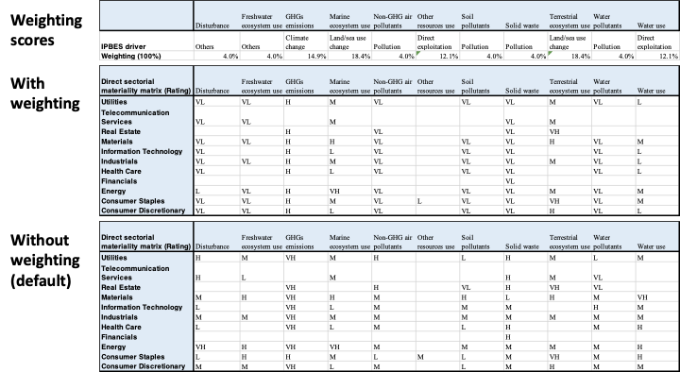

TA 3.4 Sectoral Materiality matrix interim results
Interim results are shown below, grouped by key issue area (note not all SBTN Issue Areas are currently available in ENCORE), and GICS Sector and Subindustry. Each value is formatted to represent materiality for (upstream/direct operations/downstream), where VL = very low, L = low, M = medium, H = high, and VH = very high. Blank values do not indicate a lack of impact, but rather a lack of data. We will be working to fill in these blanks over the coming years.

 |  | Land/Sea Use Change |  |  | Resource Exploitation | Climate Change | Pollution |  |  |  | Invasives and Other
Sector | Sub-Industry | Terrestrial ecosystem use | Freshwater ecosystem use | Marine ecosystem use | Water use | GHGs emissions | Non-GHG air pollutants | Water pollutants | Soil pollutants | Solid waste | Disturbance
Consumer Discretionary | Advertising | M / / | M / / | M / / | M / M / | VH / / | M / M / | M / M / | M / L / | M / H / | M / /
Consumer Discretionary | Apparel Retail | M / / | M / / | M / / | M / M / | VH / / | M / M / | M / M / | M / L / | M / H / | M / /
Consumer Discretionary | Apparel, Accessories & Luxury Goods | M / / | M / / | M / / | M / / | VH / / | M / / | M / / | M / M / | M / / | M / /
Consumer Discretionary | Auto Parts & Equipment | M / / | M / / | M / / | M / H / | VH / / | M / VH / | M / VH / | M / VH / | M / H / | M / /
Consumer Discretionary | Automobile Manufacturers | M / / | M / / | M / / | M / H / | VH / / | M / VH / | M / VH / | M / VH / | M / H / | M / /
Consumer Discretionary | Automotive Retail | M / / | M / / | M / / | M / M / | VH / / | M / M / | M / M / | M / L / | M / H / | M / /
Consumer Discretionary | Broadcasting | M / / | M / / | M / / | M / M / | VH / / | M / M / | M / M / | M / L / | M / H / | M / /
Consumer Discretionary | Cable & Satellite | M / VL / | M / L / | M / / | M / / | VH / / | M / / | M / / | M / / | M / / | M / VH /
Consumer Discretionary | Casinos & Gaming | M / / | M / / | M / / | M / / | VH / / | M / / | M / / | M / / | M / H / | M / /
Consumer Discretionary | Computer & Electronics Retail | M / / | M / / | M / / | M / M / | VH / / | M / M / | M / M / | M / L / | M / H / | M / /
Consumer Discretionary | Consumer Electronics | M / / | M / / | M / / | M / / | VH / / | M / / | M / VH / | M / VH / | M / M / | M / /
Consumer Discretionary | Department Stores | M / / | M / / | M / / | M / M / | VH / / | M / M / | M / M / | M / L / | M / H / | M / /
Consumer Discretionary | Distributors | M / / | M / / | M / L / | M / / | VH / H / | M / M / | M / L / | M / VL / | M / / | M / L /
Consumer Discretionary | Education Services | M / / | M / / | M / / | M / M / | VH / / | M / M / | M / M / | M / L / | M / H / | M / /
Consumer Discretionary | Footwear | M / / | M / / | M / / | M / M / | VH / / | M / M / | M / M / | M / H / | M / H / | M / /
Consumer Discretionary | General Merchandise Stores | M / / | M / / | M / / | M / M / | VH / / | M / M / | M / M / | M / L / | M / H / | M / /
Consumer Discretionary | Home furnishing Retail | M / / | M / / | M / / | M / M / | VH / / | M / M / | M / M / | M / L / | M / H / | M / /
Consumer Discretionary | Home Furnishings | M / / | M / / | M / / | M / H / | VH / / | M / VH / | M / VH / | M / VH / | M / H / | M / /
Consumer Discretionary | Home Improvement Retail | M / / | M / / | M / / | M / M / | VH / / | M / M / | M / M / | M / L / | M / H / | M / /
Consumer Discretionary | Homebuilding | M / / | M / H / | M / / | M / H / | VH / M / | M / L / | M / VL / | M / M / | M / / | M / H /
Consumer Discretionary | Hotels, Resorts & Cruise Lines | M / / | M / / | M / / | M / / | VH / / | M / / | M / / | M / / | M / M / | M / /
Consumer Discretionary | Household Appliances | M / / | M / / | M / / | M / H / | VH / / | M / VH / | M / VH / | M / VH / | M / H / | M / /
Consumer Discretionary | Housewares & Specialties | M / / | M / / | M / / | M / / | VH / / | M / VH / | M / VH / | M / H / | M / VH / | M / /
Consumer Discretionary | Internet & Direct Marketing Retail | M / / | M / / | M / / | M / M / | VH / / | M / M / | M / M / | M / L / | M / H / | M / /
Consumer Discretionary | Leisure Products | M / / | M / / | M / / | M / H / | VH / VH / | M / L / | M / H / | M / M / | M / H / | M / /
Consumer Discretionary | Motorcycle Manufacturers | M / / | M / / | M / / | M / H / | VH / / | M / VH / | M / VH / | M / VH / | M / H / | M / /
Consumer Discretionary | Movies & Entertainment | M / / | M / / | M / / | M / M / | VH / / | M / M / | M / M / | M / L / | M / H / | M / /
Consumer Discretionary | Publishing | M / / | M / / | M / / | M / M / | VH / / | M / M / | M / M / | M / L / | M / H / | M / /
Consumer Discretionary | Restaurants | M / / | M / / | M / / | M / / | VH / / | M / / | M / / | M / / | M / H / | M / /
Consumer Discretionary | Specialty Stores | M / / | M / / | M / / | M / M / | VH / / | M / M / | M / M / | M / L / | M / H / | M / /
Consumer Discretionary | Textiles | M / VL / | M / / | M / / | M / H / | VH / / | M / / | M / / | M / M / | M / / | M / /
Consumer Discretionary | Tires & Rubber | M / / | M / / | M / / | M / VH / | VH / H / | M / H / | M / M / | M / / | M / VH / | M / H /
Consumer Staples | Agricultural Products | H / / | M / / | M / / | M / / | VH / / | L / / | M / VL / | L / / | M / / | L / /
Consumer Staples | Brewers | H / / | M / / | M / / | M / VH / | VH / H / | L / / | M / VL / | L / VL / | M / M / | L / /
Consumer Staples | Distillers & Vintners | H / / | M / / | M / / | M / VH / | VH / H / | L / / | M / VL / | L / VL / | M / M / | L / /
Consumer Staples | Drug Retail | H / / | M / / | M / / | M / M / | VH / / | L / M / | M / M / | L / L / | M / H / | L / /
Consumer Staples | Food Distributors | H / / | M / / | M / L / | M / / | VH / H / | L / M / | M / L / | L / VL / | M / / | L / L /
Consumer Staples | Food Retail | H / / | M / / | M / / | M / M / | VH / / | L / M / | M / M / | L / L / | M / H / | L / /
Consumer Staples | Hypermarkets & Super Centres | H / / | M / / | M / / | M / M / | VH / / | L / M / | M / M / | L / L / | M / H / | L / /
Consumer Staples | Packaged Foods & Meats | H / / | M / / | M / / | M / VH / | VH / / | L / / | M / H / | L / / | M / H / | L / /
Consumer Staples | Personal Products | H / / | M / / | M / / | M / H / | VH / VH / | L / L / | M / H / | L / M / | M / H / | L / /
Consumer Staples | Soft Drinks | H / / | M / / | M / / | M / VH / | VH / / | L / / | M / H / | L / / | M / H / | L / /
Consumer Staples | Tobacco | H / VH / | M / / | M / / | M / VH / | VH / VH / | L / / | M / H / | L / H / | M / / | L / /
Energy | Coal & Consumable Fuels | M / / | M / H / | H / / | H / / | VH / VH / | M / H / | M / M / | M / VH / | M / L / | H / H /
Energy | Integrated Oil & Gas | M / H / | M / / | H / / | H / M / | VH / VH / | M / VH / | M / H / | M / M / | M / VH / | H / /
Energy | Oil & Gas Drilling | M / VH / | M / H / | H / / | H / / | VH / / | M / M / | M / H / | M / VH / | M / / | H / /
Energy | Oil & Gas Equipment & Services | M / / | M / / | H / / | H / / | VH / / | M / VL / | M / VL / | M / VL / | M / H / | H / /
Energy | Oil & Gas Exploration & Production | M / H / | M / M / | H / / | H / / | VH / H / | M / M / | M / H / | M / VH / | M / M / | H / /
Energy | Oil & Gas Refining & Marketing | M / / | M / / | H / / | H / VH / | VH / / | M / M / | M / M / | M / VL / | M / / | H / /
Energy | Oil & Gas Storage & Transportation | M / L / | M / / | H / / | H / / | VH / VL / | M / / | M / / | M / / | M / / | H / /
Financials | Asset Management & Custody Banks | VL / / | / / | / / | VL / / | L / / | VL / / | VL / / | / / | H / H / | / /
Financials | Consumer Finance | VL / / | / / | / / | VL / / | L / / | VL / / | VL / / | / / | H / H / | / /
Financials | Diversified Banks | VL / / | / / | / / | VL / / | L / / | VL / / | VL / / | / / | H / H / | / /
Financials | Diversified Capital Markets | VL / / | / / | / / | VL / / | L / / | VL / / | VL / / | / / | H / H / | / /
Financials | Financial Exchanges & Data | VL / / | / / | / / | VL / / | L / / | VL / / | VL / / | / / | H / H / | / /
Financials | Insurance Brokers | VL / / | / / | / / | VL / / | L / / | VL / / | VL / / | / / | H / H / | / /
Financials | Investment Banking & Brokerage | VL / / | / / | / / | VL / / | L / / | VL / / | VL / / | / / | H / H / | / /
Financials | Life & Health Insurance | VL / / | / / | / / | VL / / | L / / | VL / / | VL / / | / / | H / H / | / /
Financials | Multi-line Insurance | VL / / | / / | / / | VL / / | L / / | VL / / | VL / / | / / | H / H / | / /
Financials | Multi-Sector Holdings | VL / / | / / | / / | VL / / | L / / | VL / / | VL / / | / / | H / H / | / /
Financials | Other Diversified Financial Services | VL / / | / / | / / | VL / / | L / / | VL / / | VL / / | / / | H / H / | / /
Financials | Property & Casualty Insurance | VL / / | / / | / / | VL / / | L / / | VL / / | VL / / | / / | H / H / | / /
Financials | Regional Banks | VL / / | / / | / / | VL / / | L / / | VL / / | VL / / | / / | H / H / | / /
Financials | Reinsurance | VL / / | / / | / / | VL / / | L / / | VL / / | VL / / | / / | H / H / | / /
Financials | Specialized Finance | VL / / | / / | / / | VL / / | L / / | VL / / | VL / / | / / | H / H / | / /
Financials | Thrifts & Mortgage Finance | VL / / | / / | / / | VL / / | L / / | VL / / | VL / / | / / | H / H / | / /
Health Care | Biotechnology manufacturing | / / | / / | / / | / VH / | / / | / M / | / H / | / M / | / H / | / /
Health Care | Biotechnology services | / / | / / | / / | / / | / / | / / | / / | / / | / H / | / /
Health Care | Health Care Distributors | / / | / / | / L / | / / | / H / | / M / | / L / | / VL / | / / | / L /
Health Care | Health Care Facilities | / / | / / | / / | / / | / / | / / | / VH / | / H / | / H / | / /
Health Care | Health Care Services | / / | / / | / / | / M / | / / | / M / | / M / | / L / | / H / | / /
Health Care | Health Care Technology | / / | / / | / / | / M / | / / | / M / | / M / | / L / | / H / | / /
Health Care | Life Sciences manufacturing | / / | / / | / / | / VH / | / / | / M / | / H / | / M / | / H / | / /
Health Care | Life Sciences Tools services | / / | / / | / / | / / | / / | / / | / / | / / | / H / | / /
Health Care | Managed Health Care | / / | / / | / / | / / | / VH / | / / | / M / | / M / | / / | / /
Health Care | Pharmaceuticals manufacturing | / / | / / | / / | / VH / | / / | / M / | / H / | / M / | / H / | / /
Health Care | Pharmaceuticals services | / / | / / | / / | / / | / / | / / | / / | / / | / H / | / /
Industrials | Aerospace & Defense | M / / | M / / | M / / | M / H / | VH / / | M / VH / | M / VH / | M / VH / | M / H / | M / /
Industrials | Agricultural & Farm Machinery | M / / | M / / | M / / | M / H / | VH / / | M / VH / | M / VH / | M / VH / | M / H / | M / /
Industrials | Air Freight & Logistics | M / / | M / / | M / L / | M / / | VH / H / | M / M / | M / L / | M / VL / | M / / | M / L /
Industrials | Airlines | M / / | M / / | M / / | M / L / | VH / / | M / M / | M / / | M / VL / | M / L / | M / H /
Industrials | Airport Services | M / / | M / / | M / / | M / L / | VH / / | M / M / | M / / | M / VL / | M / L / | M / H /
Industrials | Building Products | M / / | M / / | M / / | M / / | VH / / | M / VH / | M / M / | M / / | M / M / | M / /
Industrials | Construction & Engineering | M / M / | M / / | M / VL / | M / M / | VH / / | M / / | M / L / | M / L / | M / / | M / /
Industrials | Construction Machinery & Heavy Trucks | M / / | M / / | M / / | M / H / | VH / / | M / VH / | M / VH / | M / VH / | M / H / | M / /
Industrials | Diversified Support Services | M / / | M / / | M / / | M / M / | VH / / | M / M / | M / M / | M / L / | M / H / | M / /
Industrials | Electrical Components & Equipment | M / / | M / / | M / / | M / / | VH / / | M / / | M / VH / | M / VH / | M / M / | M / /
Industrials | Environmental & Facilities Services | M / / | M / / | M / / | M / / | VH / / | M / / | M / / | M / / | M / M / | M / /
Industrials | Heavy Electrical Equipment | M / / | M / / | M / / | M / H / | VH / / | M / VH / | M / VH / | M / VH / | M / H / | M / /
Industrials | Highways & Rail tracks | M / / | M / H / | M / / | M / H / | VH / M / | M / L / | M / VL / | M / M / | M / / | M / H /
Industrials | Human Resource & Employment Services | M / / | M / / | M / / | M / M / | VH / / | M / M / | M / M / | M / L / | M / H / | M / /
Industrials | Industrial Machinery | M / / | M / / | M / / | M / H / | VH / / | M / VH / | M / VH / | M / VH / | M / H / | M / /
Industrials | Marine | M / / | M / / | M / H / | M / / | VH / / | M / / | M / VH / | M / H / | M / / | M / VH /
Industrials | Marine Ports & Services | M / / | M / M / | M / M / | M / / | VH / / | M / / | M / M / | M / M / | M / H / | M / VH /
Industrials | Railroads | M / / | M / / | M / / | M / / | VH / / | M / / | M / M / | M / M / | M / / | M / VH /
Industrials | Research & Consulting Services | M / / | M / / | M / / | M / M / | VH / / | M / M / | M / M / | M / L / | M / H / | M / /
Industrials | Security & Alarm Services | M / / | M / / | M / / | M / M / | VH / / | M / M / | M / M / | M / L / | M / H / | M / /
Industrials | Trading Companies & Distributors | M / / | M / / | M / L / | M / / | VH / H / | M / M / | M / L / | M / VL / | M / / | M / L /
Industrials | Trucking | M / / | M / / | M / / | M / H / | VH / / | M / VH / | M / VH / | M / VH / | M / H / | M / /
Information Technology | Communications Equipment | L / / | VL / / | L / / | M / / | VH / / | M / / | M / VH / | M / VH / | M / M / | M / /
Information Technology | Electronic Components | L / / | VL / / | L / / | M / / | VH / / | M / / | M / VH / | M / VH / | M / M / | M / /
Information Technology | Electronic Equipment & Instruments | L / / | VL / / | L / / | M / / | VH / / | M / / | M / VH / | M / VH / | M / M / | M / /
Information Technology | Electronic Manufacturing Services | L / / | VL / / | L / / | M / / | VH / / | M / / | M / VH / | M / VH / | M / M / | M / /
Information Technology | IT Consulting & Other Services | L / / | VL / / | L / / | M / M / | VH / / | M / M / | M / M / | M / L / | M / H / | M / /
Information Technology | Office Services & Supplies | L / / | VL / / | L / / | M / M / | VH / / | M / M / | M / M / | M / L / | M / H / | M / /
Information Technology | Semiconductor Equipment | L / / | VL / / | L / / | M / VH / | VH / / | M / / | M / M / | M / H / | M / / | M / /
Information Technology | Technology Distributors | L / / | VL / / | L / L / | M / / | VH / H / | M / M / | M / L / | M / VL / | M / / | M / L /
Information Technology | Technology Hardware, Storage & Peripherals | L / / | VL / / | L / / | M / / | VH / / | M / / | M / VH / | M / VH / | M / M / | M / /
Materials | Aluminium | H / / | M / / | M / / | H / / | VH / / | M / / | M / M / | M / / | M / / | M / /
Materials | Commodity Chemicals | H / VL / | M / / | M / / | H / H / | VH / / | M / VH / | M / / | M / M / | M / M / | M / /
Materials | Construction Materials | H / / | M / VH / | M / H / | H / / | VH / / | M / H / | M / L / | M / / | M / H / | M / M /
Materials | Copper | H / / | M / H / | M / / | H / / | VH / VH / | M / H / | M / M / | M / VH / | M / L / | M / H /
Materials | Diversified Chemicals | H / / | M / / | M / / | H / VH / | VH / / | M / / | M / / | M / / | M / / | M / /
Materials | Diversified Metals & Mining | H / / | M / H / | M / / | H / / | VH / VH / | M / H / | M / M / | M / VH / | M / L / | M / H /
Materials | Fertilizers & Agricultural Chemicals | H / / | M / / | M / / | H / H / | VH / / | M / VH / | M / M / | M / / | M / / | M / /
Materials | Forest Products | H / / | M / / | M / / | H / / | VH / / | M / / | M / / | M / / | M / / | M / /
Materials | Gold | H / / | M / H / | M / / | H / / | VH / VH / | M / H / | M / M / | M / VH / | M / L / | M / H /
Materials | Industrial Gases | H / / | M / / | M / / | H / / | VH / / | M / / | M / / | M / / | M / / | M / /
Materials | Iron | H / VL / | M / / | M / / | H / VH / | VH / / | M / H / | M / / | M / / | M / / | M / M /
Materials | Metal & Glass Containers | H / / | M / / | M / / | H / M / | VH / VH / | M / M / | M / M / | M / M / | M / H / | M / /
Materials | Paper Packaging | H / / | M / / | M / / | H / / | VH / / | M / H / | M / VH / | M / VH / | M / / | M / /
Materials | Paper Products | H / / | M / / | M / / | H / / | VH / / | M / VH / | M / VH / | M / / | M / / | M / /
Materials | Precious Metals & Minerals | H / / | M / H / | M / / | H / / | VH / VH / | M / H / | M / M / | M / VH / | M / L / | M / H /
Materials | Silver | H / / | M / H / | M / / | H / / | VH / VH / | M / H / | M / M / | M / VH / | M / L / | M / H /
Materials | Specialty Chemicals | H / / | M / / | M / / | H / / | VH / / | M / / | M / H / | M / / | M / / | M / /
Materials | Steel | H / / | M / / | M / / | H / / | VH / / | M / / | M / / | M / / | M / H / | M / /
Real Estate | Diversified Real Estate Activities | L / VH / | VL / / | VL / / | L / / | H / VH / | L / H / | L / VL / | L / VL / | M / H / | VL / /
Real Estate | Real Estate Development | L / VH / | VL / / | VL / / | L / / | H / VH / | L / H / | L / VL / | L / VL / | M / H / | VL / /
Real Estate | Real Estate Operating Companies | L / VH / | VL / / | VL / / | L / / | H / VH / | L / H / | L / VL / | L / VL / | M / H / | VL / /
Real Estate | Real Estate Services | L / VH / | VL / / | VL / / | L / / | H / VH / | L / H / | L / VL / | L / VL / | M / H / | VL / /
Telecommunication Services | Alternative Carriers | / / | / / | / / | / / | / / | / / | / / | / / | / / | / H /
Telecommunication Services | Integrated Telecommunication Services | / H / | / / | / / | / / | / / | / / | / VL / | / / | / H / | / /
Telecommunication Services | Wireless Telecommunication Services | / H / | / / | / / | / / | / / | / / | / VL / | / / | / H / | / /
Utilities | Electric Utilities | M / / | M / / | M / / | M / L / | VH / VL / | M / / | M / / | M / / | M / / | M / /
Utilities | Gas Utilities | M / / | M / / | M / / | M / / | VH / / | M / / | M / / | M / / | M / / | M / /
Utilities | Independent Power Producers & Energy Traders | M / / | M / / | M / / | M / L / | VH / VL / | M / / | M / / | M / / | M / / | M / /
Utilities | Renewable Electricity | M / / | M / / | M / / | M / / | VH / / | M / / | M / / | M / / | M / / | M / /
Utilities | Water Utilities | M / H / | M / M / | M / / | M / H / | VH / / | M / / | M / H / | M / / | M / / | M / /

Technical Annex 4: Measurement Framework and Translation

TA4.1 Measurement Framework
In the workbook attached, you will find SBTN's draft crosswalk of indicators. These indicators will be used for target setting on specific issue areas.

Our emphasis is on targets which deliver a measurable benefit to nature, targets which companies can easily quantify progress towards, and targets which are compatible with existing frameworks for action (in society at large, and also within the corporate sector).

In the crosswalk, you will be able to see how indicators for environmental issue areas matchup against those used for the planetary boundaries framework, societal goals (and their measurement frameworks), and to corporate frameworks. We then make an initial determination of whether companies can measure their baseline impact today, and identify tools available to support that process.

TA4.2 Translation: Introduction
This section discusses further the key concepts around translation introduced in Section 2.3 of the interim guidance. We call these concepts ‘connection’, ‘allocation’ and ‘application’. Connection refers to making planetary boundaries and global-level societal goals relevant to the scales (including landscape or “shed”) and contexts at which companies operate. Allocation involves decisions of how much of a given resource an actor can use, and how much effort an actor needs to make toward improving and ensuring the functioning of nature. Application involves expressing objectives for nature determined in the language of ecological limits or societal targets in terms that are more relevant for companies
Our core work on translation will be developed in cooperation with the Earth Commission (see ‘Who We Are’, in our interim guidance), including defining methodological options for each of the three concepts and connecting these methods to the safe and just corridors that the Earth Commission’s work will describe.
Over the next two years the SBTN and the Earth Commission will be:
- navigating normative judgements in downscaling and prioritization;
- defining standard methods for estimating the impacts on nature of company activities;
- identifying the right combination of indicators to collectively define SBTs for nature, and an appropriate monitoring, reporting, verification, and validation system for them (see Sections 3.4 and 3.6); and,
- defining how to deal with uncertainty in cause-effect relationships.

TA 4.3 Translation: Connection

Species
Global targets for species are well established within the framework of the Convention on Biological Diversity (CBD). However, despite twenty years of defined targets for biodiversity through the CBD’s 2010 Decade on Biodiversity and the 2010-2020 Aichi Biodiversity Targets, almost all targets defined for species over the past twenty years have achieved limited success, if any success at all. Furthermore, these targets have gone through an extensive downscaling process through national consultations and in setting national biodiversity targets that are intended to support global targets. Progress on these targets is mixed but there are some major advancements (notably the European Union’s Natura 2000 program). Whether this failure is due to the targets themselves or national politics, the ambiguity of most of the Aichi Biodiversity Targets leads to a manufactured confusion that paralyzes progress.
In downscaling global targets for species there remains a gap between what is required to address the global biodiversity crisis and the biodiversity information that is available to make informed decisions. The most comprehensive global framework for addressing the conservation status of species is the IUCN Red List of Threatened Species, but other information such as the Key Biodiversity Areas Partnership, Important Bird Areas, and Alliance for Zero Extinction sites provides a more geographically descriptive assessment of species conservation thresholds for most terrestrial and freshwater regions. While marine species are typically under-represented and data-poor, those with economic value through fisheries assessments and the existence of marine protected areas can confer some understanding of the needs of marine species. The Red List criteria are well established and can provide effective thresholds for target setting based on the Red List assessment criteria and categories. The Red Listing process also provides a relevant framework through its threats classification system to identify the threats faced by species facing extinction risk.
In addition to the threats themselves, the Red List assessments provide other incidental information on the scope and severity of the threats faced by a species. This information is combined into the Species Threat Abatement and Restoration (STAR) metric. STAR “informs target-setting across spatial scales, and allows countries and other entities (such as NGOs and businesses) to measure their potential contribution towards species conservation. The metric considers two complementary site-based actions for species conservation: (i) the abatement of threats in order to prevent further deterioration in species survival probability, and (ii) the restoration of habitat in order to contribute to improving species survival probability.
Most importantly for SBTN, STAR provides a threshold for species conservation status improvement that can be deconstructed based on the main threats facing species within a geography as well as providing recommended conservation actions that can alleviate the most pressing threats. Companies and other entities can (i) determine the potential maximum contribution that their actions can make in improving the conservation status of species within their geography and (2) compare different actions in different places to achieve optimized species conservation outcomes and extinction risk reductions.
However, it is important to recognize that by taking a species-oriented response to target setting it is likely that the interactions among species may not receive the priority they deserve. For this reason SBTN is also interested in setting ecosystem area and integrity targets that can be downscaled from global to regional geographies and hopefully informed by bottom-up target setting processes.

Ecosystems
The Millennium Ecosystem Assessment defines ecosystems as “a dynamic complex of plant, animal and microorganism communities and the non-living environment interacting as a functional unit” Muller (2005), and later modified by Haase et al. (2018), proposed that an ecosystem index should be composed of indicators of ecosystem structure such as biotic and abiotic state, and ecosystem functioning such as water, mass and energy balance. In contrast to a species level approach to biodiversity (examinea species richness or the extinction risk of threatened species), ecosystem level approaches explicitly consider ecosystem structure and functioning. The process of downscaling ecosystem goals to regional targets should consider ecosystem functioning at different scales, for instance, consideration of functional diversity within communities (the diversity of functional traits of organisms present within an ecosystem) and the functional security of biomes (biophysically coherent global scale systems, such as coral reefs, river systems, or tropical rainforests) (Mace et al. ).
The Zero Order Draft of the Post-2020 Biodiversity Framework currently in review by the CBD identifies a global goal for ecosystems as “no net loss by 2030 in the area and integrity of freshwater, marine and terrestrial ecosystems, and increases of at least 20% by 2050, ensuring ecosystem resilience”. The outcome-orientated goals of the Framework are linked with 2030 action targets whose implementation will provide the first steps towards achieving the 2050 goals. Of relevance to ecosystems, one suggested target is “retain and restore freshwater, marine and terrestrial ecosystems, increasing by at least 50% the land and sea area under comprehensive spatial planning addressing land/sea use change, achieving by 2030 a net increase in area, connectivity and integrity and retaining existing intact areas and wilderness”.
Initial guidance: An ecosystem target for businesses should ensure that both the area and integrity of ecosystems are considered and responses should include both the maintenance as well as the restoration of ecosystems. In particular, intact areas and wilderness areas should be targeted for retention.
To downscale the global goal of no net loss in the context of ecosystems, it is necessary to understand both the potential extent of ecosystems, or the baseline extent as well as the current extent. Sayre et al. (2020) defines the potential and current extent of ecosystems using geophysical parameters. In contrast, recent work on the Red List of Ecosystems proposes a more stakeholder-driven system of designation which nests ecosystems within a hierarchical structure ranging from ecosystem types to realms. The Red List of Ecosystems typology reflects both functional and biogeographical elements of ecosystem organization.
To downscale the global goal of no net loss in the integrity of ecosystems, it is necessary to understand both ecosystem functioning and composition, and how these have been altered from baseline conditions, but to ensure that critical functioning is maintained, it is also necessary to understand the threshold levels of ecosystem integrity required to maintain earth system processes and nature’s contributions to people. Biotic intactness indicators such as the Biodiversity Intactness Index (Newbold et al. 2016), the Mean Species Abundance index (Alkemade et al. 2009) or the Global Plant Species Persistence index (Di Marco et al. 2019) can provide information on the composition and resilience of ecosystems although they do not account for landscape-level factors such as connectivity. The functioning of ecosystems is more context-dependent but can be measured through a combination of indices such as carbon balance, nutrient cycling, water filtration, or net primary production. However, further research on thresholds is required before targets are set.
An ecosystem focus has particular relevance to businesses. As the loss of composition and functioning within ecosystems reduces the provision of ecosystem services upon which businesses are dependent, any target set by businesses can then be directly linked to reducing risks and creating opportunities.

Nature’s Contributions to People
Many different NCP assessment frameworks have been developed for a diverse array of global, regional, and local contexts. Some were designed for policy contexts, others for business applications. Some are conceptual frameworks that aim to encourage the consideration of nature in new ways, while others are computer models that may or may not come with input datasets. Some conceptual frameworks contain categories that are general enough for application anywhere in the world, while others are tailored to specific regions or contexts; the same holds true for the computer models.
Data availability is a significant consideration, as existing datasets may not have the spatial/temporal resolution or be available for the NCP categories most appropriate to a particular context; thus, primary data collection may be required to perform a meaningful NCP assessment. This may limit companies’ abilities to evaluate and monitor their interactions with NCP.
Rather than advocating some methods over others, this report provides a comprehensive menu of options with a fair assessment of strengths, weaknesses, and considerations for use.
In addition, SBTN offers some basic recommendations for how to think about moving between scales. Global analyses like that shown in Section 2 enable a rough assessment of the magnitude of the opportunity and a coarse identification of places around the world that merit a closer look. However, finer-resolution datasets and more context-appropriate methods, including stakeholder engagement, are required to draw meaningful conclusions about what is ‘valuable’ or important for a given geographic context. It should also be noted that the categories of NCP that are considered relevant (or for which data are available) at the global scale are likely to be different from the categories of NCP for which data might be available at a local or regional scale. Stakeholder engagement is essential at the local scale, and evaluating the potential consequences to a NCP provision of different management interventions requires going beyond data analysis/synthesis into scenario modeling. For details on scale, data availability, etc. of different NCP schemes, please see the NCP Frameworks Spreadsheet.
While the limitations of data availability (spatial/temporal resolution, categories measured) is a potentially serious consideration for moving between schemes and scales, research is ongoing to derive relationships between remotely-detectable parameters like biomass or vegetation structure and derived features such as ecosystem integrity, intactness, and function, which may be used to estimate the provision of certain categories of NCP. As this research progresses, some of the data limitations mentioned previously may become less of a problem.
When translating between NCP frameworks (large-scale <> small-scale, policy <> business, conceptual <> computer model), the user must decide how the different NCP categories present in the different frameworks relate to one another. Each scheme contains different categories with different definitions (and, if present, different calculation methods). The user should also consider whether it is more meaningful to aggregate all NCP categories into an index or to consider each NCP category separately, and whether these assessments should be done in a spatially explicit fashion or averaged across the area of interest.
Computer models that enable use of existing datasets to map NCP provision include InVEST and Co$tingNature. Conservation International and King’s College London have used the latter to create the maps of highest aggregate NCP provision globally. These maps show the general spatial patterns of NCP provision around the world and highlight key opportunity areas in relation to biologically distinct provinces known as ecoregions. For companies whose activities span the globe or large parts of it, overlaying these maps with maps of companies’ activity footprints can help identify key places where company activities may interact with NCPs. If companies then want to examine their interactions with NCP provision at finer scales, this may be possible for some NCPs with some models, but for others, inadequate data resolution (space/time) or availability (for some NCP categories) may make this impossible. Following a conceptual scheme such as the WRI 2008 or IPBES 2019 framework may be more appropriate in some contexts, which may entail primary data collection; working closely with local stakeholders is strongly recommended.
A persistent challenge is how to define what nature needs and how to delineate, communicate and modulate what people need from nature and when. Any conservation, restoration, or development initiative must consider how people and nature interact and depend upon each other. The interests of people and of nature are not opposed, but significant questions remain surrounding the ability of nature to bend to human modifications and the consequences for both when these systems break down.
Nested underneath global goals must be a suite of targets that not only identify what steps along the pathway must be taken, but these targets must also provide concise, clear, and unambiguous language that allows many actors from different sectors to contribute to and engage with actions that incrementally help achieve such targets over time. This encompasses more than an approach that simply seeks to “do better” wherever it may be possible; effective targets should guide actions to places where they will have the most impact on the quantifiable indicators that have been chosen to measure progress.
The science-based target setting process will distinguish itself in this pursuit by identifying such thresholds and providing a mechanism for allocating responsibility for incremental progress. These must be compatible with global goals and current knowledge on planetary boundaries, but stakeholder-driven processes in different geographies may also be important at a regional level. Without meaningful metrics and indicators of the range of environmental and ecological criteria that contribute to the function and persistence of habitats, species, and nature’s contributions to people , setting effective targets for which progress is not measurable or for which no effective corporate responses are available will be a hollow exercise.
The task of science-based targets is to inform actions in places. Unlike climate targets, nature is not equally distributed, is complex, and different facets respond differently to humans. This places SBTN in the unique position of working to determine and allocate targets for nature that are based on a constantly expanding understanding of the role of earth system processes in supporting each other and human economies and societies whose existence tends to modify and often degrade them.
There is no shortage of global analyses and frameworks for determining the status of nature and most of these systems do well to communicate the various harms suffered by nature as unchecked development and human activities modify the natural world. These tools help to characterize and monitor some of the critical components of degradation and environmental harm and their endpoints have been well characterized in international treaties and overarching global recommendations. However, for all their use in providing a damage report, they almost always fail to deliver recommendations for how much effort is required and where that would lead to better outcomes. As such, many of these processes include statements like “stop species loss” or “halt deforestation” but do not provide a reasonable metric for total or iterative steps that actors can take to make these statements a reality.

TA 4.4 Translation: Allocation
Allocation refers to a methodological step that determines how much of a given resource an actor can use, and how much effort an actor needs to make toward improving and ensuring the functioning of nature within a predefined geographical scale. The determination of such values is often described as the ‘fair share’ of a single actor’s contribution to the achievement of a shared goal to safeguard our global commons. It is anything but trivial to judge what ‘fairness’ actually means since the term is less related to scientific findings than to the careful consideration of ethical and philosophical questions. It will be one of SBTNs key tasks to weigh thoroughly which moral principles to consider for the allocation of shared resources. Further below, we provide an overview for some of the most prominent ‘allocation principles’ in table format as well as a high level graphical summary in which each principle is placed along two axes of different moral views. Several reviews of allocation principles are available, as shown in the references at the end of this section. Many were applied at the country level and need further translation for companies.
At this point, it is not the SBTN’s intention to endorse one principle over another, but rather to outline their strengths and weaknesses for method development and foster capacity building of businesses and cities. We distinguish between ‘Impact-Based’ and ‘Capacity-based’ allocation principles. Impact-based principles assign responsibilities based on the magnitude of negative environmental (or societal) impacts. The higher the negative impacts of an actor, the more ambitious are its targets to reduce resource use and its contribution to the improvement of the state of nature compared to other actors. Capacity-based principles assign responsibilities based on the magnitude of financial power or economic throughput. Depending on the nature of these principles, higher capacities can lead to higher or smaller shares in resource use. The design of both impact-based and capacity-based principles is intrinsically connected with moral judgements that either promote ‘Inertia’ or ‘Historical Justice’ to varying degrees. Principles that promote inertia grant actors with high resource requirements higher shares than other actors. However, these principles tend to solidify existing resource use patterns, hampering growth of smaller, more resource-intensive actors who have not yet contributed significantly to major environmental damage. Hence, it is more likely that existing balances of power will be retained. On the contrary, principles that promote historical justice grant actors with historically lower resource requirements significantly higher shares than the established economic forces. Such principles are intended to take into account the development needs of those actors who have not yet contributed significantly to environmental damage and planetary capacity.
Generally, each allocation principle can be applied on different spatial scales and with or without consideration of additional stakeholders. Ideally, allocation principles are applied in the places where impacts on nature occur rather than at global scale. Depending on the complexity of a company's value chain as well as a company's position within the value chain, this may be more or less challenging. For example, multinational downstream companies using complex global supply chains will find it easier to act if allocation principles are applied to global amounts of resource use allowances rather than to more regionalized values from hundreds of sourcing regions. However, global values inherit a higher degree of inaccuracy, which leads to greater uncertainties with regards to the alignment of business actions with societal sustainability goals and biophysical limits. By contrast, the application of allocation principles at smaller scales or places (for example: regions, landscapes, watersheds), in which especially mid- and upstream companies drive impacts on nature, will provide more precise values for permissible amounts of resources use and pollution. This also ensures that target ambition levels align with the needs of specific places. Such application will likely involve greater efforts from companies that operate across multiple places. This requires the derivation of multiple values.
For some environmental issues (e.g.: biodiversity), target achievement does not only depend on the type of management practices applied within one´s own operations and supply chain locations, but also on the actions of other businesses and stakeholders operating in the surrounding landscape or seascape. For example, business-specific actions that establish favorable habitat conditions for endangered species may be insufficient to change existing trends in extinction risk when management practices applied in adjacent areas are conflicting. For other issues (e.g.: water, land), businesses may achieve their individual targets, but the benefits for nature remain rather small or dissolve entirely due to a lack of scaling effects and ‘the tragedy of the commons’. In the case of freshwater use, water savings by one company may be used up by other water users if all stakeholders continue to act independently from one another, following their own self-interest. Both examples illustrate, positive impacts for companies and nature not only depend on the actions of individual actors, but also on a common understanding and collective actions among the various users of shared resources. The application of allocation principles achieves the greatest added value when all relevant stakeholders participate within a multi-stakeholder process. However, such processes are more time-consuming than corporate solo efforts. Costs and benefits may not be balanced for smaller companies with lower resource consumption requirements and pollution levels. On the other hand, multi-stakeholder dialogues provide a reasonable level of engagement for large-scale businesses to leverage their influence and contribute to meaningful change across places. It will be one of SBTNs key tasks to balance different levels of complexity and feasibility when designing appropriate allocation mechanisms for different types of companies and sectors while ensuring that we achieve our global goals.

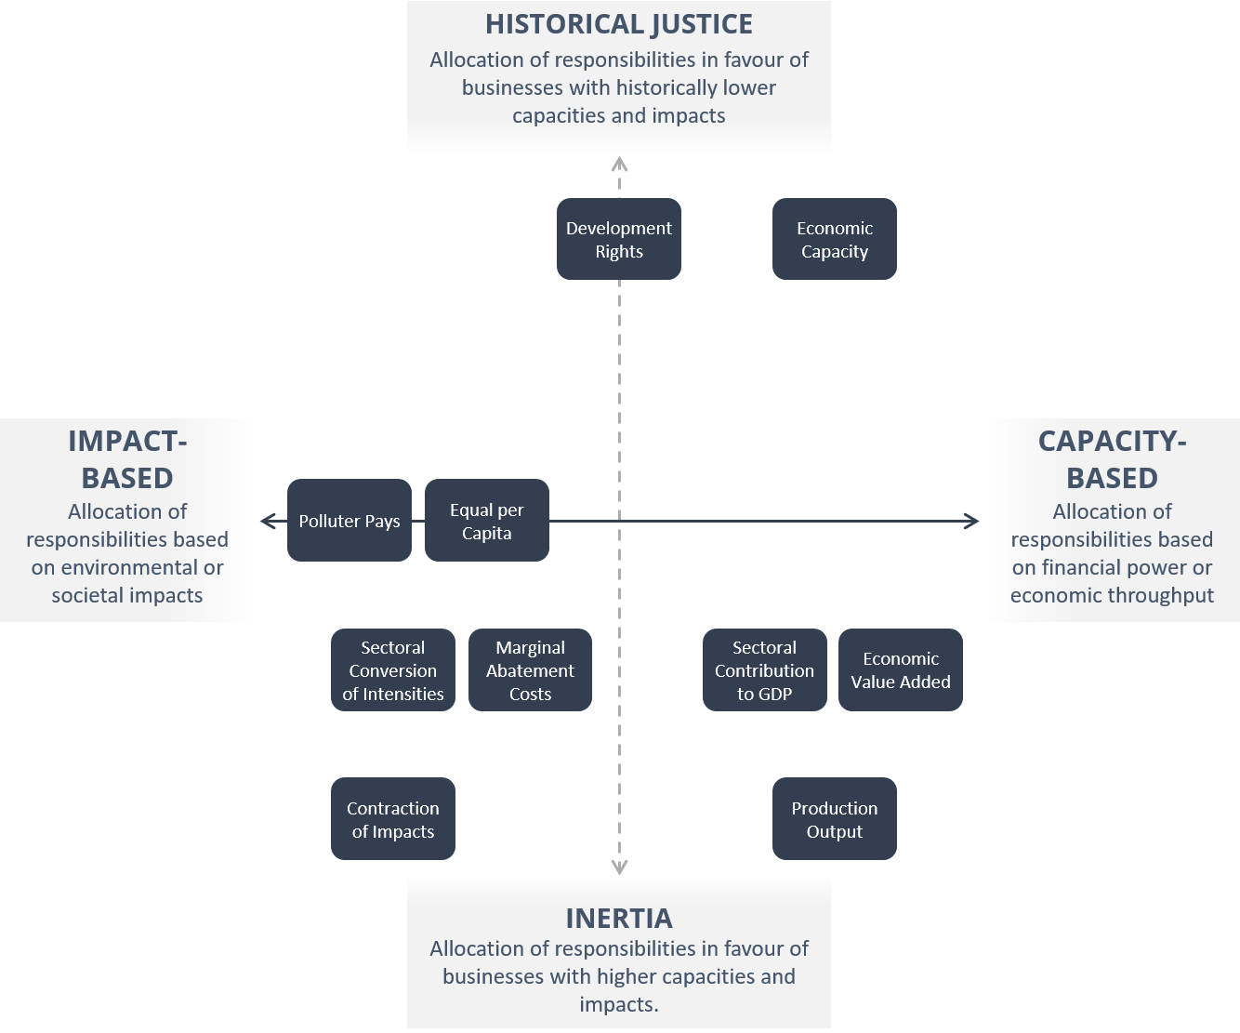

TABLE: Classification of a selection of allocation principles along different dimensions of ethical norms. Wording of ethical norms may differ depending on the literature (eg: Inertia or Inegalitarian; Historical Justice or Prioritarian; Capacity-Based or Utilitarian)

Contraction of Impacts
Short Description | All companies reduce their absolute impacts at a uniform rate, meaning that the company-specific level of decrease equals the level of decrease of all companies.
Strengths | - Lower barriers to corporate participation in schemes  - Reduction targets dependent on the size of the environmental impacts (higher impacts yield greater reduction targets)  - Promotes security of current livelihoods (especially for labour-intensive industries with local/regional surplus meaning) in contrast to approaches aimed at historical justice, which may provoke uncertainties to economic continuity
Considerations | - Businesses with high resources needs are granted higher shares, provoking inertia on existing resource use patterns  - Requires all businesses, regardless of place and development stage, to reach equal impact reductions, thereby hampering growth of resources-intensive businesses that have not yet contributed significantly to environmental damage/ reductions in overall budget

Economic Capacity (or else known as: Ability to Pay)
Short Description | Distributes permissible environmental impacts according to a business’s capacity to act or pay. Businesses with high financial capacity will receive smaller shares for resources use and emissions, leading to more ambitious reduction/ regeneration/ restoration targets.
Strengths | - Companies with the greatest financial means have the greatest capacity to solve ecological and social problems  - Has the potential to work well in landscapes dominated by business, particularly when turnover and/or profit margins are high enough to invest in nature
Considerations | - Requires extensive financial data across all businesses operating within a predefined place  - Turnover and profit are susceptible to fluctuations, which will influence business specific shares  - Businesses may be tempted to reduce profit (through investments) to receive higher shares of impact allowances  - Primary sector dominated landscapes may not have the capacity to reach socio-environmental goals when profit margins to reduce/ restore/ regenerate are low (approach requires linkage with value chain allocation mechanism, allowing shared responsibility among actors)  - Other businesses may create a lot of profit but have low environmental impacts in the places where they operate in, thus, would need to invest extensive resources, although they have not contributed significantly to environmental impacts

Marginal Abatement Costs (or else known as: Economic Efficiency)
Short Description | Distributes permissible environmental impacts according to the costs of measures to reduce environmental impacts. MACCs compare the environmental impact reduction potential of a specific measure to its cost. Multiple estimations of costs and reduction potentials are sorted next to each other to identify the best options. Actors with the lowest marginal cost of abatement will need to set higher reduction targets than highly efficient businesses.
Strengths | ● Impose higher burden sharing for wasteful businesses  ● Identifies highest benefit for nature and businesses associated with the lowest costs
Considerations | ● Allocated impact reductions may not add up to nature´s needs, even if all businesses perform well in efficiency terms  ● Due to higher costs, restoration and regeneration measures critical to return to safe corridors for nature may not be considered  ● May be impractical for places with large amounts of businesses as it requires extensive data on business specific efficiency parameters  ● May be impractical to scale as context-specific information are needed for dozens of places

Development Rights
Short Description | Distributes permissible environmental impacts according to historic shares of total environmental impacts (responsibility) and an entities economic power (capacity). Originally designed for more equitable climate mitigation targets, respecting the development needs of countries that have not yet contributed to the climate crisis. Entails a development threshold, below which people are not expected to share costs of the climate transition.
Strengths | ● Presumably, one of the fairest approaches for companies in the primary and secondary sectors as it requires high impact businesses to set the most ambitious reduction targets for nature. In contrast, start-ups/ low impact businesses receive higher shares to embrace their development needs
Considerations | ● Not yet transferred to the business context (translation may lead to impracticalities for a stand-alone approach: some sectors have high capacity in terms of turnover/ profit but low responsibility due to the nature of their business models; others may have a high responsibility but low capacity)

Equal per capita allocation
Short Description | Distributes permissible environmental impacts equal to each human being within a predefined area. Based on the concept that each human being has equal rights to the access of planetary resources. Largely applied at national scale, where a global budget in resource use or emissions is distributed according to a country's share in the global population.
Strengths | ● Has the potential to incentivize decoupling of environmental impacts from resources use
Considerations | ● Not yet transferred to the business context (translation may not be possible)

Production Output
Short Description | Distributes permissible environmental impacts according to a company’s production volume. The higher the volume, the larger its budget for resource use and emissions.
Strengths | ● Favors development needs of circular businesses, which, compared to other companies, can generate higher production volumes with an equal amount of resources or emissions
Considerations | ● Businesses with high resource needs are granted higher shares, provoking inertia on existing resource use patterns  ● Environmental impacts of production volumes will vary by sector, some businesses are characterized by low production volumes associated with high impacts

Economic Value Added
Short Description | Distributes permissible environmental impacts according to a company’s increase in product value before it is sold to customers. The larger the value added of produced products, the larger a company’s share of resources and emissions.
Strengths | ● ...
Considerations | ● Businesses with higher added value are granted higher shares, provoking inertia on existing resource use patterns  ● Requires extensive financial data across all businesses operating within a predefined place  ● Added value is susceptible to fluctuations, which will influence business specific shares  ● Primary sector dominated landscapes may only generate low added value and do not have the capacity to achieve socio-environmental goals (approach requires linkage with value chain allocation mechanism, allowing shared responsibility among actors)  ● Other businesses may create high added value but have low environmental impacts in the places where they operate in, thus, would need to invest extensive resources, although they have not contributed significantly to environmental impacts

Polluter Pays
Short Description | Businesses pay for the costs of environmental damage that stem from their activities.
Strengths | ● Internalization of externalities (businesses pay social costs)  ● Higher impacts result in higher expenditures for nature
Considerations | ● For businesses with greater financial means, focus on allocation of costs does not necessarily incentivize less polluting practices  ● Ratio between business impacts and required financial expenditures for remedy may be off balance. Businesses may not be able to generate enough profit to compensate for induced damage  ● Focus on pollution, not yet translated to resource use or service sector  ● Not a precautionary approach as it assigns costs only after impacts occurred  ● Principle works well for point source emissions but may be more difficult to implement for non-point source emissions  ● Difficult to determine the optimum costs resulting from environmental damage

Sectoral Contribution to GDP
Type | Economic Performance, Inertia
Short Description | Distributes permissible environmental impacts according to the contribution of economic sectors to the place-based GDP. Similar to Value Added approach, when both are designed to distinguish between economic sectors. However, GDP only measures finished goods and service. The larger the sectoral contribution to the GDP, the larger a company’s share of resources and emissions.
Strengths | ● GDP data publicly available (as opposed to required business specific data for the Added Value approach)
Considerations | ● Shares similar disadvantages as the Economic Added Value Approach, additionally:  ● Sectoral approach disregards differences in business performances within sectors (e.g. all agribusinesses receive an equal share)  ● GDP data may not be available at relevant scales, requiring rough/imprecise estimates on sectoral contributions  ● Businesses that produce intermediate goods are not incorporated in the overall GDP, which distorts GDP share of each sector for places

Sectoral Convergence of Intensities
Short Description | Impact intensity of each business will need to converge to a sector-specific intensity target. Rooted in the Sectoral Decarbonisation Approach (SDA) of the SBTi. SDA is based on sector-specific least-cost emission reduction pathways to reach global goals. The annualized rate of decrease will depend on: current carbon intensity of the company and sector, projected future market share, and target intensity of the sector.
Strengths | ● Considers specific characteristics of sectors  ● Links intensity targets with absolute impact reductions needed to safeguard nature  ● Provides growth opportunities for resources intensive businesses that have not yet contributed significantly to environmental damage/ reductions in planetary capacity
Considerations | ● Designed for carbon emissions reductions and not yet translated to sector-specific reduction scenarios for resources use an emissions beyond climate (e.g.: land intensity)  ● Requires start-ups/ low impact businesses to advance more quickly on their economic transition to achieve environmental and societal goals

For further reading:
Baer, P., Athanasiou, T., Kartha, S. & Kemp-Benedic, E. The Greenhouse Development Rights Framework. The right to development in a climate constrained world. Revised second edition. Publication Series on Ecology – Volume 1 (2008). https://www.boell.de/sites/default/files/GDR-second-edition-i.pdf
Bjørn, A. et al. Review of life-cycle based methods for absolute environmental sustainability assessment and their applications. Environ. Res. Lett. 15 083001 (2020). https://doi.org/10.1088/1748-9326/ab89d7
Gladek, E. (Ed.). Setting Science Based Targets for Nature: A pilot to assess planetary boundaries for water, land, nutrients and biodiversity in Alpro’s soy and almond value chains (2018-2019). https://www.metabolic.nl/publication/alpro-setting-science-based-targets-for-nature/
Lucas, P. & Wilting, H. Using planetary boundaries to support national implementation of environment-related Sustainable Development Goals. PBL Netherlands Environmental Assessment Agency, The Hague, The Netherlands (2018). https://doi.org/10.13140/RG.2.2.15143.80806
Sabag Muñoz, O. & Gladek, E. (Metabolic). One Planet Approaches. Methodology Mapping and Pathways Forward (2017). https://www.metabolic.nl/publications/one-planet-approaches-methodology-mapping-and-pathways-forward/
Science Based Targets initiative. Approaches and methods (2018). https://sciencebasedtargets.org/methods-2/. Accessed July 2020.
van den Berg, N.J., van Soest, H.L., Hof, A.F. et al. Implications of various effort-sharing approaches for national carbon budgets and emission pathways. Climatic Change 162, 1805–1822 (2020). https://doi.org/10.1007/s10584-019-02368-y

TA 4.5 Translation: Conversion
Application describes the process of converting between cause and effect relationships to connect a desired change in the state of nature in a specified place (e.g. extent and condition of ecosystems, level of water stress, etc...) with specific actions that companies should take.
A helpful rubric for understanding the types of indicators and targets companies might measure is the DPSIR (driver-pressure-state-impact-response) framework, which connects the underlying causes of nature loss (drivers and pressures) to the state of nature, impacts on ecosystems, and potential responses companies can take. Examples of DPSIR relationships are shown in the following table, which connects biophysical limits (planetary boundaries) and societal sustainability goals (SDGs) for different environmental issues to commonly tracked indicators for companies (e.g. from CDP, GRI, SASB disclosures). 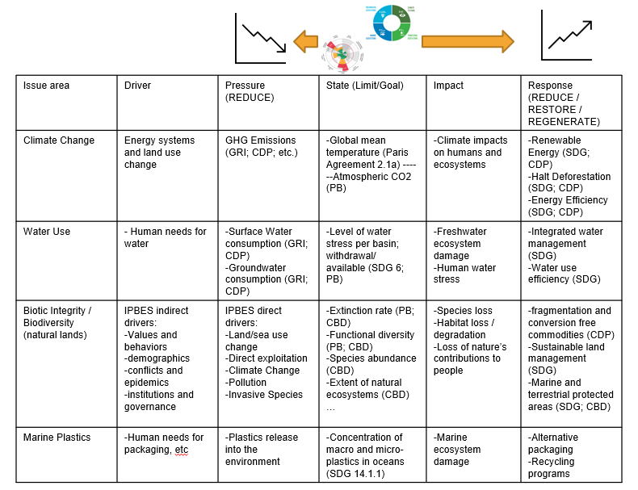
TABLE: Examples of cause-effect relationships connecting biophysical limits (PB) and societal goals (SDG, CBD, etc) to their causative pressures and potential responses (including indicators from existing corporate and government disclosure frameworks). Note that different terms and frameworks exist for such relationships, e.g. the IPBES GLobal Assessment uses “Direct Driver” and “Indirect Driver” for “Driver” and “Pressure”.

Global goals for nature and sustainable development (e.g. through the CBD, CCD, and SDGs) have historically used a combination of indicators and targets across the DPSIR causal levels, including targets on the state of nature, the pressures on it (like deforestation, wildlife trade), and specific responses (e.g. protected areas). Importantly, these different types of indicators have tradeoffs in the criteria listed above. For instance, state (S) indicators may be considered the most science-based due to the direct connection to the desired state for nature and people; however, they may be more costly and less practical to measure, and less controllable by individual companies or other actors. On the other hand, pressure (P) and response (R) indicators and targets may be more practical for sub-national actors, and more aligned with existing corporate sustainability practices like reporting standards, but still require further cause-effect translation to connect to the desired state.

Technical Annex 5: Crosswalk of frameworks, Mitigation Hierarchy-Conservation Hierarchy-AR³T Action Framework

SBTN Action Framework Term | Mitigation Hierarchy | Conservation Hierarchy
Avoid | Avoid | Avoid
Reduce | Reduce | Reduce
Restore & Regenerate | Restore | Offset
Transform | No direct equivalent, some overlap with Additional Conservation Actions | No direct equivalent, some overlap with Proactive Conservation Actions

Technical Annex 6: Avoid

TA 6.1 What to avoid?
Avoidance measures should be designed to avoid significant negative consequences to nature. Additional detail on these consequences is provided in Table 6.1. These can be avoided through a wide range of measures. Examples are provided in the next section.

Table 6.1: Avoidance measures are designed to prevent significant consequences for nature
What to avoid | Rationale | Further information
Species extinction or ecosystem collapse | Global extinction of species must be avoided at all costs as there are no options for restoration. Regional or national extirpation should also be avoided, as although restoration may be theoretically possible it may not be practically feasible.  Damaging and degrading ecosystems to the point of collapse means that no remediation measures are available to restore it. Such collapse can result in species extinction, and severe impacts on NCP. | - Consult the IUCN Red List for information on species status.  - A potential species target has been proposed by Rounsevell et al (2020)  - The theory behind ecosystem collapse was presented by MacDougall et al (2013)
Adverse effects on internationally recognised no-go areas | Certain areas, e.g. World Heritage Sites, and some Protected Areas, are recognised for their global significance for biodiversity. Avoiding any development these areas will ensure that these globally significant values are maintained | - IUCN resolution from 2016 on no-go areas  - TBC analysis of what this declaration means for the private sector.
Species or ecosystems to be listed as threatened or to move into a higher category of threat, according to the criteria of the IUCN Red List of Threatened Species and the IUCN Red List of Ecosystems | A change in Red List status means that a species of ecosystem is moving closer to extinction. | - Consult the IUCN Red List for information on species status.  - Consult the IUCN Red List of ecosystems
Destruction of local and irreplaceable values
A disproportionately large Negative effect on ecosystems’ abilities to generate Nature’s Contribution to People

Land degradation neutrality at a relevant scale |  | The UN Convention to Combat Desertification defines Land Degradation as “A state whereby the amount and quality of land resources, necessary to support ecosystem functions and services and enhance food security, remains stable or increases within specified temporal and spatial scales and ecosystems.”
Surface or groundwater stress that exceed environmental flow limits

TA 6.2 Approaches to avoidance
There are two broad approaches to assessing what should be avoided and how much avoidance is required: prescriptive and risk-based.

Prescriptive avoidance refers to categorical exclusions of impacts to particular areas, species or ecosystem processes, types of impact, technologies, or processes. Prescriptive avoidance is appropriate where there is a strong and well-understood scientific and societal basis that certain activities would impinge on meeting societal sustainability goals for nature and would threaten Earth’s known limits.

Risk-based avoidance does not set definitive exclusions but uses criteria and thresholds to identify needs for avoidance on a case-by-case basis depending on the likelihood and consequences of a potential impact to nature. Risk-based avoidance takes account of the fact that our knowledge of nature and impacts may be insufficiently granular to define prescriptive avoidance measures and allows companies and stakeholders the flexibility to identify locally-appropriate ways of meeting societal sustainability goals for nature and remaining within Earth’s known limits.

A prescriptive approach is relatively straightforward. A binary choice as to where or what an actor will or will not do. Many companies, and jurisdictions already have these in place. For example Royal Dutch Shell will not operate in natural World Heritage Sites, and Cargill has committed to eliminating deforestation (based on the High Carbon Stock approach) in its supply chain.
Risk-based approaches are more nuanced and enable an actor to avoid the most significant impacts, while continuing to allow operations in other circumstances. The key to these approaches is the consideration of such as the likelihood, significance and consequence of impacts. If an impact is considered too high risk, i.e. the implications exceed a threshold, then that impact must be avoided. To do this an actor will need to set the parameters for assessing risk. For biodiversity these can include factors such as
- the IUCN Red List status of a species or ecosystem (the higher the status the higher the risk),
- the proportion of the species or ecosystem distribution which will be impacted, and
- the irreversibility of impacts.
An actor may choose to develop their own thresholds and responses to different-levels of risk. Alternatively existing systems could be employed. Two of the most widely-used systems are Critical Habitat, as defined by the IFC Performance Standard 6, and EBRD Performance Requirement 6, and the High Conservation Value framework.

TA 6.3 How much to Avoid? The concept of “as low as reasonably practicable" (ALARP)
Over and above these minimum requirements recommended above, companies should set specific targets for avoiding impacts on the components of biodiversity, water, land and oceans that are material to them. These should aim to bring remaining impacts to As Low As Reasonably Practicable (ALARP). The principle of ALARP has a wide basis in environmental practice, and implies a cost-benefit analysis which takes into account other considerations (social, financial, technical). The core principle is that actors should seek to avoid impacts unless the cost is grossly disproportionate to the benefit.
ALARP allows for an informed judgment as to how much effort (or cost) should be made to avoid an impact before the cost overwhelms the benefits. Costs might, for example be financial costs, opportunity costs, time delays, or negative impacts to another aspect (such as local communities customary rights). An important element when applying ALARP is transparent demonstration of how decisions and where necessary compromises have been made, including documenting the severity of the risk, and assessing alternatives.
The concept of ALARP is widely used in many sectors. Most notably in the field of health and safety. The concept can be applied to managing impacts to nature. The UK Health and Safety Executive has useful resources on ALARP (others are available).

BOX: Early screening to inform avoidance
Screening provides a relatively rapid and cost-effective means to identify early opportunities for avoidance. It makes the most of already available information, extracted from global biodiversity databases and spatial layers. Due to its effectiveness as an early decision support tool, desk-based biodiversity screening is increasingly applied and integrated into due diligence and investment decision processes.
Biodiversity screening is most effective when undertaken at the very early stage of project or investment planning, prior to formalising investment or development decisions, and when there are still opportunities for avoidance of impacts. This approach can help save significant time and resources by helping identify and avoid the most serious risks early on. It can also be useful for helping to prioritise further assessment and mitigation on the most pertinent risks.
Screening can also help businesses assess the biodiversity risks associated with projects or investments, for example, as part of an internal review of assets against company standards or financial safeguards, or to understand liabilities associated with acquisitions.
The Integrated Biodiversity Assessment Tool (IBAT) provides its users with a rapid visual screening for biodiversity, based on three authoritative global biodiversity datasets: the IUCN Red List, World Database of Protected Areas and World Database of Key Biodiversity Areas.
A number of organisations have developed screening tools to support businesses across different sectors. For example, WWF has developed a Supply Risk Analysis Tool for application to the production of agricultural commodities and WRI has developed Global Forest Watch to monitor risks posed by illegal activities and hazards like fire. National-level screening tools also exist. The South Africa National Biodiversity Institute (SANBI) has developed a Biodiversity Screening Tool based on mapped areas of high biodiversity significance, primarily aimed at avoiding impacts from forestry, but with wide application potential across sectors and supply chain assessments.
The Biodiversity Consultancy’s Industry Briefing Note provides further information.

TA 6.4 Further information on existing approaches to managing impacts to nature

Approach | Audience | Scope ( aspects of biodiversity, NCP covered) | Key features of the approach | Science and/or societal basis
BBOP principles | Companies, financial institutions, practitioners, government agencies, civil society | All biodiversity impacted by development as well as stakeholders affected by the offset | Establishes a framework for designing and implementing biodiversity offsets, based on a set of good practice principles, to deliver no net loss or net gain of biodiversity | Formulated based on input from a wide range of private sector and civil society members, and led by an executive committee with broad representation including government and finance institutions
IUCN policy on offsets | Broad audience including all IUCN Members, National and Regional Committees, and partners from the  private and public sector, including communities | All biodiversity impacted by development as well as stakeholders affected by the offset | Provide as framework to guide the design, implementation and  governance of biodiversity offset schemes and projects | Developed by the IUCN Biodiversity Offsets Technical Working Group; based on a number of IUCN technical studies on biodiversity offsets
IUCN policy on protected areas | Governments, owners, managers and users (including private sector) of protected areas | Biodiversity, ecosystem services and cultural values associated with protected areas | Identifies protected areas based on six management categories (I-VI) | Developed by the IUCN World Commission on Protected Areas (WCPA) and associated Specialist Groups and Task Forces, with input and review by a wide range of subject-matter experts as well as the private sector (e.g. the International Council on Mining and Metals (ICMM)
IFC PS6 / EBRD PR6 / World Bank ESS6 | Private sector (PS6 and PR6) and governments (ESS6) | Biodiversity and living natural resources (ecosystem services) | Identifies requirements for mitigation to achieve biodiversity targets (no net loss/net gain), based on impacts to areas of high biodiversity value (‘Critical Habitat’, based on quantitative thresholds) and areas of natural habitat. Requires rigorous application of the mitigation hierarchy and application of offsets to address residual impacts. | Developed in consultation with a wide range of international conservation organisations and leading specialists. Takes into account many pre-existing conservation  approaches, such as Key Biodiversity Areas and Alliance for Zero Extinction Sites.
Zero deforestation | Consumer goods companies with commodity supply chains | Forests and associated ecosystem services and social values | A company pledge and commitment to eliminate deforestation from its supply chain. Typically requires identification and addressing commodities within supply chain that impacts forests. Impacts typically assessed through HCV approach (see below). | Voluntary zero deforestation commitments have been made by over 500 companies.
No peat | Consumer goods companies with commodity supply chains, particularly palm oil companies | Peatlands and associated biodiversity and ecosystem service values | Encourages use of good management practices on existing plantations on peat. Where possible, peat restoration should also be implemented. | Developed for certification by the Roundtable on Sustainable Palm Oil (RSPO), comprised of expert specialist groups and task forces
High Conservation Value (HCV)  High Carbon Stock Approach (HCSA) | Consumer goods companies with commodity supply chains | Forests and associated ecosystem services and social values impacted by agriculture, livestock, palm oil pulp & paper, pulp & timber, etc. | Identifies areas of high carbon and conservation value that warrant protection, as well as lands suitable for development. Conservation value based on criteria defined by the FCS. Thresholds are locally determined, stakeholder driven, that account for rare and threatened species, ecosystems and landscapes and internationally recognised areas.  Includes forests, but also other ecosystems and social values associated with these ecosystems.  Focus is on avoidance and minimisation of forest impacts, while securing the rights and livelihoods of communities. | Concepts developed through a number of consultation processes, led by a scientific advisory panel and technical working groups.  Has gained widespread appeal and use in certification schemes

TA 6.5 Data sources for informing avoidance

Various global data layers exist that can be used to inform avoidance measures. Note that some of these may have commercial use restrictions. Please consult the relevant Terms and Conditions.

Layer name | What does it show? | What is the science basis? | How would a company use it for avoidance? | Notes and issues to be aware of | Data source and availability
World Database of Protected Areas (WDPA) | Global database and map of protected areas | Compilation and management of the WDPA is carried out by UNEP-WCMC, in collaboration with governments, non-governmental organisations, academia and industry.  WDPA is used to report on progress towards the CBD Aichi Targets and to track progress towards the 2030 Sustainable Development Goals | To identify locations of protected areas to avoid | Some sites are only available as point data  Not all protected areas may be reported to the WDPA (e.g. community-based management areas); further assessment needed at site level | Available for commercial use through the Integrated Biodiversity Assessment Tool (IBAT)
Alliance for Zero Extinction (AZE) sites | Map and database with map sites that support last-remaining populations of the Earth’s most threatened species | Site identification and verification led by a global steering committee comprised of conservation specialists, supported by regional experts. AZE sites are identified based on specific qualifying criteria, equivalent to KBA criterion A1e: “Site regularly holds effectively the entire global population size of a Critically Endangered or Endangered species.”  AZE sites are a recognized indicator for the CBD Aichi Targets and integrated into an increasing number of government policies | To identify sites of critical conservation value to avoid | Sites supporting critical species populations, but which have not been globally assessed are not mapped; site specific assessments will be needed in many cases | Available for commercial use through the Integrated Biodiversity Assessment Tool (IBAT)
Key Biodiversity Areas (KBAs) | Global database and map of areas recognised as contributing significantly to the global persistence of biodiversity | Identification based on a global standard which sets out agreed criteria (11), led by the IUCN WCPA-SSC Joint Task Force on Biodiversity and Protected Areas.  Sites identified through a consultative process | To help identify sites of biodiversity importance including specific sensitivities associated with KBAs (e.g. sensitive bird colonies), to prioritise for avoidance | Presence of a KBA does not necessarily mean strict avoidance must be implemented. Depending on the type of development and the biodiversity values for which the KBA was identified, avoidance can still be achieved within a KBA. | Available for commercial use through the Integrated Biodiversity Assessment Tool (IBAT)
Global Critical Habitat screening layer | Global map of marine and terrestrial areas likely or potentially qualifying as Critical Habitat under IFC PS6 criteria | Developed based on global biodiversity layers and assessment against IFC PS6 criteria.  Findings published in a peer-reviewed journal:  Marine layer  Terrestrial layer | Can help identify areas of potential high biodiversity value, for prioritisation as avoidance areas in risk-based approaches. | Layer provides an indication of potential presence of Critical Habitat, based on known or inferred presence of biodiversity features. Further assessment needed to confirm presence of biodiversity values that qualify as Critical Habitat. | Available for commercial use through the UNEP-WCMC Ocean Data Viewer
Species Threat, Abatement and Restoration (STAR) | Measure based on biodiversity value within an area of interest, based on the population significance and threat status of species. In turn, this can be used to target investments and activities to achieve conservation outcomes and contribute to global policy aims. | Currently being developed and trialled by IUCN and other leading biodiversity specialists as an effective approach to measure progress towards global, national and site-level biodiversity targets. | Provides a rapid tool that can be applied to assess the conservation significance (and thus avoidance priorities) associated with any area, from site to global scale. | Metric based on presence and status of threatened species groups that have been assessed on the Red List. Limitations include freshwater, marine and wide-ranging species. Further site level assessment may therefore be needed.
Range rarity | Global layer identifying areas supporting a relatively high number of range-restricted species, based on information from the IUCN Red List | Applies IUCN Red List data on species threat status and range | Identifies areas that are of high biodiversity significance based on the potential presence of species with a relatively small range. Can be used alongside other global biodiversity layers to identify avoidance priorities. | Only considers the following species groups: amphibian, birds and mammals.  Needs to be considered alongside other significance measures including species richness and threat status | Available through IUCN Red List
Ecoregions | Maps of areas supporting geographically distinct assemblages of species, communities, and environmental conditions across terrestrial, freshwater and marine biomes | Identified through regional analyses of biodiversity across the globe, in collaboration with regional experts and literature review | Provides an initial screening for broad areas that may support sensitive biodiversity features for avoidance | Only identifies geographically large ecoregions so not practical for site-level avoidance; requires further site-level screening and assessment. | Available through WWF website
Last chance ecosystems (TNC) | Terrestrial Ecosystems which have undergone significant conversion, but have relatively low proportion of protected sites |  | To identify potentially sensitive ecosystems |  | Available as a layer from TNC
Nature Map | Will provide a synthesis of terrestrial biodiversity, carbon and ecosystem service layers to support spatial planning and identification of conservation and restoration opportunities | Initiative will synthesize the best available data and local information and apply methodologies that are globally consistent. Data will be validated through a consultation and evaluation process  With subject-matter experts | Can help screen areas of particularly high biodiversity value and carbon stocks, to prioritise avoidance | Application aimed primarily for national and regional-level assessments so applicability to site level may be limited and require further assessment | Layer to be made available through the UNEP-WCMC data portal (date?)
Global Forest Watch | Global forest cover, as well as additional information on forest loss, or above ground biomass | Based on analysis of remote sensing data. Peer-reviewed. | Supports the identification of forest areas, for example for no deforestation policies | Resolution might not be high enough for small sites. | Data portal available from WRI

TA 6.6 Maps of potential no-go areas (AZE, World Heritage Sites, IUCN Cat. I and II Protected Areas)
Illustrative maps of areas of high risk for significant impacts to nature are provided below. For each section the maps show the global distribution of areas, in addition to focussing on different regions.
These maps show sites which could be considered as “no-go” areas. Sites which companies would commit to avoiding all impacts. This may require going beyond not operating within these sites, to including not carrying out activities which may impact sites at a distance.
Alliance for Zero Extinction (AZE) sites are a subset of Key Biodiversity Areas which are home to the last remaining population of a species.
World Heritage Sites are a suite of sites nominated by nation states, and listed by UNESCO for their Outstanding Universal Values. They are nominated for natural and/or cultural values.
Protected Areas are defined by IUCN as “A clearly defined geographical space, recognised, dedicated and managed, through legal or other effective means, to achieve the long-term conservation of nature with associated ecosystem services and cultural values”. The IUCN categorises protected areas based on their management objectives. Category I and II areas have the strictest regulations promoting biodiversity conservation, and include Strict Nature Reserves, Wilderness Areas and National Parks.
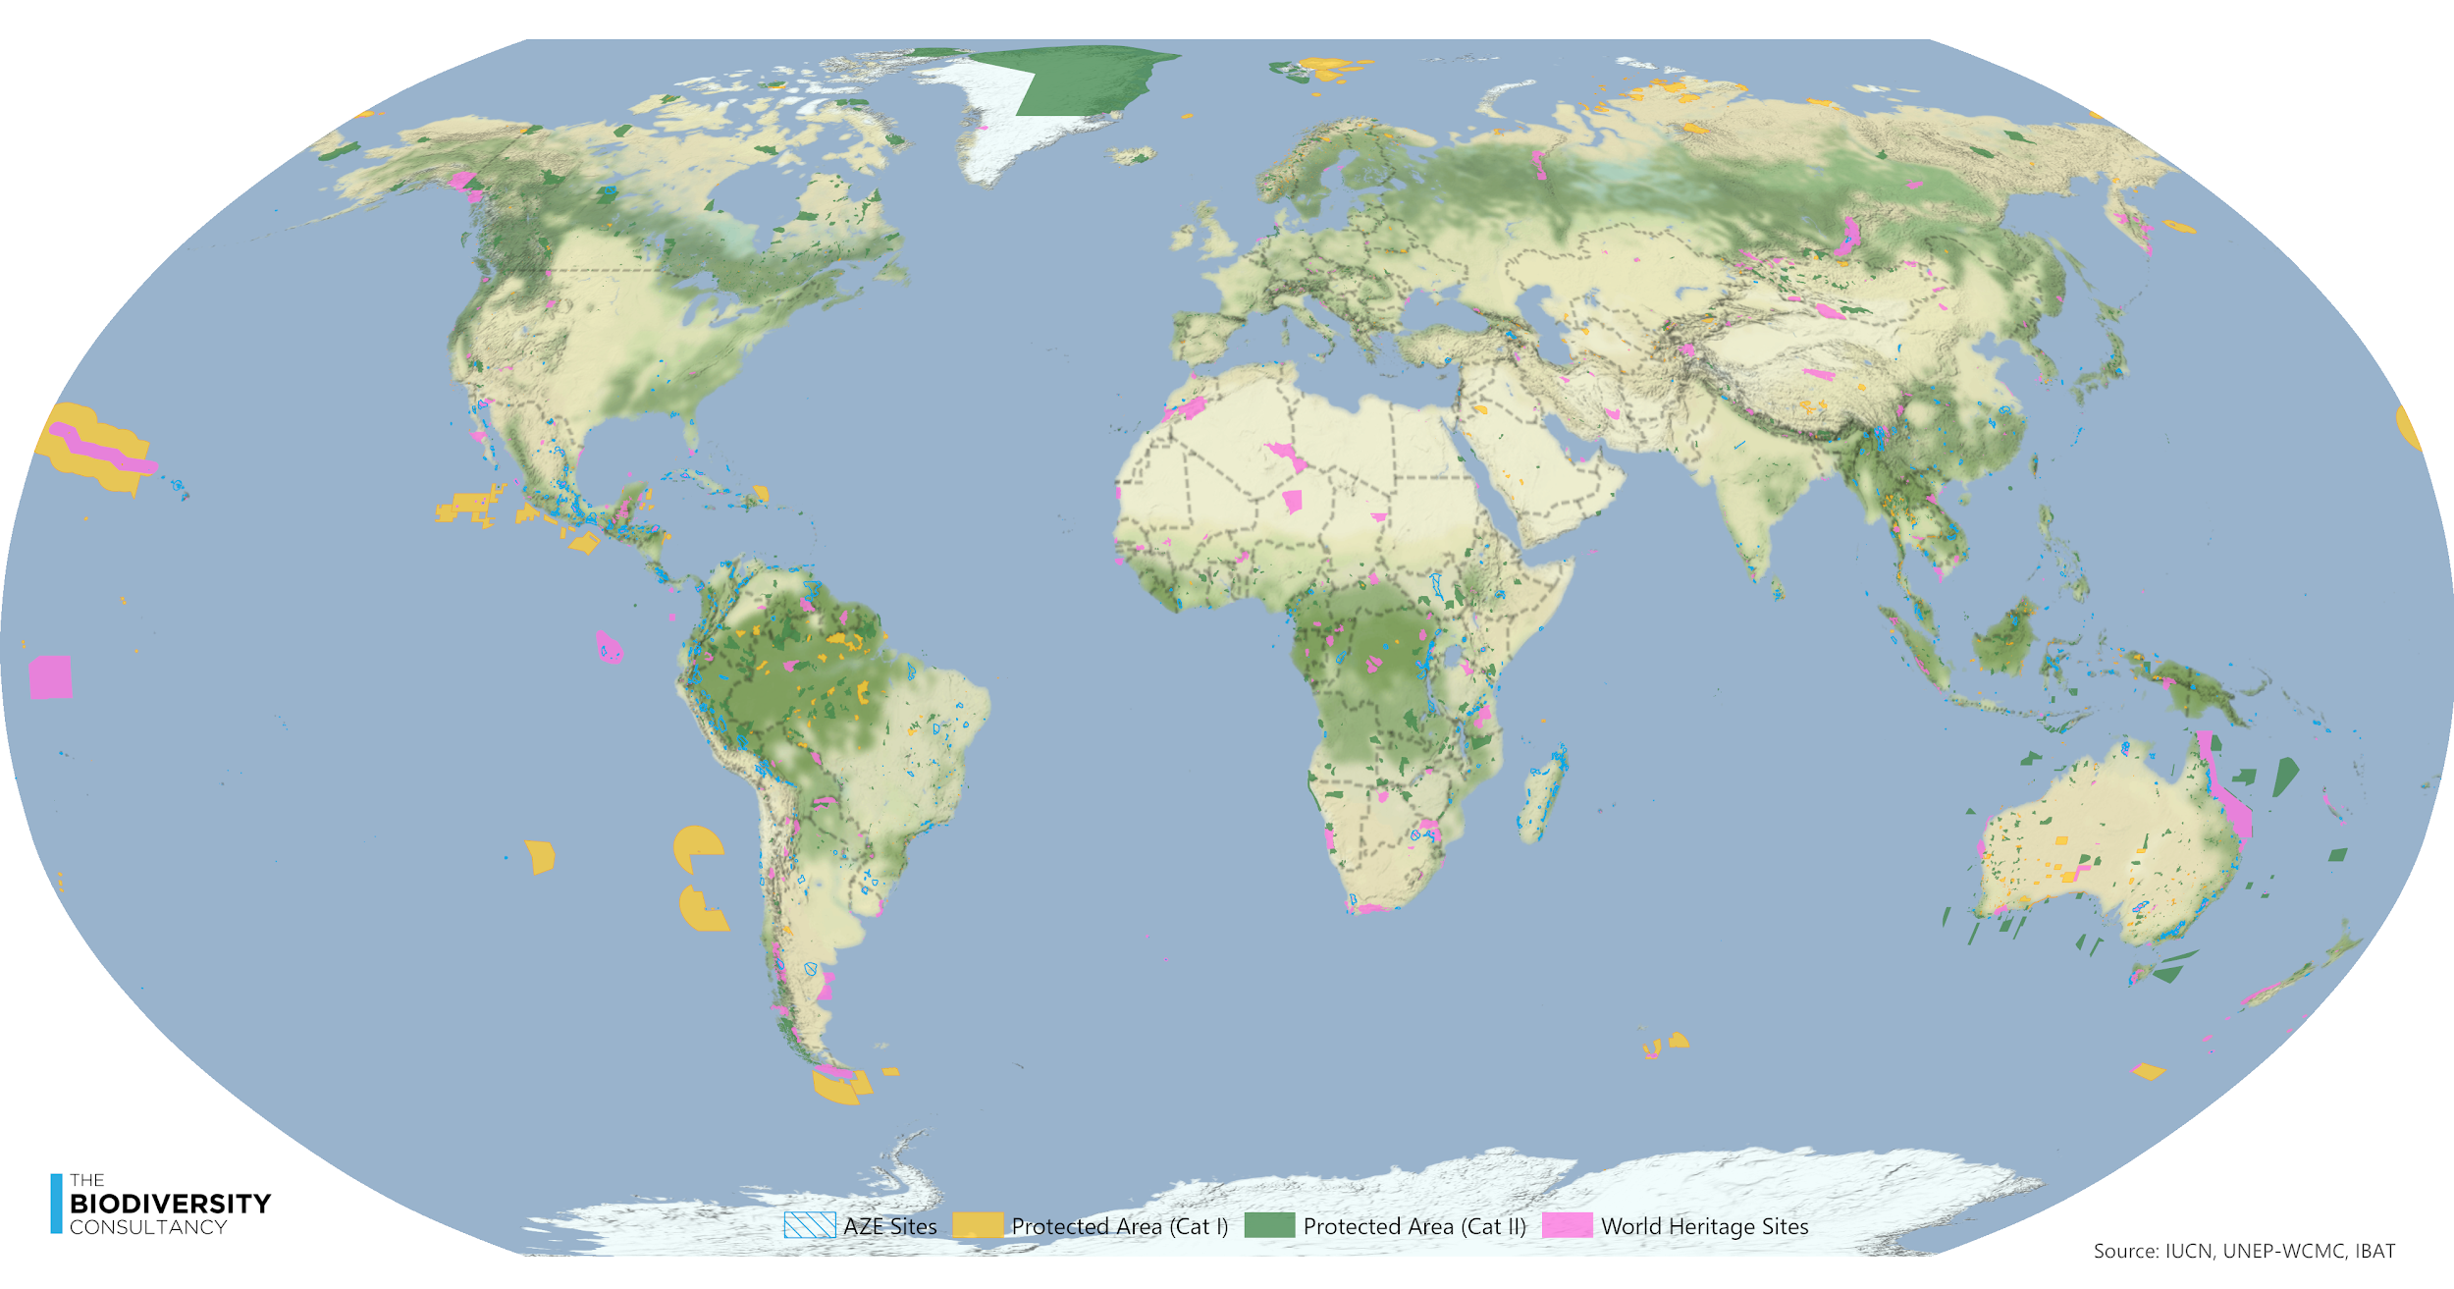
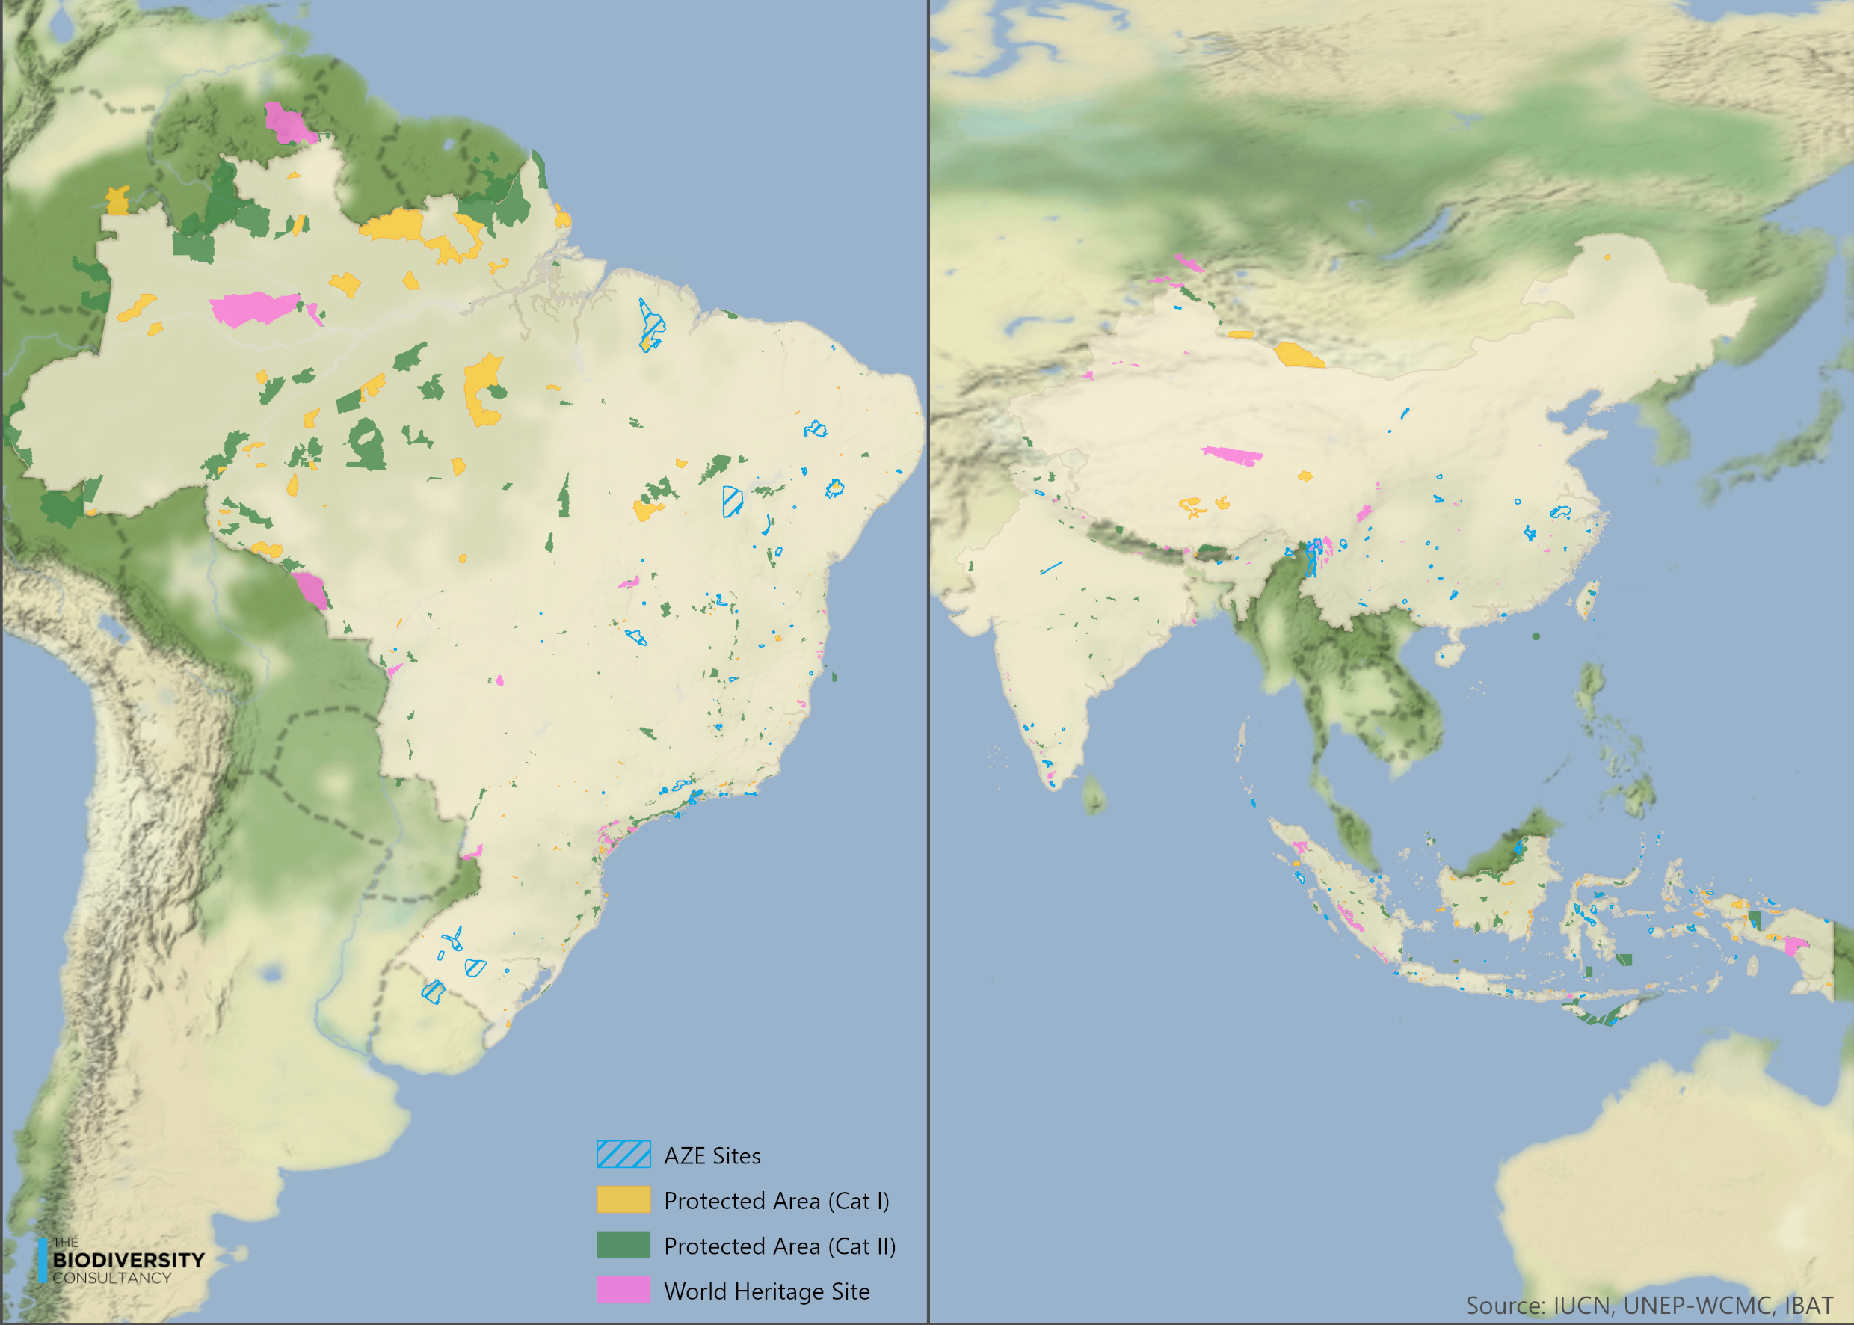

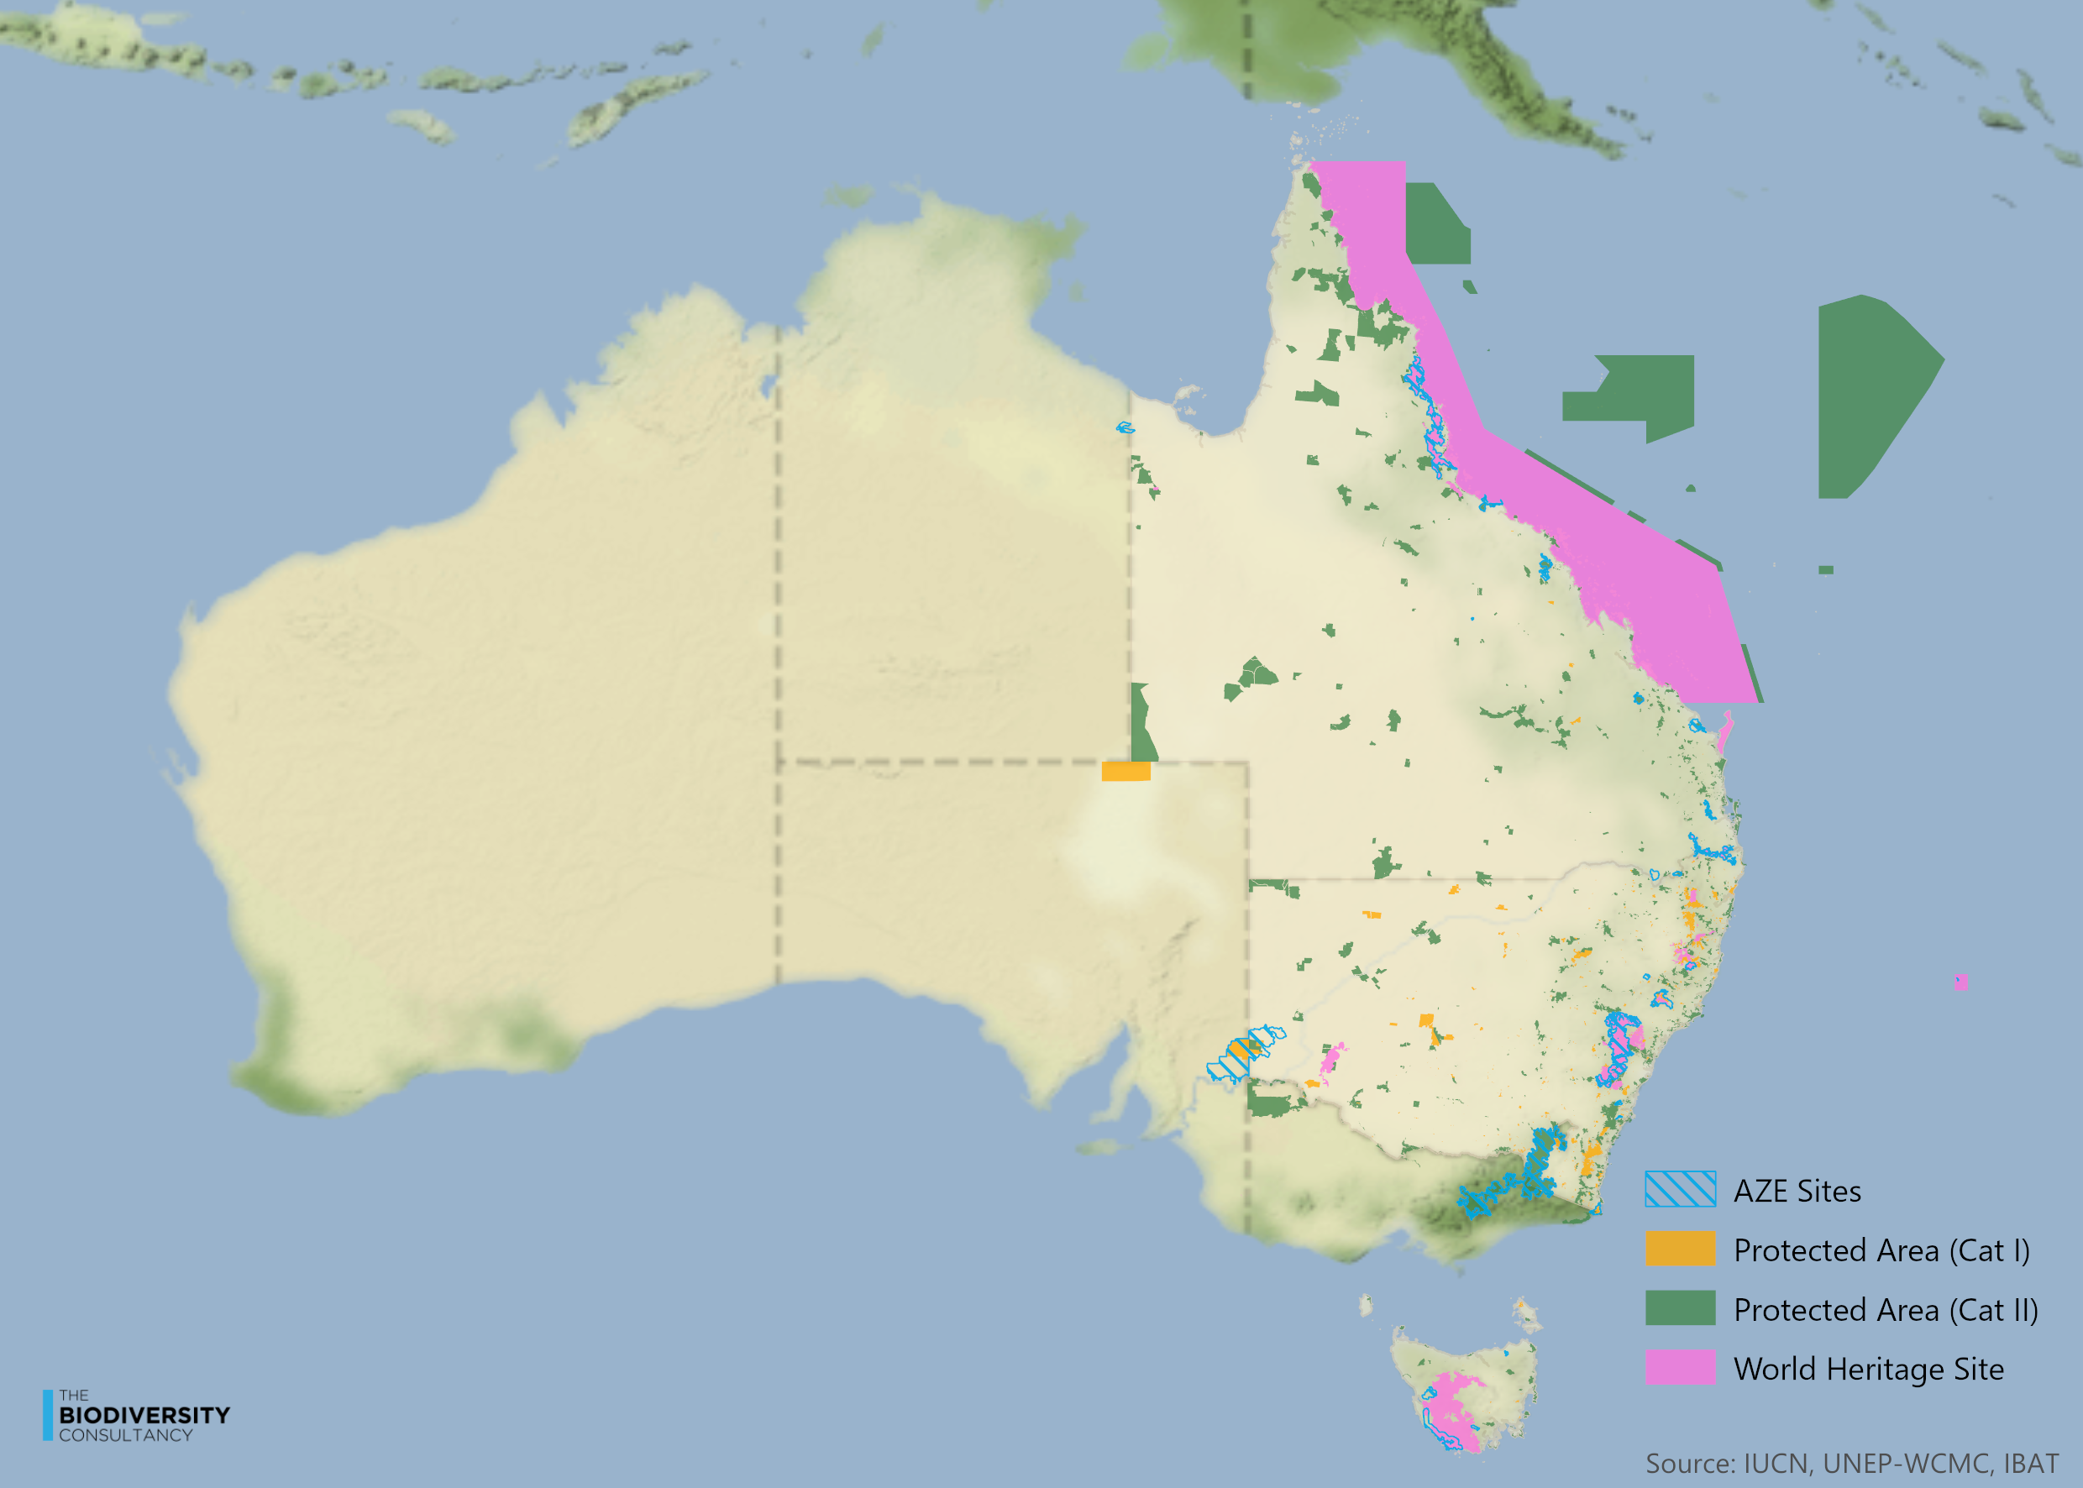

TA 6.7 Maps of potential high-risk areas (KBAs, potential CH)
Key Biodiversity Areas and areas which are potentially Critical Habitat should be screened for the potential presence of nature for which impacts should be avoided.
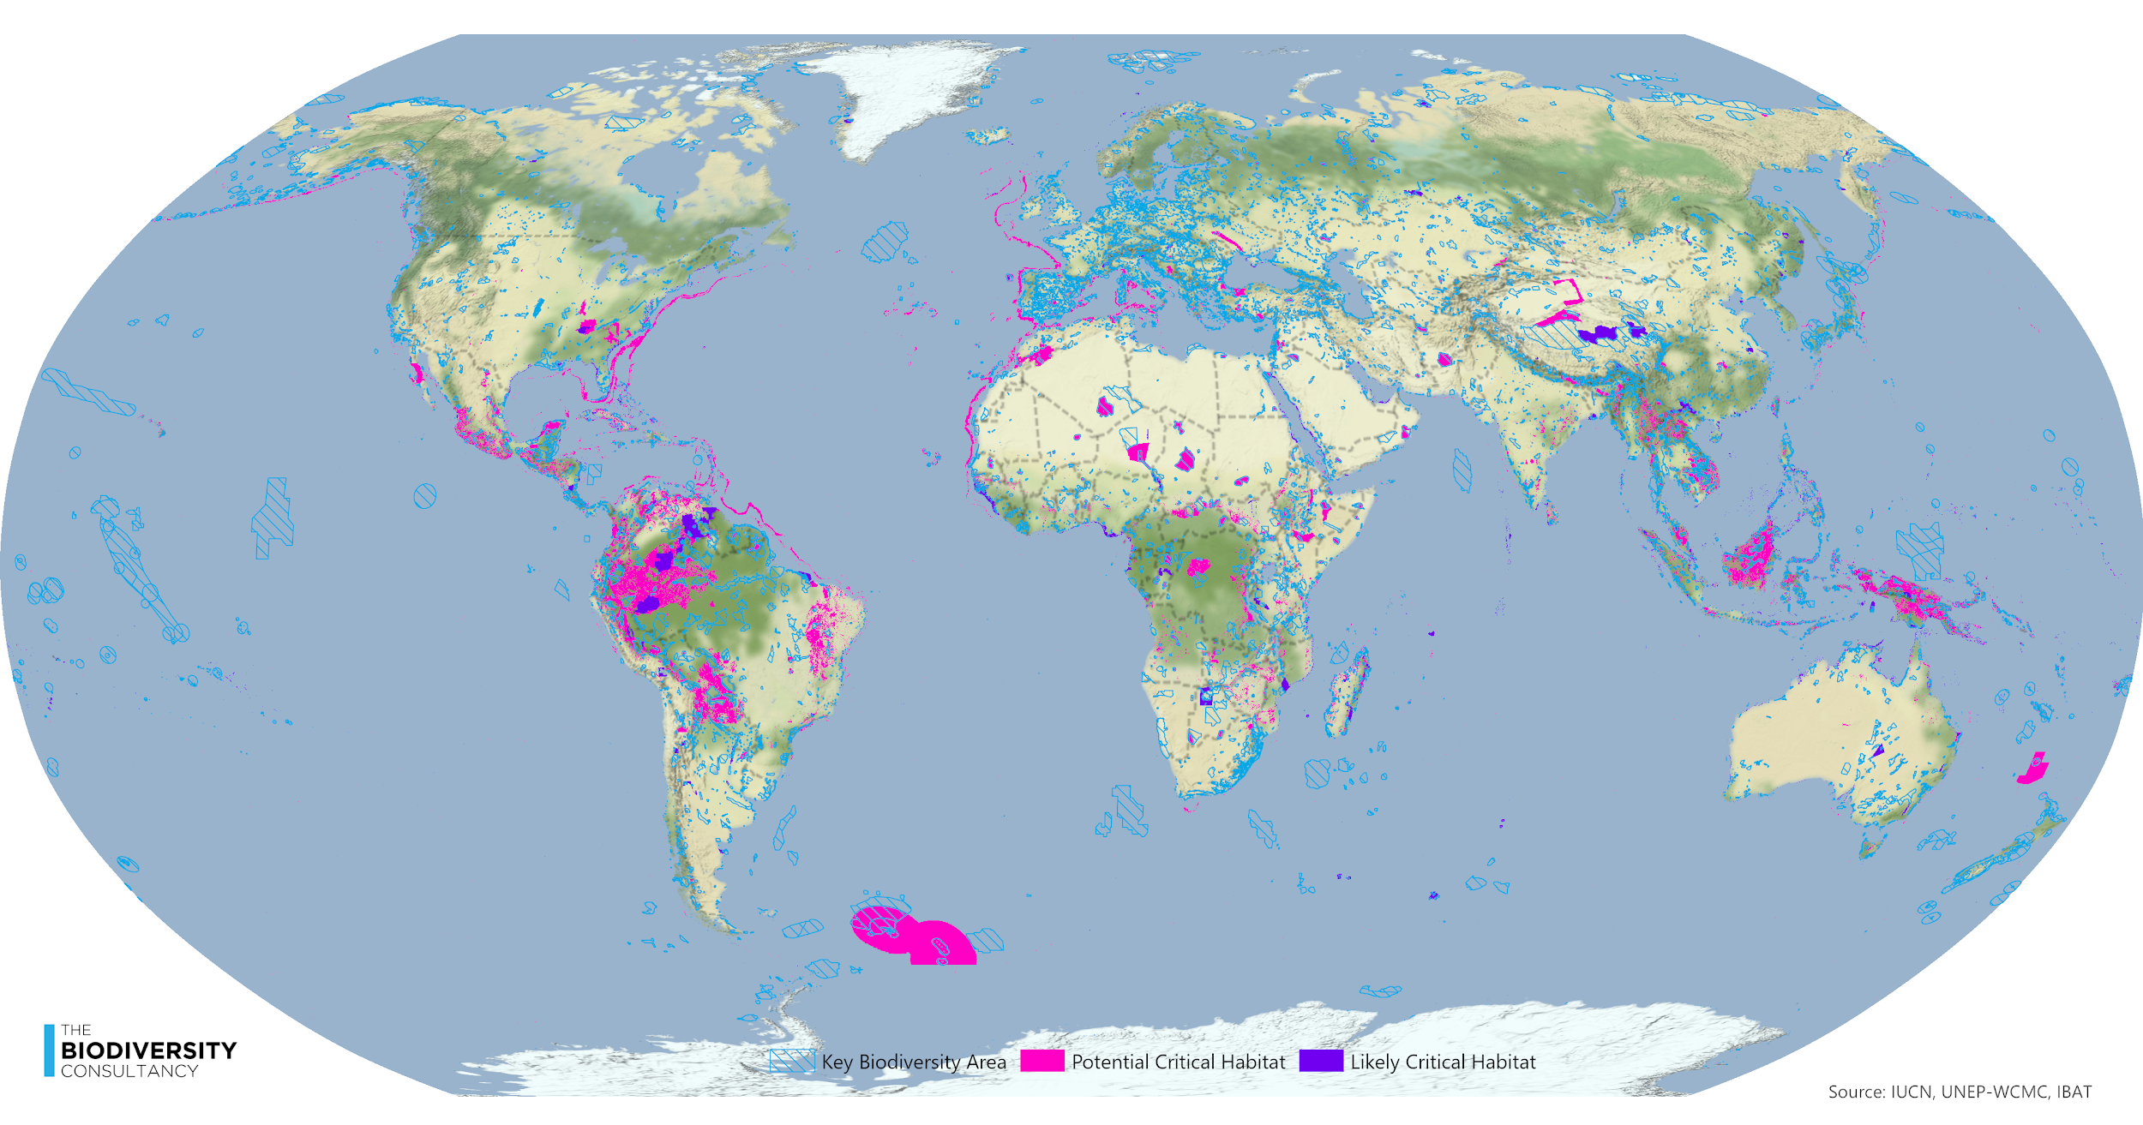

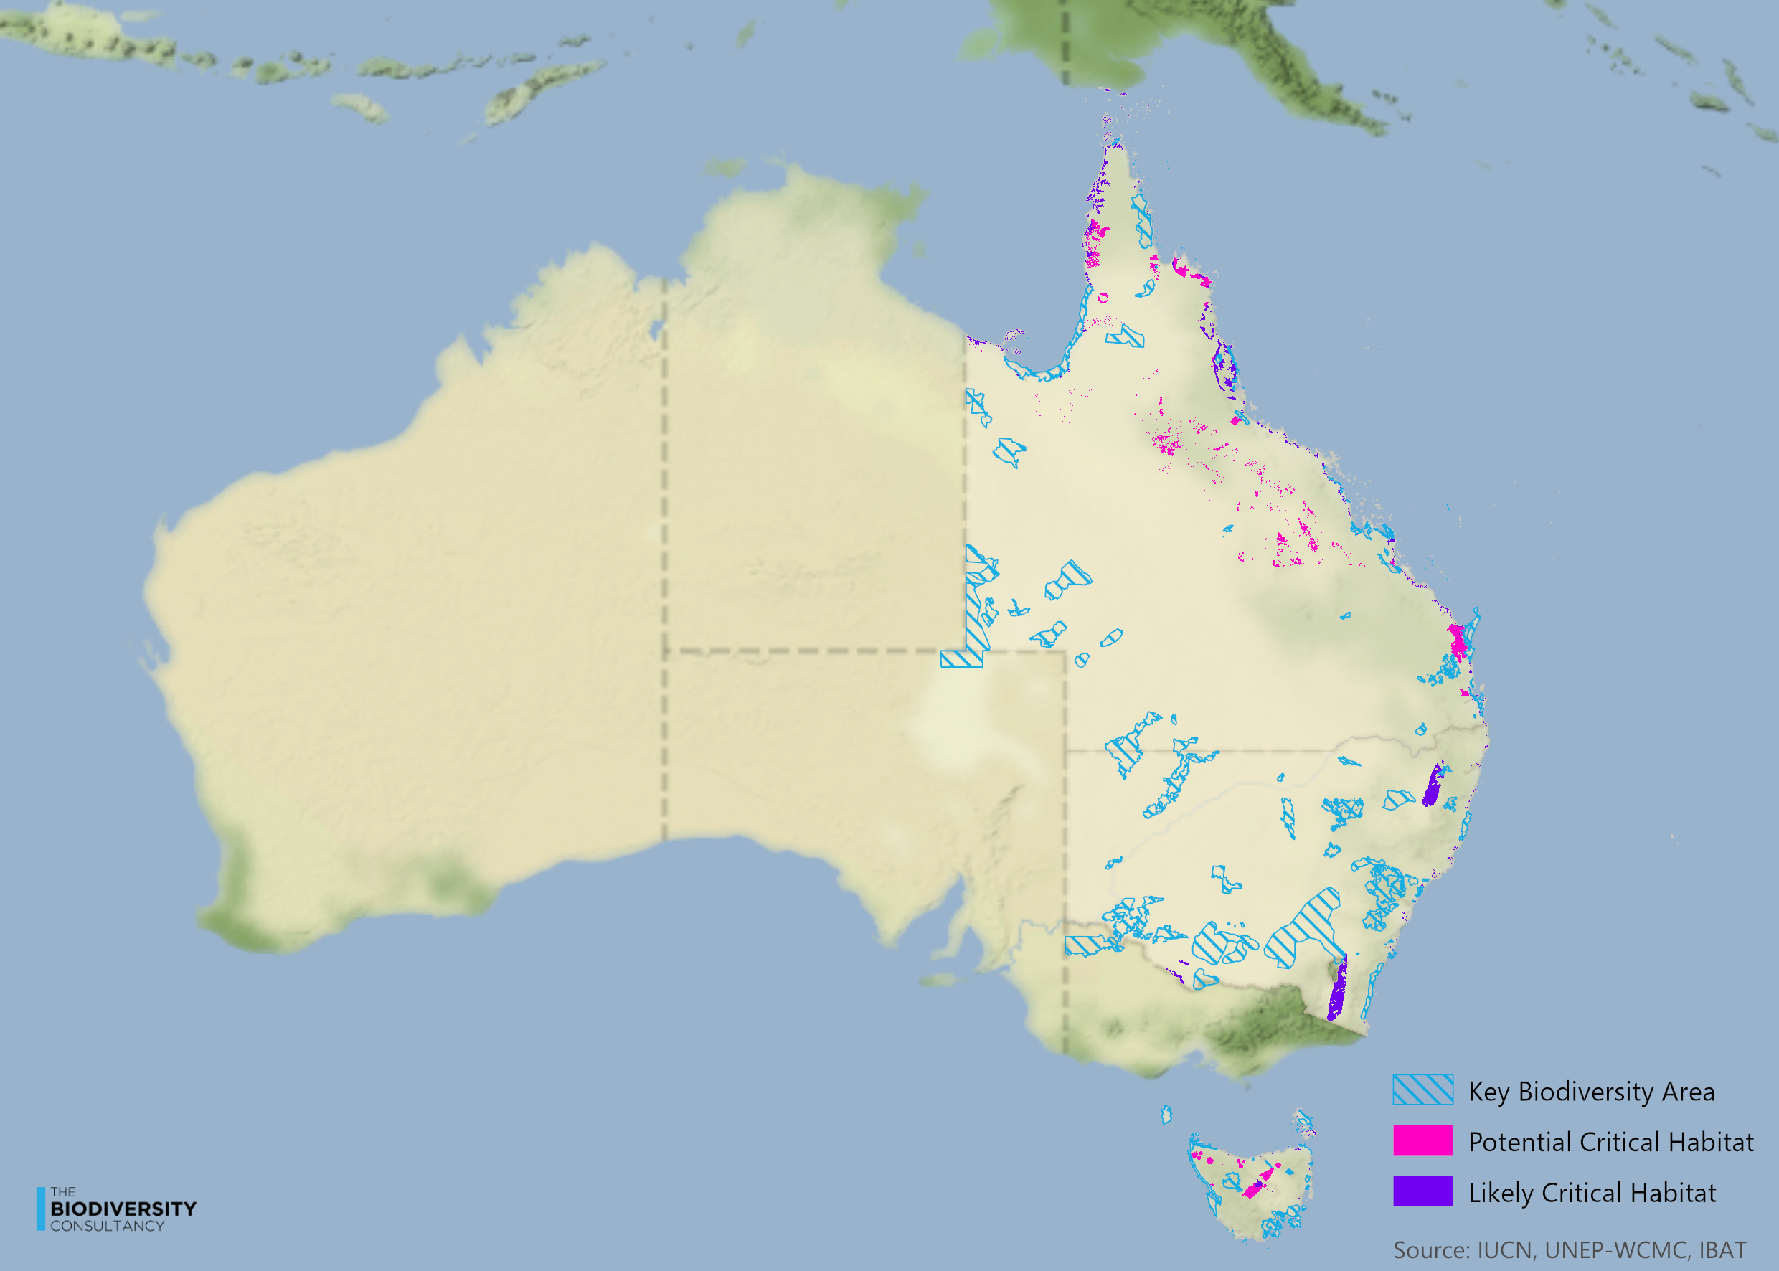
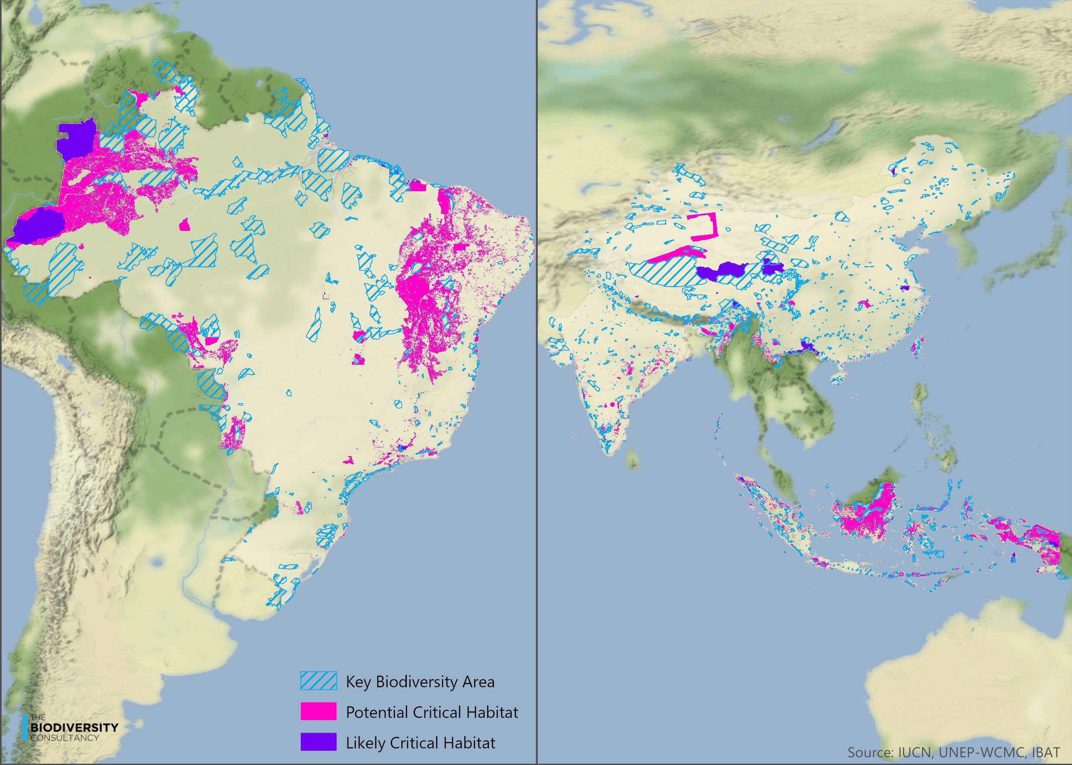

TA 6.8 Regions with high likelihood of threatened or range-restricted species (Range-rarity)
The presence of a high concentration of threatened species, or those with limited geographic ranges (known as restricted-range species), is an indication of increased risk of significant impacts to nature. The range-rarity data set is a potential tool for identifying areas of high global importance for species conservation. These areas should be screened for the potential presence of species for which impacts should be avoided.
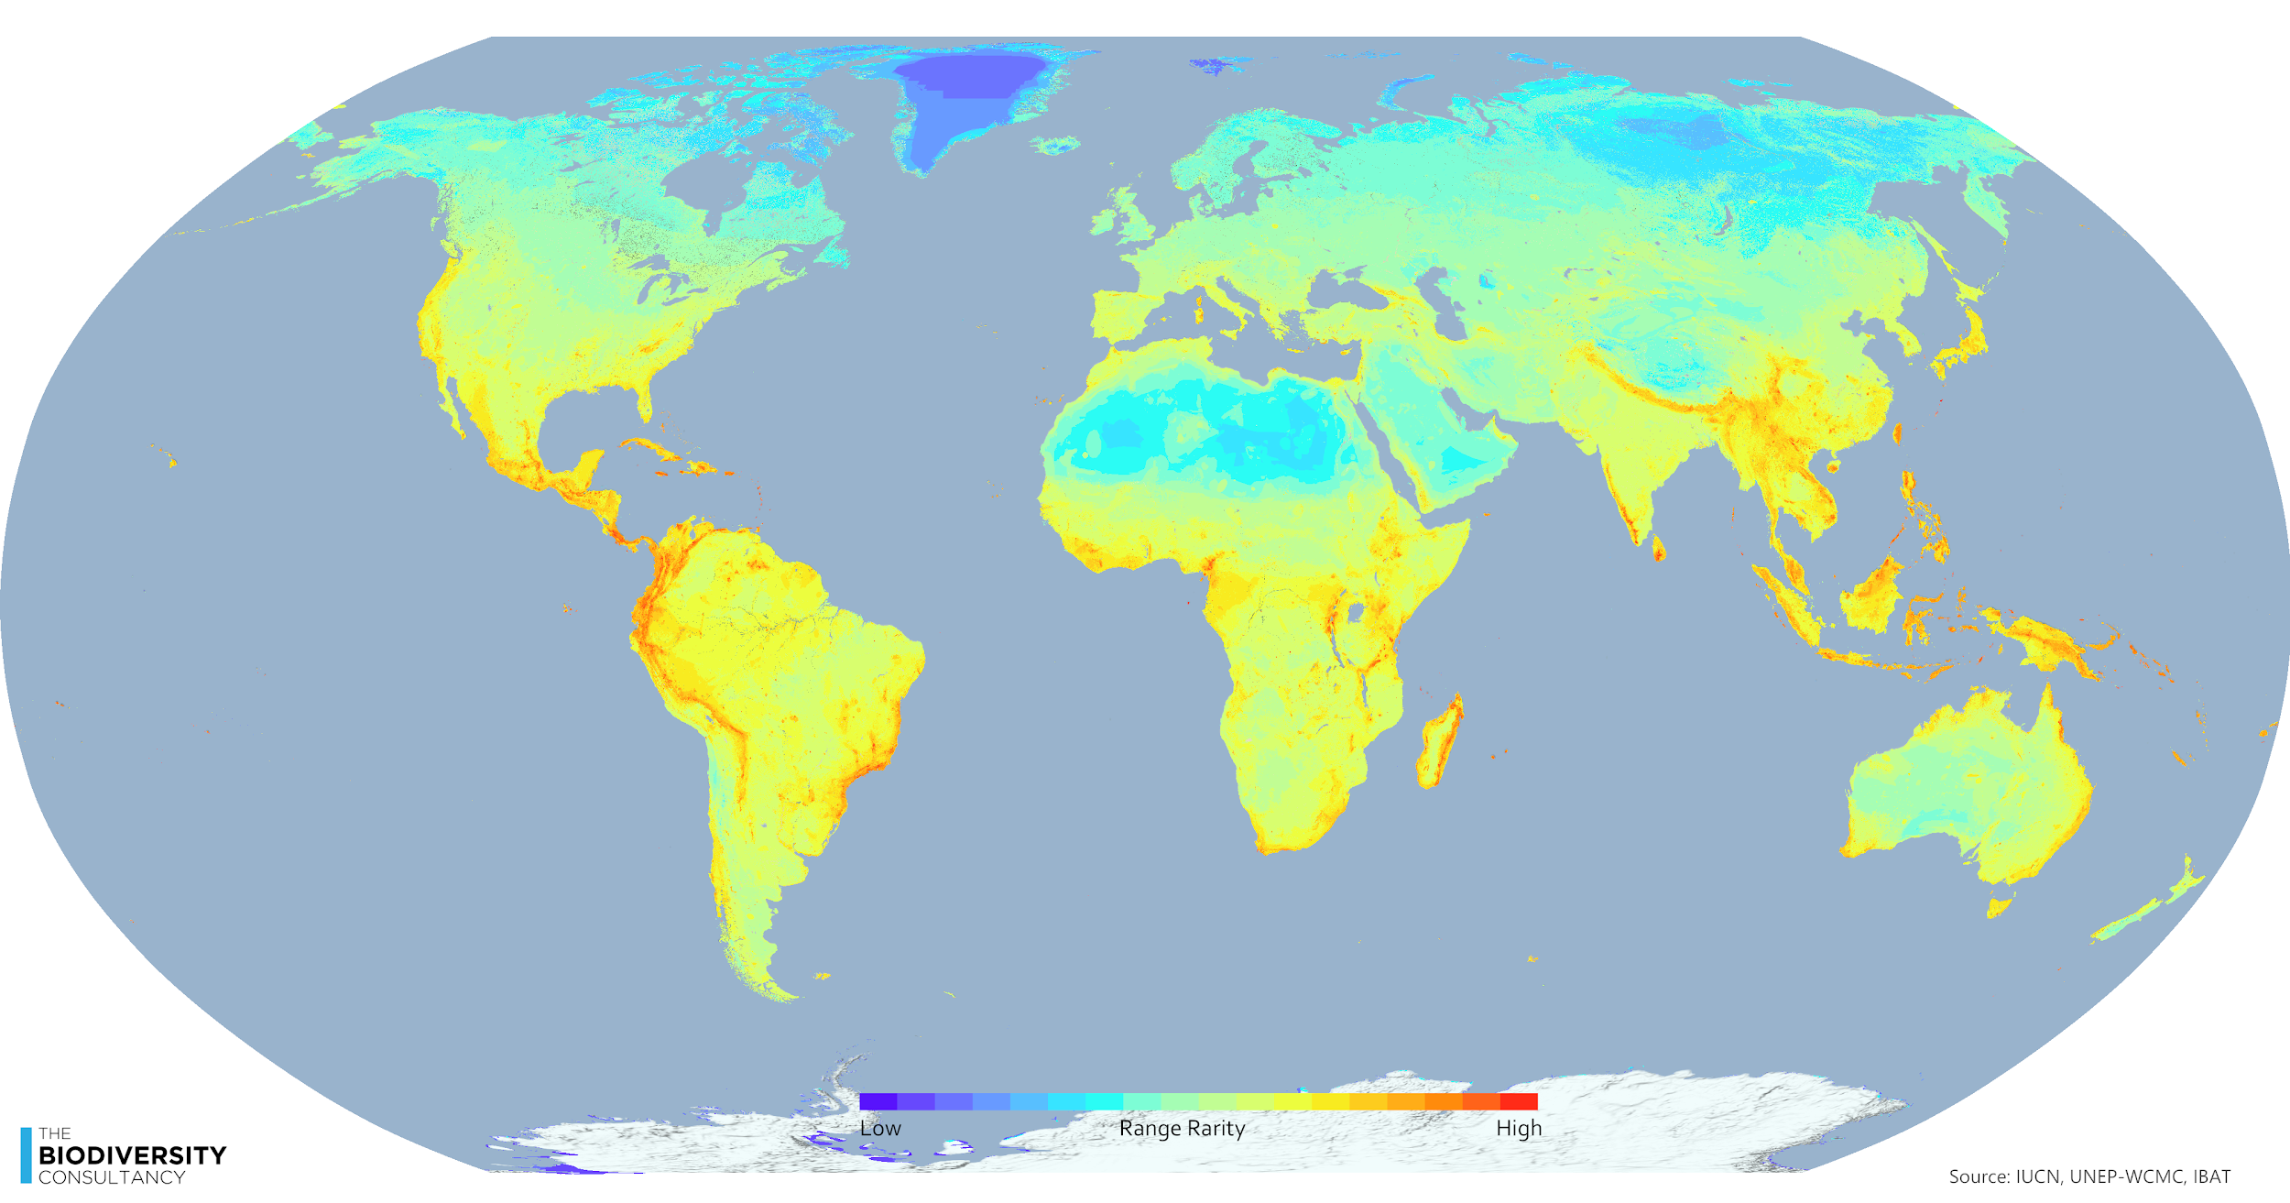
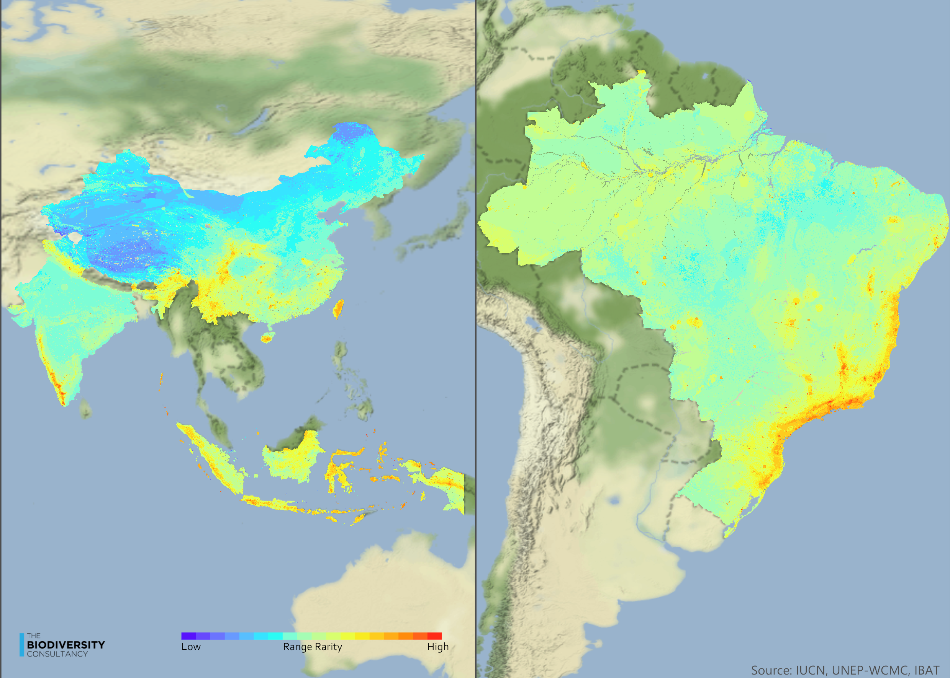

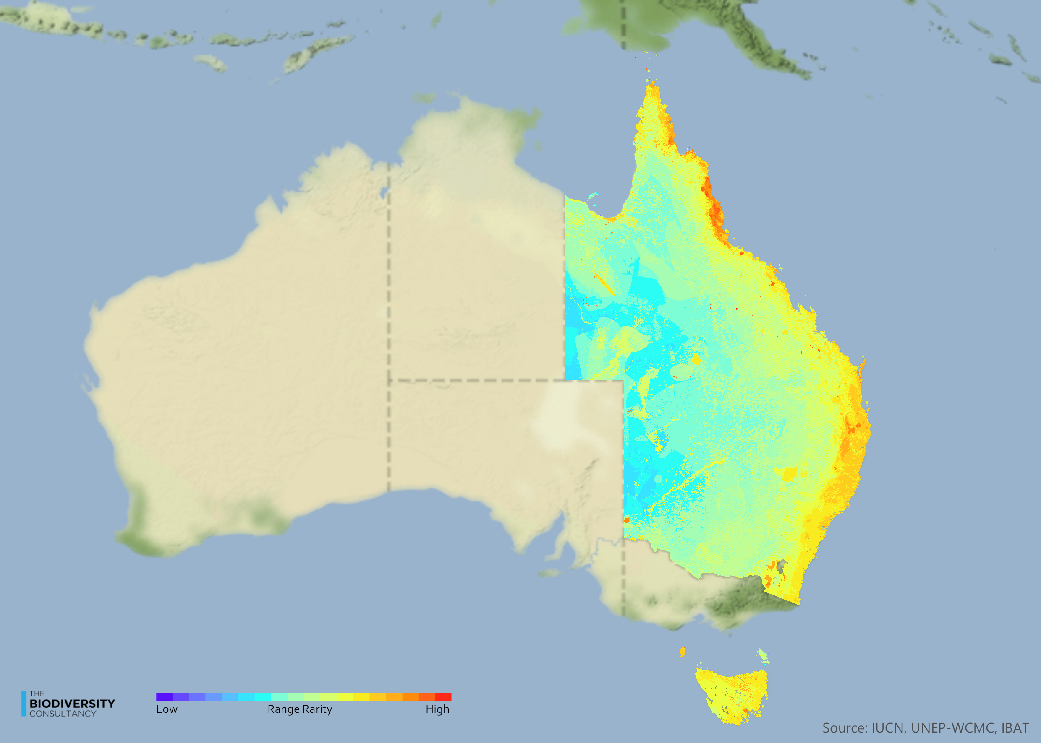

TA 6.9 Other resources
Below are additional resources which can be used to guide application of the mitigation hierarchy, and the development of appropriate avoidance strategies.

Resource | Note | Availability
GIBOP. Biodiversity Offset Policies | Global Inventory of Biodiversity Offset Policies (GIBOP) | Global database on national biodiversity offset policies | https://portals.iucn.org/offsetpolicy/
de Silva GC de S, Regan EC, Pollard EHB, Addison PFEA. The evolution of corporate no net loss and net positive impact biodiversity commitments: Understanding appetite and addressing challenges | Paper on private sector No Net Loss policies. | https://onlinelibrary.wiley.com/doi/full/10.1002/bse.2379
Risk management for biodiversity and ecosystem services: the business case. | Briefing note on the business case for biodiversity risk management | https://www.thebiodiversityconsultancy.com/business-case-for-bes/
A cross-sector guide to implementing the Mitigation Hierarchy (2015) | Publication from CSBI and TBC. A practical guide to site based application of the Mitigation Hierarchy | http://www.csbi.org.uk/our-work/mitigation-hierarchy-guide/
Good Practices for the Collection of Biodiversity Baseline Data | Report from Multilateral Financing Institutions Biodiversity Working Group & CSBI on biodiversity baseline data collection.  Authors: Gullison RE, Hardner J, Anstee S, and Meyer M. | http://www.csbi.org.uk/our-work/good-practices-for-the-collection-of-biodiversity-baseline-data/
Good Practices for Biodiversity Inclusive Impact Assessment and Management Planning | Report from Multilateral Financing Institutions on integration of biodiversity issues in EIAs.  Authors: Hardner J, Gullison RE, Anstee S, and Meyer M. | https://publications.iadb.org/publications/english/document/Good-Practices-for-Biodiversity-Inclusive-Impact-Assessment-and-Management-Planning.pdf
Pilgrim JD, Brownlie S, Ekstrom JMM, Gardner TA, von Hase A, Kate K ten, et al. A process for assessing the offsetability of biodiversity impacts | Paper on the limits to biodiversity offsets.  Conserv Lett. 2013 Jan;6:376–84. | https://conbio.onlinelibrary.wiley.com/doi/full/10.1111/conl.12002
Gardner TA, Von Hase A, Brownlie S, Ekstrom JMM, Pilgrim JD, Savy CE, et al. Biodiversity Offsets and the Challenge of Achieving No Net Loss | Paper on the basic principles of offsets and use of the mitigation hierarchy.  Conserv Biol. 2013;27:1254–64. | https://conbio.onlinelibrary.wiley.com/doi/10.1111/cobi.12118
Biodiversity and ecosystem services fundamentals. Guidance document for the oil and gas industry (2016) | IPIECA guide to managing biodiversity and ES risk for the oil and gas industry. | http://www.ipieca.org/sites/default/files/publications/BES_fundamentals_2016_05.pdf
Pollard E, Bennun L. Who are Biodiversity and Ecosystem Services Stakeholders? | Paper on value of and identification of stakeholder for biodiversity and ecosystem services for the oil and gas industry | https://www.onepetro.org/conference-paper/SPE-179458-MS
Addison PFE, Bull JW, Milner‐Gulland EJ. Using conservation science to advance corporate biodiversity accountability | Paper on setting corporate biodiversity policies | https://conbio.onlinelibrary.wiley.com/doi/full/10.1111/cobi.13190
Bull JW, Gordon A, Watson JE, Maron M. Seeking convergence on the key concepts in ‘no net loss’ policy. | Paper on the core components of corporate no net loss policies | http://onlinelibrary.wiley.com/doi/10.1111/1365-2664.12726/full
Technical conditions for positive outcomes from biodiversity offset | Input paper for the IUCN policy on biodiversity offsets  Authors: Ekstrom J & Pilgrim J. | Available from: https://portals.iucn.org/library/node/44775
Biodiversity offsets technical study paper | Input paper to the IUCN.  Authors: Kate K ten, Pilgrim JD | Available from: https://portals.iucn.org/library/node/44900
No Net Loss and Net Positive Impact Approaches for Biodiversity | IUCN paper on the use of NNL approaches in agriculture and forestry | http://www.thebiodiversityconsultancy.com/wp-content/uploads/2015/06/IUCN-Agriculture-and-Forestry-final-report-April-2015.pdf
Biodiversity A-Z website | UNEP-WCMC website with referenced definitions for key biodiversity terminology | www.biodiversitya-z.org
A Global Standard for the Identification of Key Biodiversity Areas | The IUCN standard for the identification of Key Biodiversity Areas | https://portals.iucn.org/library/sites/library/files/documents/2016-048.pdf
Guiding Principles and Recommendations for Responsible Business Operations in and around Key Biodiversity Areas | KBA partnership guidance containing information on operations which may have negative impacts on KBAs | https://www.iucn.org/sites/dev/files/content/documents/draft2_guiding_principles_and_recommendations_for_businesses_in_and_around_kbas_2december.pdf
The HCS Approach Toolkit Version 2.0: Putting No Deforestation into Practice. | Toolkit for the identification of High Carbon Stock forest | http://highcarbonstock.org/the-hcs-approach-toolkit/
Common Guidance for the Identification of HCV. | Toolkit on the identification of High Conservation Values | https://hcvnetwork.org/library/common-guidance-for-the-identification-of-high-conservation-values/
Exploring Natural Capital Opportunities, Risks and Exposure [ENCORE] | Online tool for identifying Natural Capital risks and opportunities | https://encore.naturalcapital.finance/en
Assessment Of Biodiversity Measurement Approaches For Businesses And Financial Institutions | Summary of potential biodiversity metrics | https://ec.europa.eu/environment/biodiversity/business/assets/pdf/European_B@B_platform_report_biodiversity_assessment_2019_FINAL_5Dec2019.pdf
Soil Erosion Risk Assessment in Europe data (MESALES model) | Dataset on soil erosion risk | https://esdac.jrc.ec.europa.eu/content/soil-erosion-risk-assessment-europe-data-mesales-model-dataset
A desertification risk assessment decision support tool (DRAST) |  | ttps://www.sciencedirect.com/science/article/abs/pii/S0341816219305557

Technical Annex 7: Transform
Within the Global Commons Alliance, transformational change is being tackled at several levels. The Earth Commission, through its Transformation Working Group, is exploring the social perspectives of the transformation that is required to ensure society operates safely and justly within planetary boundaries. The Systems Change Lab is working on the “factors and drivers that come together to accelerate systemic change in the right direction.” The Lab’s work will provide a succinct picture of transitions underway globally across a range of systems, identify drivers of past successful transitions and create a ‘dashboard’ to track progress on these transitions.
Within the Science Based Targets Network, we are focusing on the ways in which transformative actions unlock necessary changes within businesses as entities and within the value chains, landscapes, and systems with which companies where they make their lives.

TA 7.1 The need for transformational change
The extreme degradation and loss of nature, the catastrophic impacts on our climate from ‘business as usual’ over the last 50 years, and the ten year window given to us by scientists to shift these trends create an undeniable case for transformation across our society. It is necessary, but insufficient (Global Biodiversity Outlook 2020) to avoid and reduce our negative impacts, and to give back to nature by restoring and regenerating our landscapes and stocks of capital. Transformative actions, directed at changes in the socioeconomic, political and cultural systems that tie us together are an essential part of the portfolio of actions which society as a whole must pursue. Each of us has our own role to play in these transformations.
The need to transform is acknowledged in policy, planning, academic debate, and media -- whether in the context of decarbonization, resilience, national development plans, equity and justice, or sustainability objectives. There has been and continues to be important research into how society responds to environmental change and how sustainability transformations are understood across societies (Feola 2015). As a result, insight has been gained regarding how to drive behavior change toward ways of living which are compatible with the biophysical limits of our world, as well as compatible with the visions of well being held across societies and within different societies.
Underlying drivers of nature loss may be thought to stem from the current dominant belief and values systems of individuals and societies (IPBES 2019). Based on these value systems, individuals and societies develop political context, institutions and governance structures, investment and business models, economic paradigms, and so on.
The SBTN framework provokes a re-evaluation of the way people and businesses connect with nature. While this includes activities like taking a walk in the park and birdwatching, it goes beyond, to giving time and consideration to one’s role within an ecosystem -- as a giver or a taker of services and capital.

TA 7.2 “Transform” as part of science-based targets for nature: what does it mean and what actions can a company take now?
Key messages:
- Transformative change in the way companies operate is required in order to deliver on global goals for nature, climate and development in unison
- Transformation entails contributing to ‘systems change’ beyond usual boundaries (e.g. the supply chain), and with recourse to new modes of action (e.g. assessing material risks from a societal perspective)
- Actions under the umbrella of transformation fall along a spectrum, ranging from those that take place within a company’s ‘sphere of operations’ to those beyond a company’s immediate geographic and operational boundaries, into a company’s ‘sphere of influence’
- Actions under the category of transform are not a final consideration once other options are explored; companies’ roles in transformation relate to building an ‘enabling environment’ that can increase the likelihood of success in achieving their own targets as well as those of other actors
- Commitments and actions under transform should catalyze and leverage a fundamental shift in norms of behavior and culture--within the company, local stakeholders, suppliers, industry investors, regulators, and beyond--to support climate and nature goals
Key terms:
Transform: a major change in form, nature, or function
Transformation: a marked change in form, nature, or appearance
Transition: the process or a period of changing from one state or condition to another
Pathway: a series of actions that can be taken in order to achieve something

How does Transform fit within SBTs for Nature?
This section focuses on some of the key issues around culture, values and behaviors – specifically focusing on connecting people to nature through personal and professional experience and knowledge and understanding of the fundamental and critical value that nature provides. It also sets out the parameters around the type of actions and targets that companies will have to commit to in order to contribute to what is needed for delivering on global goals for nature and the system change that entails.
The transform element of AR³T is not designed to be implemented last but rather to support the entire framework in three main ways:
- Outline the actions that may be prerequisites for the other elements, e.g. creating the enabling environment can be a very first step for companies setting out their ‘action plan for nature’
- Outline the actions that can augment and support the other elements of SBTN (avoid, reduce, restore, regenerate), so that actions taken are mutually reinforcing and synergistic
- Outline the actions that can deliver on transformative change over and above what is needed at a minimum to secure a safe and just future.
For science-based targets for nature, we focus on the transform element on specific actions that individual companies can take now in order to (i) provide the enabling environment that will help ensure the success of actions to avoid and reduce impacts and restore and regenerate nature, and (ii) catalyze and leverage a shift in norms of behavior and culture to support climate and nature goals. The latter involves highlighting, reinforcing and reinvigorating the link between nature and ‘culture’ – basically, changing how we buy, use and dispose of ‘products’ and how we live and move and connect with nature.

What actions can a company take?
In Transform, there are two main perspectives for action: those that take place within the company’s ‘sphere of operations’ and those that extend beyond geographic and operational boundaries into a company’s ‘sphere of influence’. Examples of the kind of actions that can be taken for each sphere are given in Table 1. Across all of these, three cross-cutting themes emerge that underpin credible and effective action:
- Seeking and engaging in collaboration and collective action wherever possible
- Coherence across commitment and action – all activities of a company, from marketing to lobbying to R&D, should be aligned with a company’s nature commitments and targets
- Long-term commitment to sustained action to deliver enduring outcomes

Table 1. Illustrative actions that companies can take under Transform.
Sphere of Operations:  Business Strategies & Models | Sphere of Influence:  Advocacy & External Communications
v VALUE CHAIN APPROACHES  Ø Seek and engage in collaboration & collective action wherever possible  § Engage proactively in partnerships and landscape-level initiatives to tackle challenges that cannot be effectively tackled on a company-by-company basis, investing in relevant data resources and spatial planning, etc  § Provide financial support and incentives for suppliers to meet desired standards and to engage in building more sustainable supply chains and sourcing  § Provide technical assistance and other support for suppliers (e.g. small-holder primary producers) to transition to improved practices | v PUBLIC INITIATIVES  Ø Seek and engage in collaboration & collective action wherever possible. Ensure coherence across commitment and action  § Ensuring that the company is aligned across marketing, R&D, lobbying etc with its nature commitments and actions  § Policy engagement (e.g. lobbying government for appropriate legislation)  § Join and participate in collective action e.g. Business for Nature, Nature Champions Agenda, One Planet Business for Biodiversity, Fashion Pact
v CORPORATE CULTURE & INTERNAL COMMUNICATION  Ø Commit to long term plan of action around building engagement in the role of nature in business operations, strategy and employee accountability at all levels of the company  § Develop a long running (1-5 year) ‘nature/biodiversity’ program (with incentives for annual participation) for all employees, including C suite  § Incentives / KPIs for executives (and others) aligned with SBTN target outcomes  § Local biodiversity efforts around facilities with/for employees  § Regular engagement with all employees on building the understanding of the relationship between nature conservation, SBTs and business operations and strategy.  § Support for employees to make more sustainable and nature-positive lifestyle choices, both within and outside work | v COMMUNICATION  Ø Transparency on progress, milestones, targets  § Promote and participate in transparency efforts (E.g., publish sourcing geographies, concessions, traceability systems)  § Triple bottom line approach, integrated reporting, B corporation  § Marketing with nature that gives back to nature e.g. The Lions Share
v CONSUMER OUTREACH
Ø Long term commitment to communication approaches to build awareness and consistency of messaging
§ Company creates a ‘voice’ to communicate with customers/clients on how to effect nature positive behavioral changes
§ Communicate about responsible purchasing options
v OPERATING MODELS  Ø Commit to address material issues and to change business models to operate within planetary boundaries  § Strategies and approaches in place that enable coherence between business and nature commitments and actions  § Clear commitment to act on ‘material issues’, i.e. those that have significant impact on nature but also are critical to the business  § Invest in R&D to develop new technologies and business models are lower-impact or nature positive  § Commit to transition away from technologies and business models that are excessively harmful to nature and climate | v REGULATION  Ø Coherence between action within and outside the company  § Advocate with creditors and governances for financial incentives that promote desired response options  § Advocate for government policies that promote desired responses and limit bad actors  § In supply areas, communicate about the important of good governance

Examples of good practice for corporate action – guidance and resources
Table 2 presents examples of existing good practice and resources that can be used by companies wishing to design practices and actions under Transform. Note that these best practices do not necessarily focus on all the key issues of SBTN Transform as the focus on nature is still relatively nascent across many sectors. However, there are also examples of more broad sustainability and livelihood initiatives that companies have engaged that can be used as models for more specific nature-based actions .

Table 2. Examples of guidance and resources for designing practices and actions for SBTN Transform
Type of Action | Best Practice | Details | Link
SPHERE OF OPERATIONS
Value/Supply Chain | Natural Capital Accounting | Effective way to understand the profile of impact across supply chains. New work to integrate biodiversity into the Natural Capital Protocol. Kering’s EP&L is a developed example of corporate natural capital accounting. | https://capitalscoalition.org/  https://kering-group.opendatasoft.com/pages/home/
 | Collaborative engagement of business units in sustainability initiatives | Different examples of how companies have created the incentives and catalysis for engaging business operations in sustainability initiatives. | https://www.cocoalife.org/
Corporate Culture & Internal Communication | Engaging employees | “Every employee is Head of sustainability” – an initiative of Unilever NZ & Australia to get employee engagement in the sustainability strategy | https://www.greenbiz.com/article/sustainability-employees-and-social-media-4-keys-success
 | Experiencing nature | Earthwatch has success in engaging corporate employees in learning from nature. | https://earthwatch.org/partnerships/corporate-social-responsibility
Operating Models | Building incentives for changing supply chains internally | Putting an internal price on carbon with business units contributing to internal funds for sustainability initiatives. It is critical that the price is set appropriately following guidance (e.g. CDP) e.g. novozymes, LVMH, Chanel. | http://b8f65cb373b1b7b15feb-c70d8ead6ced550b4d987d7c03fcdd1d.r81.cf3.rackcdn.com/cms/reports/documents/000/002/740/original/cpu-2017-how-to-guide-to-internal-carbon-pricing.pdf?1521554897  https://www.lvmh.com/news-documents/news/success-of-lvmh-internal-carbon-fund-with-more-than-six-million-euros-of-eligible-projects
 | Designing products and practices for circularity | Best practice can also be found in companies redesigning their practices for circularity - such as cars through using recycled aluminium | https://aluminiuminsider.com/jaguar-land-rover-launches-new-aluminium-recycling-initiative/
SPHERE OF INFLUENCE
Initiatives | Initiatives within sectors, across sectors and with multiple stakeholders | Initiatives can be within sectors and across sectors. Particularly effective initiatives are those that are “multi-stakeholder” and that include a range of supply chain actors as well as technical experts (e.g. NGOs) and that include these stakeholders in decision-making and governance processes. It is not enough for companies to join initiatives but they must have coherence between their actions/operations and the goals of the initiative. | https://www.starbucks.com/responsibility/sourcing/coffee  https://op2b.org/  https://savory.global/land-to-market/  https://www.livelihoods.eu/  https://www.greencommodities.org/content/gcp/en/home/global-initiatives/v2b.html
 |  | Some initiatives have a focus on certification and these can be important to engage in to assure integration of SBTN priorities. | https://wildlifefriendly.org/  https://textileexchange.org/  https://rspo.org/  https://grsbeef.org/  http://www.responsiblesoy.org/?lang=en
Communication | Pro-actively and transparently communicating and reporting on nature commitments and performance | A new opportunity for companies will be to profile their SBTN targets and actions through Earth HQ | http://globalcommonsalliance.org/
Consumer Outreach | Encouraging and empowering customers/clients to make nature-positive choices | Patagonia has led on using “don’t buy this jacket” as a way of highlighting the importance of more responsible consumerism. | https://www.patagonia.com/stories/dont-buy-this-jacket-black-friday-and-the-new-york-times/story-18615.html
 |  | McCartney supported a significant effort to help consumers understand how better to reduce their impacts in the way they care for their clothes. | https://www.stellamccartney.com/experience/en/sustainability/clevercare/
 | Aligning advertising with conservation outcomes | A more interesting approach than simply cause-related marketing - several brands are engaged with the Lions Share that links consumer advertising to wildlife conservation | https://www.thelionssharefund.com/
Regulation | Advocating for nature-positive regulations and policy and contributing to policy development | The mining and extractives sector has led on cross-sector initiatives to develop best practice for biodiversity offsets, which have in turn supported the rapid growth worldwide in regulation and policy requiring or enabling biodiversity offsets. | http://combo-africa.org/  https://www.forest-trends.org/bbop/
 |  | The Business and Biodiversity Offsets Programme (BBOP) (2004-2018) was a group of over 100 companies, government agencies, financial institutions, conservation NGOs and experts. BBOP developed a widely used standard and a number of other tools and resources to help project developers manage biodiversity-related risks of their projects by providing guidance for offsetting biodiversity loss and helping determine the quality and success of these efforts. | https://www.forest-trends.org/bbop/

TA 7.3 The science of transformation
In the context of achieving goals for nature, we draw from studies of systems change to inform the design of transform actions and plans for their implementation. We understand systems as “interconnected [sets] of elements that [are] coherently organized in a way that achieves something” (Meadows). Systems can be defined at varying scales of complexity: a corporation, an economy, a living body, a city, an ecological region or ecosystem can all be evaluated as systems. The work of SBTN is most closely connected to studies of socio-ecological and socio-technological systems.
One of the most important concepts for how to change systems is ‘leverage points’, which refers to ‘places’ within a complex system where a small shift in one thing can produce big changes in everything. One of the great thinkers on system change for sustainability, Donella Meadows, identifies twelve points of leverage sometimes broadly grouped (in descending order of effectiveness) as conscious/mental models, social/system structure, information/patterns of behavior and physical events (Figure 3) (Meadows 1999).
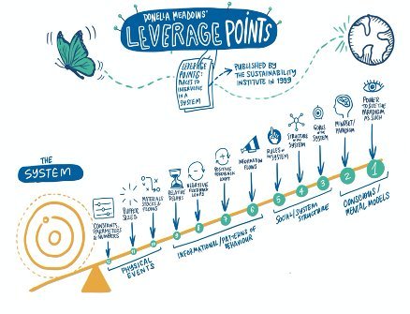
Figure 3. Leverage points to achieve systems change.
In describing ‘pathways to sustainability’ the IPBES (2019) report highlights key levers in terms of governance, institutions and environmental laws that require all actors in society including companies. Key leverage points from the report that can enable a transformative change are included in Box 2.
1. Embrace diverse visions of a good life
2. Reduce total consumption and waste
3. Unleash values and action
4. Reduce inequalities
5. Practice justice and inclusion in conservation
6. Internalize externalities and tele-coupling
7. Ensure technology, innovation and investment
8. Promote education and knowledge generation and sharing
Box 2. Eight key leverage points that could enable a transformative change (IPBES 2019)

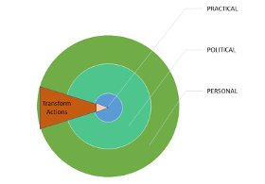
Leverage points are sometimes grouped as practical, political and personal (Figure 4) (Linnér & Wibeck). While all these need to work together to drive transformative change, it is the ‘personal’ – “the mindset or paradigm out of which the system — its goals, structure, rules, delays, parameters — arises” – that is most powerful (Meadows 1999).

Figure 4. Leverage points to achieve systems change can be grouped as practical, political and personal.

Another model commonly referred to in systems change thinking is the ‘iceberg model’ (Figure 5) – this again highlights the fundamental role of our mindset or ‘mental model’ in creating and sustaining systems – and consequently how changing our mental model is essential to achieve systems change.
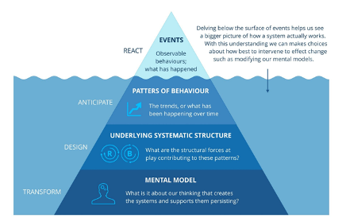

Figure 5. The ‘iceberg model’ of systems change.

An important element of the literature to date is the acknowledgement of the drivers or ‘root causes’ for our current situation and how these need to be addressed if we are to ‘transform.’ Specifically, there is a focus on ‘values and behaviors’ (Figure 2). While value pluralism exists in fact, it is hardly given space in practice. Depending on the approach taken to value, different outcomes in terms of policy, safety and justice will be achieved through formal and informal institutions, as well as through the actions of individuals or organizations.
These institutions exist somewhat independently of values, but may also co-evolve with values (see Pascual et al. 2017, Figure 1).

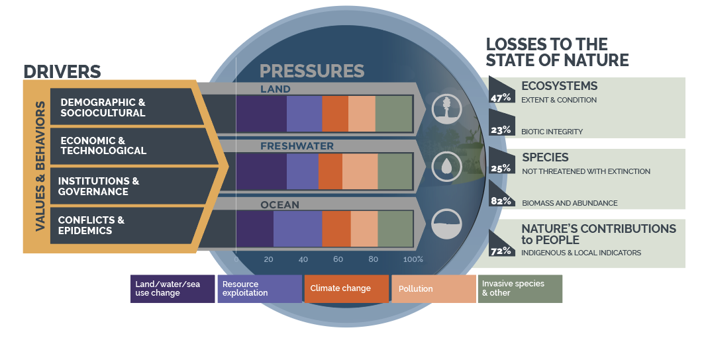
Figure 2. Our values and behaviors are the root causes (drivers) of nature loss. (adapted from IPBES 2019). Note: IPBES uses ‘indirect drivers’ and ‘direct drivers’ whereas we use ‘drivers’ and ‘pressures.’

TA 7.4 Transformation and transitions for sustainability
The past decades have seen many scholars and practitioners put forward their proposals of what needs to be done, and by whom, to achieve a ‘transformation’. The process or steps to achieve a transformative change are often articulated, somewhat confusingly, as “transformations”, “transitions”, “pathways”, “transformative pathways” and/or “scenarios”.
Theories of transformative change are applied in the context of the systems related to keeping climate change within 1.5C (e.g. IPCC SR15), meeting global goals for nature (e.g. IPBES GA 2019), and achieving the SDGs (Sachs et a. 2019). Similarly, transitions may be needed to achieve objectives for social justice while staying within planetary boundaries Doughnut Economics (Raworth 2017). Drawing on a multi-decade review of environmental and sociopolitical trends, the Global Assessment published by IPBES in 2019 proposes that six transformations are required to achieve the socioeconomic objectives of the SDGs and the environmental objectives of the Convention on Biological Diversity in tandem (see Box 1).
Additionally, there are several descriptions of sectoral “transitions” whereby the pathways to sustainability comprise specific actions and steps by sectors or systems. This is the case with the WEF New Nature Economy Paper (WEF 2020) that articulates what is needed for transitioning three main ‘systems’ (such as food, land and ocean use, infrastructure and the built environment, energy and extractives) while highlighting the economic opportunities associated. The FOLU report released in 2019 aims to ‘pave the way for a movement’ to transform the food and land use system. Other analyses chart what is needed from specific groups to support transitions and transformations, for example the work of WBCSD for corporate leaders.
Transformation 1.
Feeding humanity without degrading terrestrial nature resources
Transformation 2.
Meeting climate goals without incurring massive land-use change and biodiversity loss
Transformation 3.
Conserving and restoring nature on land while contributing positively to human wellbeing
Transformation 4.
Maintaining freshwater for nature and humanity
Transformation 5.
Balancing food provision from oceans and coasts with biodiversity protection
Transformation 6.
Resourcing growing cities while maintaining the ecosystems and biodiversity that underpin them
Box 1. Linking the pathways needed for nature restoration and conservation with the six transformations required to achieve the SDGs (IPBES Report 2019).
One important element that is recognized is the integration of the nature perspective into transitions and pathways (CITE). This is one of the transformational elements of Raworth’s approach -- which evaluates economies (from municipal, to state, to global level) according to both socioeconomic and biophysical parameters. As well, this is central to the process of setting science-based targets for nature, given that we approach assessments of materiality (Step 1 of setting SBTs) from a societal or environmental perspective of materiality.

TA 7.5 Evolutions in this space
IPBES has launched a new programme of work that includes a thematic assessment of transformative change. Their objective is to understand and identify factors in human society at both the individual and collective levels, including behavioral, social, cultural, economic, institutional, technical and technological dimensions, that may be leveraged to bring about transformative change.
Complementarily, the Systems Change Lab under the Global Commons Alliance for the Global Environment Facility, is working on recommendations on the “factors and drivers that come together to accelerate systemic change in the right direction” (see 7.1).
Both of these initiatives will deliver outputs between 2020-2022 that will provide critical input into the ongoing development of transform within the SBTN framework.

------
What is outlined above is by no means an exhaustive list of the different ways forward that are being proposed by experts, but it does illustrate that there is an impressive range of knowledge, data and analyses that can be used to design evidence-based action and steps that can be taken by individual companies to contribute to transformative change.

Authors: Helen Crowley, Helen Temple

Technical Annex 8: MRV
The technical annex on MRV consists of 6 boxes. These are introduced in the table below.
Box 1: Definitions MRV and related concepts | It is crucial to have a common understanding of what is meant with monitoring, reporting, verification. Therefore, these as well as related concepts are clarified in Box 1.
Box 2: Holistic monitoring approach | Science based targets for nature will encompass several natural capital elements. For establishing an efficient and effective monitoring program, it is very important to have a good understanding of the interconnections between those natural capital elements. Box 2 illustrates this with an example, including KPIs for measuring state, pressures and actions.
Box 3: Rough decision framework on biodiversity measurement approaches for business (Source: EU Business @ Biodiversity Platform 2019) | Measuring biodiversity is far more challenging compared to measuring water (e.g. quality, scarcity) or climate (e.g. GHG emissions, global warming). Nevertheless, an increasing number of biodiversity measurement approaches for businesses is becoming available, each with their own merits and shortcomings, and suitable for supporting specific business decisions. Box 3 refers to ongoing work on how to select a suitable measurement approach.
Box 4: Common ground principles for biodiversity measurement approaches | Measurement approaches should be underpinned by a number of principles such as rigor, transparency, etc. As a source of inspiration, Box 4 provides common ground principles for biodiversity measurement approaches.
Box 5: Reporting principles that are relevant in the context of SBT for Nature corporate disclosure (based on TCFD and Biological Diversity Protocol) | Analogous to measurement principles, reporting should be based on common ground principles too. Box 5 refers to two key sources of inspiration that could help shape such reporting principles in the context of SBT for Nature corporate disclosure.
Box 6: E-GAAP | A key initiative (driven by the EC) which is worth highlighting in the context of developing a harmonised approach on MRV related to SBT for Nature, is E-GAAP (generally accepted accounting principles for environment). Companies that have committed to SBT should make use of E-GAAP (where available) for compiling consistent, comparable and regular information on progress to targets using an accounting approach on natural capital stocks as well as the flow of services (NCP) generated in physical terms.

Box 1: Definitions MRV and related concepts (from Natural Capital Protocol, Biological Diversity Protocol, ISO 9001, …)
MRV: this acronym is often used for the process of monitoring, reporting and verification to provide assurance over the assessment and its results and/or use in decision-making
Monitoring: to watch closely over time in order to observe, record, or detect; in the context of SBTs for nature, monitoring refers to the process of tracking progress to target
Measurement: the act of determining the actual traits of something (such as dimensions, capacity, etc); in the context of SBTs for nature, measurement applies to the process of collecting data for baseline setting
Verification:Independent process involving expert review to check that the documentation of the assessment is complete and accurate and gives a true representation of the process and results. “Verification” is used interchangeably with terms such as “audit” or “assurance”.
Validation:Internal or external process to check the quality of the assessment, including technical credibility, the appropriateness of key assumptions, and the strength of your results. This process may be formal or informal, and typically relies on self-assessment.
Accreditation: Accreditation is the process in which certification of competency, authority, or credibility is presented. Organizations that issue credentials or certify third parties against official standards are themselves formally accredited by accreditation bodies; hence they are sometimes known as "accredited certification bodies"
Certification: the formal attestation or confirmation of certain characteristics of an object, person, or organization. This confirmation is often, but not always, provided by some form of external review, education, assessment, or audit.
Reporting: Reporting refers to the preparation of a formal written document for a specific business purpose, and typically connected to desired objectives, outcomes or outputs. Intervals for reporting should ideally correspond to the desired long-term outcomes and interim milestones. Effective and transparent business reporting allows organisations to present a cohesive explanation of their business and helps them engage with internal and external stakeholders, including customers, employees, shareholders, creditors, and regulators. Organizations conduct a wide range of reporting for both internal (e.g. management reports, sales data, employee turnover) and external audiences. Examples of the latter include financial and regulatory reporting, environmental, social, and governance (ESG) reporting (or sustainability reporting), and, increasingly, integrated reporting.
Disclosure: Disclosure refers to the voluntary or required/statutory release of any information relevant to a company, security, fund or any third party to external stakeholders; in the context of SBTs for nature, external reporting and disclosure can be used interchangeably.
Natural capital accounting: a framework or method that approximates financial accounting standards by collecting and structuring information on natural capital by compiling consistent, comparable and regularly produced data using an accounting approach on natural capital and the flow of services generated in physical and/or monetary terms. It can be used for disclosure either in national or business accounts. Natural capital accounts are a possible output from a natural capital assessment; in the context of SBTs for nature, annual natural capital accounts include information on SBTs and progress on targets.

Box 2: Holistic monitoring approach
Science based targets for nature will encompass several natural capital elements. For establishing an efficient and effective monitoring program, it is very important to have a good understanding of the interconnections between those natural capital elements. Let's illustrate this with the example of wetland restoration. Wetland restoration can be one of the actions under a broad corporate level science-based target such as Net Positive Impact or a more specific science-based target to restore the population of an endangered amphibian species or even a water-related target such as restoring the natural water system in a certain area. It is clear that the interconnections between water and biodiversity need to be clarified, and depending on the specific situation, also land use. In this illustrative example, let’s assume the following description of the challenge:
“Due to intensive farming practices over the past decades which have put high pressures on available water resources and water quality and transformed original wetlands into new agricultural land, the local ecosystem is heavily degraded. The involved agro-industrial company has committed to apply a science-based target for nature approach and has set up an action plan for achieving NPI within 10 years. A key action is the restoration of the original wetlands”.
An effective ‘tracking progress to target’ approach will rely on the adequate monitoring of a number of KPIs. In this case the following KPIs and monitoring frequency might be relevant:
- State of the wetlands, both in terms of extent and condition;
  - therefore, the envisaged end-state of the wetland habitats should be specified as well as the anticipated interim results (e.g. succession stages of vegetation);
  - preferably, state needs to be defined by means of a combination of biotic and abiotic parameters;
    - examples of biotic parameters are numbers and diversity of selected indicator species (plants, birds, mammals, amphibians, …) as well as extent and condition of specific habitat types; examples of abiotic parameters are water quality and water levels;
  - once these KPIs are defined, a baseline measurement should take place (T0) allowing monitoring of progress on defined time intervals (T1, T2, …)
- Pressures
  - Evolution of land conversion (e.g. turning farmlands into wetlands again)
  - Evolution of water extraction
  - Evolution of water pollutants
- Actions
  - Progress on implementation of action plan (e.g. which actions have been implemented, which actions are delayed, how resources have been allocated for targets…)

Box 3: Rough decision framework on biodiversity measurement approaches for business (Source: EU Business @ Biodiversity Platform 2019)
Since 2018 the EU Business@Biodiversity Platform has assessed an increasing number of biodiversity measurement approaches for businesses and financial institutions. Based on the increasing demand from its business members (including financial services providers) for more standardized biodiversity measurement approaches the EU B@B Platform facilitated the sharing of methodologies and started a critical and constructive assessment (partly in cooperation with the UNEP WCMC Aligning Biodiversity Measurement for Business (ABMB) project) of (a sample of) measurement approaches to find more common ground (convergence) between these approaches. This has resulted in an initial ‘decision framework’ for corporates and financials on how to select a suitable measurement approach, see matrix below. Based on assessments of concrete case studies (ongoing process by the EU Business @ Biodiversity Platform in 2020 – 2022) and further in-depth assessments of measurement approaches this decision framework will be further refined by the end of 2020. It will be aligned with and complementary to the Navigation Tool developed as part of the Biodiversity Guidance to the Natural Capital Protocol and which will be available on the Capitals Coalition’s website from 2021.
The matrix is built on two key entrances, i.e. business applications and organizational focus areas. In the context of SBTs for nature the ‘tracking progress to target’ business application is relevant as well as the ‘corporate organizational focus area’. It becomes clear that at this moment at least 6 different measurement approaches might be applied for tracking progress to SBT targets, i.e.:
- ABD Index or Agrobiodiversity Index, developed by Bioversity Int and relying on a composite index
- GBS or Global Biodiversity Score, developed by CDC Biodiversité and relying on MSA (mean species abundance)
- BD or Biological Diversity Protocol, developed by the Endangered Wildlife Trust of South Africa and which is more an accounting approach (based on extent and condition)
- STAR or Species Threat Abatement and Recovery, developed by IUCN and based on extinction risk of IUCN red List species
- LIFE, a combined checklist and quantitative assessment approach developed by the Brazilian LIFE Institute, and which also takes ecosystem services into account
- BIE, now renamed as BISI (Biodiversity Indicators for Site-based Impacts), developed by UNEP WCMC, is a typical site or project level tool based on pressure-state response data.

Figure 1: Categorization of biodiversity measurement approaches updated from a report by CDC Biodiversite based on the 2019 assessment of measurement approaches conducted by the European B@B Platform.

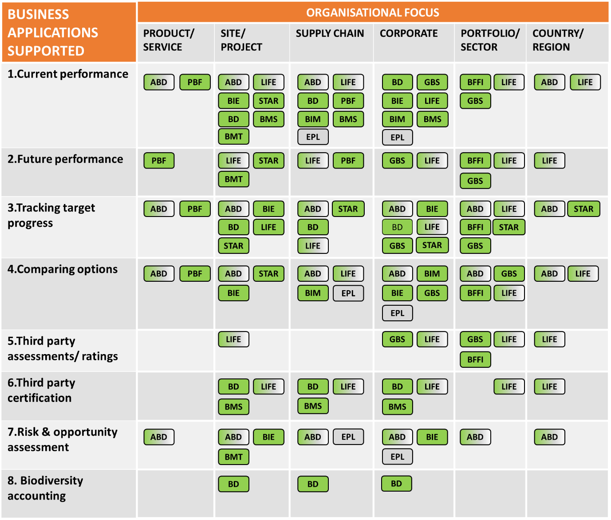
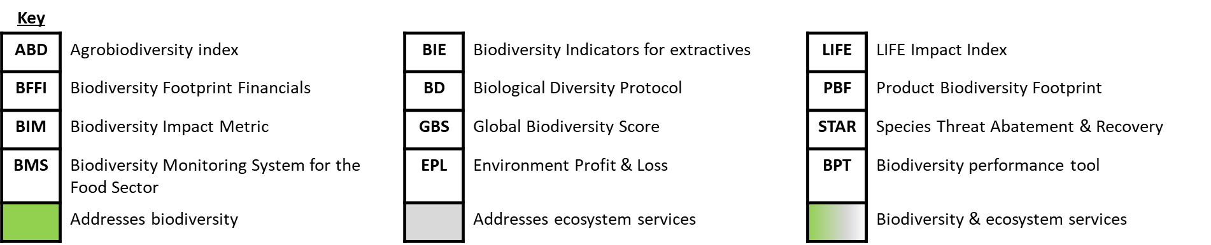

Whilst this matrix is potentially valuable, it could be improved by the use of color to differentiate those approaches that use modelled data or direct measurement, those that adopt a pressures based approach or biodiversity state approach. Further categorization of the approaches according to whether they deliver a qualitative or quantitative score was also considered valuable. A critical review of this matrix against objective criteria are required to make it a more useful guidance for companies, for example, only including those approaches for which pilots or case studies exist. The issue with this matrix is that it is based on self assessments by tool developers and therefore includes a risk of overstating the utility of their tools. Therefore, the next version of the matrix will differentiate between applications that have been pilot-tested or with clear evidence of application by companies, and potential applications.

Box 4: Common ground principles for biodiversity measurement approaches
Within the ABMB initiative (see Box 3 above) the development of common ground principles for biodiversity measurement approaches were explored. However, it was felt that the Natural Capital Protocol principles of relevance, rigor, replicability and consistency (which underpinned the 2018 report) should be the starting point for measurement approaches. These principles were reviewed against areas of common ground for biodiversity footprinting identified by CDC Biodiversity et al (2018) to create a checklist that could be used by developers and users of measurement approaches to ensure they are fit for purpose (see Table 1).

Table 1: A checklist of considerations for biodiversity measurement for business that implement the Natural Capital Protocol principles.
Natural Capital Protocol Principles | Considerations for biodiversity measurement
Relevance: consider most relevant, material issues. | Approaches, data and metrics should be:  - appropriate for the type of application they aim to support;  - relevant to the businesses’ scope and boundaries;  - designed to address all issues, impacts and performance relevant to the business application.
Rigor: use technically robust, data, methods and information | Approaches should:  - achieve suitable accuracy to enable users to make decisions with reasonable assurance on the quality of information;  - be based on best available data selected against established criteria;  - be based on technically robust metrics for which key gaps and uncertainties and their implications for decision making are clear.
Replicability: assumptions, data, methods, caveats are transparent, documented and repeatable | Approaches and methodologies should:  - be transparent on limitations and how the approach works;  - be transparent on boundaries and references/baselines;  - disclose any relevant assumptions, limitations, uncertainties and references to data collection methodologies.
Consistency: data and methods are compatible with each other and scope of analysis | Approaches and data should:  - apply similar boundaries and reference/ baselines definitions to similar business applications;  - select metrics that allow for meaningful comparisons over time and between products/sites etc.

Box 5: Reporting principles that are relevant in the context of SBT for Nature corporate disclosure (based on TCFD and Biological Diversity Protocol)
The Recommendations of the Task Force on Climate-related Financial Disclosure (2017) includes an Appendix with ‘Fundamental Principles for Effective Disclosure’. These are very inspirational for being applied in the context of SBTs for nature. Having such a list of principles also facilitates external assurance. Below are those principles which are deemed relevant in an SBTs for nature reporting and verification context. The text in italic describes how this principle can be applied within the SBTs for Nature context.
Principle 1: Disclosures should present relevant information
Principle 2: Disclosures should be specific and complete
Principle 3: Disclosures should be clear, balanced, and understandable
Principle 4: Disclosures should be consistent over time
Principle 5: Disclosures should be comparable among organizations within a sector, industry, or portfolio
Principle 6: Disclosures should be reliable, verifiable, and objective
Principle 7: Disclosures should be provided on a timely basis
The organization should provide the following type of information:
- overview of identified main material impacts on nature throughout its entire value chain;
  - if some parts of the value chain are not covered yet, it should be clearly described when this will happen;
  - clarification of uncertainties, assumptions and potential scenarios (e.g. climate)
  - concise description of methodological approach
- overview of science based targets that have been set;
  - targets should at least be specified per location and can – in addition to disaggregated data – be aggregated to corporate level data if aggregation tools are available and if aggregated data are meaningful;
  - interconnections and trade-offs between targets on different natural capital elements such as freshwater, oceans, land use, climate and biodiversity should be well explained.
- the organisation’s strategy, governance, processes and action program and related timelines for achieving targets
- description of monitoring program including KPIs and monitoring frequency
- description of monitoring results and interpretation of ‘distance to target’ for each target; description of corrective actions in case progress not on track
- verification mechanism
Disclosures should be eliminated if they are immaterial or redundant to avoid obscuring relevant information. However, when a particular impact attracts stakeholder interest or attention, it may be helpful for the organization to include a statement and justification that the issue is not significant. This shows that the issue has been considered and has not been overlooked.
Disclosures should be presented in sufficient detail to enable users to assess the organization’s approach to addressing impacts on nature, while understanding that the type of information, the way in which it is presented, and the accompanying notes will be subject to change over time. Furthermore, any proposed metrics should adequately describe or serve as a proxy for pressures and/or state of nature.
Disclosures should show an appropriate balance between qualitative and quantitative information and use text, numbers, and graphical presentations as appropriate. Fair and balanced narrative explanations should provide insight into the meaning of quantitative disclosures, including the changes or developments they portray over time as well as the success level of implemented actions. Disclosures should provide straightforward explanations of issues. Terms used in the disclosures should be explained or defined for a proper understanding by the users.
Disclosures should be consistent over time to enable users to understand the development and/or evolution of the impacts and progress to targets. Disclosures should be presented using consistent formats, language, and metrics from period to period to allow for inter-period comparisons. Presenting comparative information is preferred. Changes in disclosures and related approaches or formats can be expected due to the relative immaturity of nature-related disclosures. Any such changes should be explained.
Disclosures should allow for meaningful comparisons of performance across organizations and within sectors and jurisdictions. The level of detail provided in disclosures should enable comparison and benchmarking across sectors and at the portfolio level, where appropriate.
Disclosures should provide high-quality reliable information. They should be accurate and neutral—i.e., free from bias. Future-oriented disclosures will inherently involve the organization’s judgment (which should be adequately explained). To the extent possible, disclosures should be based on objective data and use best-in-class measurement methodologies, which would include common industry practice as it evolves. Disclosures should be defined, collected, recorded, and analyzed in such a way that the information reported is verifiable to ensure it is high quality. For future-oriented information, this means assumptions used can be traced back to their sources.
Information should be delivered to users or updated in a timely manner using appropriate media on, at least, an annual basis.
The BD Protocol is based on seven accounting and reporting principles which are derived, in part, from the GHG Protocol and generally accepted financial accounting and reporting principles. These principles are intended to underpin all aspects of biodiversity impact accounting and reporting. Relevance, completeness, consistency, transparency and accuracy are principles which typically apply to reporting, but for the purposes of this biodiversity accounting approach also equivalency (net impact accounting only for equivalent biodiversity losses and gains) and time period assumption (account for biodiversity impacts consistently across business reporting periods). These accounting and reporting principles are defined as follows:
- Relevance: Ensure the biodiversity impact inventory appropriately reflects the biodiversity impacts of the company and its value chain. It shall serve the decision-making needs of users, both internal and external to the company.
- Equivalency: Ensure the notion of equity in the type of biodiversity (i.e. ecological equivalency or like-for-like principle) is integral to biodiversity impact inventory development and accounting. Undertake net impact accounting only for equivalent biodiversity losses (negative impacts) and gains (positive impacts).
- Completeness: Account for, and report on, all impacts on ecosystems but only impacts on material taxa, within the chosen organisational and value chain boundaries. Disclose and justify any exclusion.
- Consistency: Use consistent methods to allow for meaningful comparisons of biodiversity impacts over time. Transparently document any changes to the data,inventory boundary, methods or any other relevant factors in the time series.
- Transparency: Address all relevant issues in a factual and coherent manner, based on a clear audit trail. Disclose any relevant assumptions and make appropriate references to the data collection and estimation methods used.
- Accuracy: Ensure the measurement of biodiversity impacts is systematically accurate, as far as can be judged, notably by reducing uncertainties as far as is practicable. Achieve suitable accuracy to enable users to make decisions with reasonable assurance as to the integrity of the reported information. When no direct observation is possible, estimate impacts on the basis that they are reasonably likely to occur,recording all methodological limitations.
- Time period assumption: Account for biodiversity impacts consistently across business reporting periods.

Box 6: E-GAAP
From 2020 on, the European Commission has embarked on a journey to support the development of generally accepted accounting principles for the environment, the so-called E-GAAP ('Environment - Generally Accepted Accounting Principles'). E-GAAP is a term that has emerged in the natural capital accounting community in their call for standardized principles and guidelines similar to those underpinning financial accounting and reporting. Natural capital accounting (NCA) is a framework or method that approximates financial accounting standards by collecting and structuring information on natural capital by compiling consistent, comparable and regularly produced data using an accounting approach on natural capital (stocks) and the flow of environmental services generated by these in physical and monetary terms. NCA can be used for disclosures related to national or business activities, although so far the majority of applications have been done at a national level and by the public sector.
Whilst widely accepted principles and guidelines do not yet exist, demand is growing. First of all, there is a huge demand for comparable figures on company non-financial performance, not least from investors who need reliable data for benchmarking purposes and investment decisions. There is also an increasing demand from the business sector itself, and in particular, from frontrunner companies who are asking for greater transparency through use of a common set of rules on how to disclose non-financial performance. Importantly, E-GAAP will be set up to support better internal decision making, better external disclosure will come as a (much needed) bonus. Finally, there is a clear demand from regulators. The European Commission has taken the lead on tackling greenwashing by establishing a so-called taxonomy whilst also planning to revise and strengthen its policies on non-financial reporting. The Commission already provided a grant from its LIFE instrument to support the Value Balancing Alliance[1] in developing, testing, and promoting a first ‘E-GAAP’ during the period 2020-2022. The Commission will also establish an Environmental Accounting Platform in 2020 to promote best practice exchanges. The Commission’s aim is to have the E-GAAP broadly implemented, at least by the largest companies, within a few years (2025).
E-GAAP is likely to become a set of principles that give minimum quality assurance, and a way to organize data to produce information and eventually, facilitate reporting. E-GAAP is expected to draw from business practices as well as reporting and disclosure requirements defined by investors, governments and other stakeholders. Given that E-GAAP encompasses all natural capital elements, it will be well aligned with SBTN’s measurement framework (which is currently under development). That said, the evolution of the E-GAAP is very relevant for SBT reporting too. Companies that have committed to SBT should make use of E-GAAP (where available) for compiling consistent, comparable and regular information on progress to targets using an accounting approach on natural capital stocks as well as the flow of services (NCP) generated in physical terms.

[1] https://www.value-balancing.com/

Technical Annex 9: Additional Reading
This document is organized by relevant resources and citations for each section of the SBTN’s interim guidance. SBTN does not specifically endorse the concepts or details contained in these resources; however, each represents foundational previous work by SBTN partners, reviewers, and stakeholders.

Section 1. Why science-based targets (SBTs) for nature?
Andersen, I., N. Ishii, T. Brooks, C. Cummis, G. Fonseca, A. Hillers, N. Macfarlane, N. Nakicenovic, K. Moss, J. Rockström, A. Steer, D. Waughray, C. Zimm, Defining “Science-based Targets”, National Science Review, nwaa186.
CDP. (2020). Foundations for Science-based Net-Zero Target Setting in Corporate Sector.
IPBES. (2019). Global assessment report on biodiversity and ecosystem services of the Intergovernmental Science-Policy Platform on Biodiversity and Ecosystem Services. E. S. Brondizio, J. Settele, S. Díaz, and H. T. Ngo (editors). IPBES secretariat, Bonn, Germany.
Metabolic & WWF. (2017). One Planet Approaches Methodology Mapping and Pathways Forward.
Obura, D. (2020). Getting to 2030 - Scaling effort to ambition through a narrative model of the SDGs. Marine Policy. 117: 103973.
Steffen, W., K. Richardson, J. Rockström, S. Cornell, I. Fetzer, E. Bennett, R. Biggs, S. Carpenter, W. de Vries, C. de Wit, C. Folke, D. Gerten, J. Heinke, G. Mace, L. Persson, V. Ramanathan, B. Reyers, and S. Sörlin. (2015). Planetary boundaries: Guiding human development on a changing planet. Science: 347(6223), 1259855.
Task Force on Climate-related Financial Disclosures. (2017). Recommendations of the Task Force on Climate-related Financial Disclosures.
UN Global Compact CEO Water Mandate, Pacific Institute, CDP, The Nature Conservancy, World Resources Institute, WWF, UNEPDHI Partnership Centre for Water and Environment. 2019. Setting Site Water Targets Informed By Catchment Context: A Guide For Companies.
UNEP. (2015). Raising the Bar--Advancing Environmental Disclosure in Sustainability Reporting.
UN RISD. (2020) Corporate Sustainability Accounting: What Can and Should Corporations Be Doing?—Overview.
World Economic Forum. (2020). New Nature Economy Report II The Future Of Nature And Business.
World Economic Forum. (2020). Nature Risk Rising: Why the Crisis Engulfing Nature Matters for Business and the Economy.

Section 2. Step-by-step guide: Setting SBTs for nature

Step 1: Assess

Global Reporting Initiative. GRI Global Standards.
Greenhouse Gas Protocol. (2013). Accounting and Reporting Standard Amendment: Required Greenhouse Gases in Inventories.
Natural Capital Coalition. (2016). Natural Capital Protocol.
Natural Capital Finance Alliance and PricewaterhouseCoopers. (2018). Integrating Natural Capital in Risk Assessments: A step-by-step guide for banks.
Sustainability Accounting Standards Board. (2018). SASB Global Standards.

Step 2: Interpret & Prioritize

Step 3: Measure, set & disclose
Accountability Framework initiative. Accountability Framework.
Baer, P., Fieldman, G., Athanasiou, T. & Kartha, S. Greenhouse Development Rights: towards an equitable framework for global climate policy. null 21, 649–669 (2008).
Bjørn, A. et al. Review of life-cycle based methods for absolute environmental sustainability assessment and their applications. Environmental Research Letters 15, 083001 (2020). https://iopscience.iop.org/article/10.1088/1748-9326/ab89d7
Lammerant, J., A. Grigg, J. Dimitrijevic, K. Leach, S. Brooks, A. Burns, J. Berger, J. Houdet, M. Van Oorschot, and M. Goedkoop. (2019). Assessment of Biodiversity Measurement Approaches for Businesses and Financial Institutions. EU Business @ Business Platform.
Lucas, P. L., Wilting, H. C., Hof, A. F. & van Vuuren, D. P. Allocating planetary boundaries to large economies: Distributional consequences of alternative perspectives on distributive fairness. Global Environmental Change 60, 102017 (2020).
Lucas, P. & Wilting, H. Using planetary boundaries to support national implementation of environment-related Sustainable Development Goals. (2018). doi:10.13140/RG.2.2.15143.80806.
McElroy, M. (2008) Social footprints — Measuring the Social Sustainability Performance of Organizations. University of Groningen (doctoral dissertation). Available online at: https://www.rug.nl/research/portal/files/13147569/DISSERTATION-2.pdf.
McElroy, M. and van Engelen, J. (2012) Corporate Sustainability Management — The Art and Science of Managing Non-Financial Performance. Earthscan, London.
Shue, H. (1999), 'Global Environment and International Inequality', International Affairs, 75, pp. 531-45.
UN Convention on Biological Diversity. (2020). Zero Draft of the Post-2020 Global Biodiversity Framework.
UN General Assembly. (2017). Resolution adopted by the General Assembly on Work of the Statistical Commission pertaining to the 2030 Agenda for Sustainable Development.
UN Global Compact CEO Water Mandate, Pacific Institute, CDP, The Nature Conservancy, World Resources Institute, WWF, UNEPDHI Partnership Centre for Water and Environment. 2019. Setting Site Water Targets Informed By Catchment Context: A Guide For Companies.
van den Berg, N.J., van Soest, H.L., Hof, A.F. et al. Implications of various effort-sharing approaches for national carbon budgets and emission pathways. Climatic Change 162, 1805–1822 (2020). https://doi.org/10.1007/s10584-019-02368-y
WWF/Metabolic (2017) One Planet Approaches.

Step 4: Act

Conservation Hierarchy

International Finance Corporation. (2012). Biodiversity Conservation and Sustainable Management of Living Natural Resources. Performance Standard 6.

Step 5: Track
See Step 3

E.g., one way of thinking about approaches to value identifies three “types” of value: intrinsic, instrumental and relational (Pascual et al. 2017).
Note: the SDGs and CBD together cover many of the goals that SBTs empower actors to align with, but not all. A separate review of IPBES, IPCC and UNCCD materials found slightly different but mostly similar categories of transformation and action as those listed below (unpublished).

